**EMBEDDED SYSTEMS**

**AND**

**INTERNET OF THINGS**

**DOCUMENTATION BY:**

**YUVASRI G**

**TABLE OF CONTENTS**

1. INTRODUCTION TO EMBEDDED SYSTEMS
2. APPLICATIONS OF EMBEDDED SYSTEM
3. **COMPONENTS** OF EMBEDDED SYSTEM
4. CLASSIFICATION OF EMBEDDED SYSTEM
5. PROCESSOR
6. MICROPROCESSOR VS MICROCONTROLLER
7. CISC VS RISC
8. SPECIAL FUNCTION REGISTER
9. INTERNAL AND EXTERNAL PERIPHERALS
10. TIMERS AND COUNTERS
11. EXTERNAL INTERRUPT
12. PULSE WIDTH MODULATION
13. ADC AND ITS TYPES
14. SENSORS AND ITS TYPES
15. UART COMMUNICATION
16. I2C COMMUNICATION PROTOCOL
17. SPI COMMUNICATION PROTOCOL
18. INTERNET OF THINGS
19. IOT PLATFORMS
20. IOT DATA LINK COMMUNICATION PROTOCOLS
21. INTRODUCTION TO ESP32

**INTRODUCTION TO EMBEDDED SYSTEM**

**SYSTEM**

A system can be defined as an organized arrangement of interrelated components that collaborate according to a predetermined plan, program, or set of rules. It represents a way of working or organizing tasks to achieve desired outcomes. An example of a system is a watch, where its various components work together following specific rules to display time accurately. Each component relies on the others, and if any part fails, the watch ceases to function. In essence, a system involves the orderly placement of interconnected units that function collectively, accepting input and producing an expected output. It encompasses the coordination of components to fulfill a specific purpose or objective.

**EMBEDDED SYSTEMS**

An embedded system is an electronic or electromechanical system that is specifically designed to perform a dedicated function. It is an integrated system with a combination of both hardware and firmware (software) components. Embedded Systems are Built to function with little or no human intervention. It has a dedicated purpose software embedded in a computer hardware Examples of embedded systems include a microprocessor that controls an automobile engine.

**Embedded Systems are**: ❑ Unique in character and behavior

❑ With specialized hardware and software

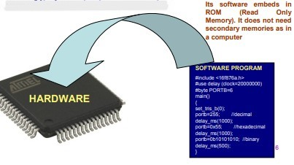

**Embedded Systems Vs General Computing Systems**

|  |  |
| --- | --- |
| **General Purpose Computing System** | **Embedded System** |
| A system which is a combination of generic hardware and General Purpose Operating System for executing a variety of applications | A system which is a combination of special purpose hardware and embedded OS for executing a specific set of applications |
| Contain a General Purpose Operating System (GPOS) | May or may not contain an operating system for functioning |
| Applications are alterable (programmable) by user . | The firmware of the embedded system is pre-programmed and it is non-alterable by end-user |

**Application areas of Embedded System**

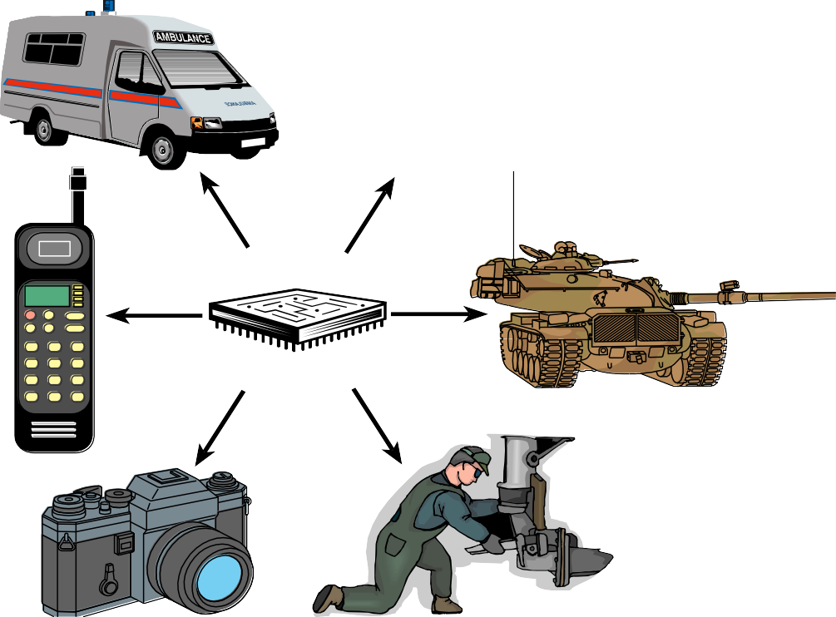

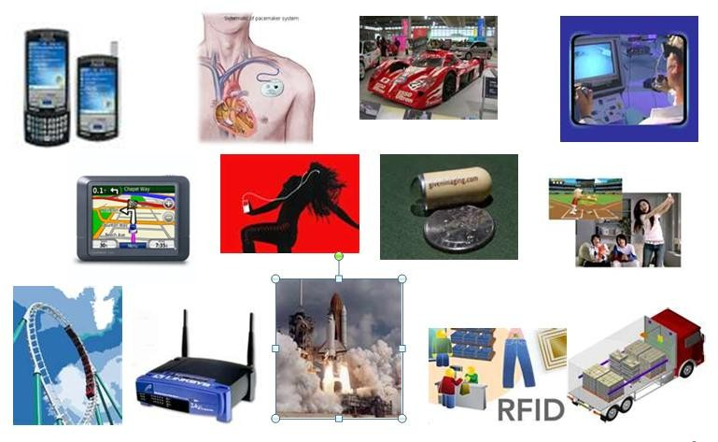

**COMPONENTS OF EMBEDDED SYSTEM**

* It has **Hardware**

Processor, Timers, Interrupt controller, I/O Devices, Memories, Ports, etc.

* It has **main Application Software** which may perform concurrently the series of tasks or multiple tasks.
* It has **Real Time Operating System (RTOS)**

RTOS defines the way the system work which supervise the application software.

It sets the rules during the execution of the application program. A small scale embedded system may not need an RTOS.

**EMBEDDED SYSTEM HARDWARE**

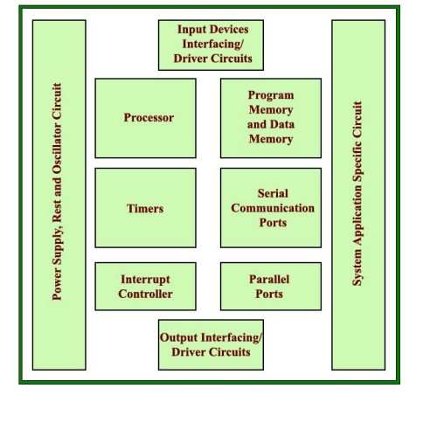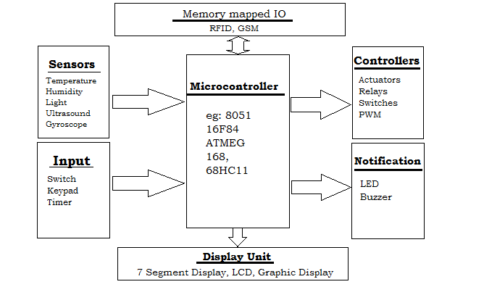

**CLASSIFICATION OF EMBEDDED SYSTEM**

Some of the criteria used in the classification of embedded systems are:

1. Based on generation

2. Complexity and performance requirements

3. Based on deterministic behavior

4. Based on triggering.

5. Classification Based on Complexity and Performance

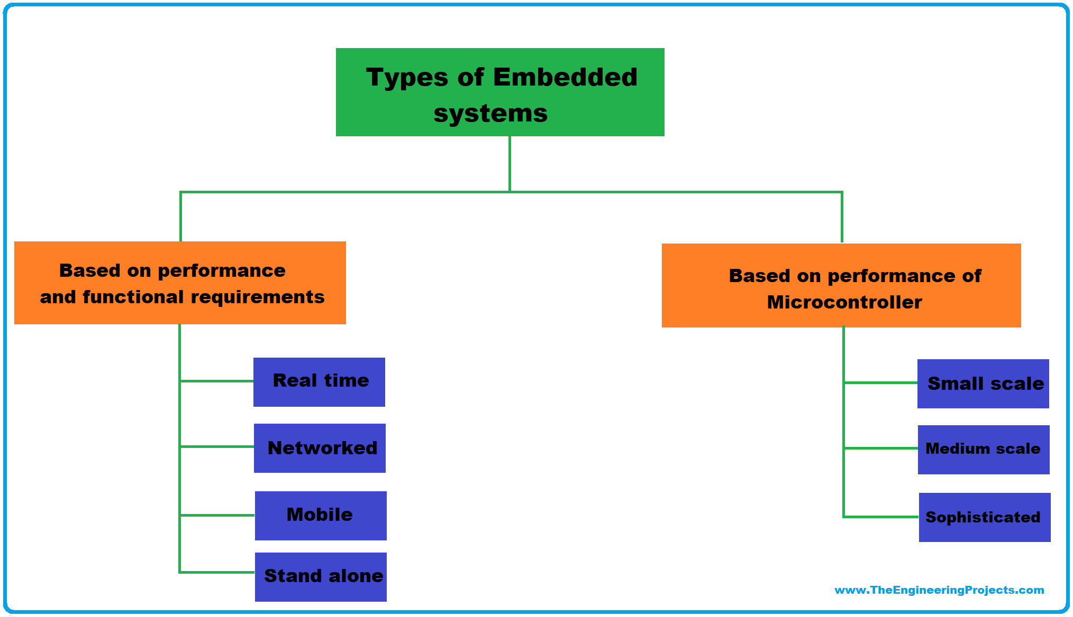

**Processor**

The processor is a key component of an embedded system. It is the central processing unit (CPU) responsible for executing instructions and performing calculations

A processor has two essential units −

* Program Flow Control Unit (CU)
* Execution Unit (EU)

The CU includes a fetch unit for fetching instructions from the memory.

The EU includes the Arithmetic and Logical Unit (ALU) and also the circuits that execute instructions for a program control task such as interrupt, or jump to another set of instructions.

## Types of Processors

Processors can be of the following categories

* General Purpose Processor (GPP)
  + - Microprocessor
    - Microcontroller
    - Embedded Processor
    - Digital Signal Processor
    - Media Processor
* Application Specific System Processor (ASSP)
* Application Specific Instruction Processors (ASIPs)
* GPP core(s) or ASIP core(s) on either an Application Specific Integrated Circuit (ASIC) or a Very Large Scale Integration (VLSI) circuit.

# **Difference between Microprocessor and Microcontroller**

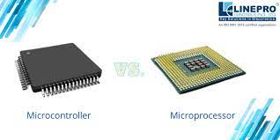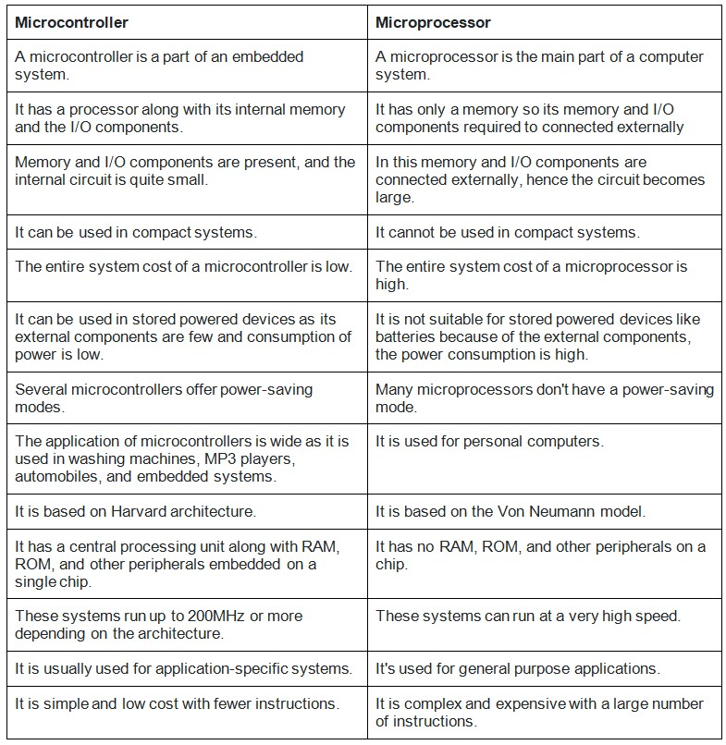

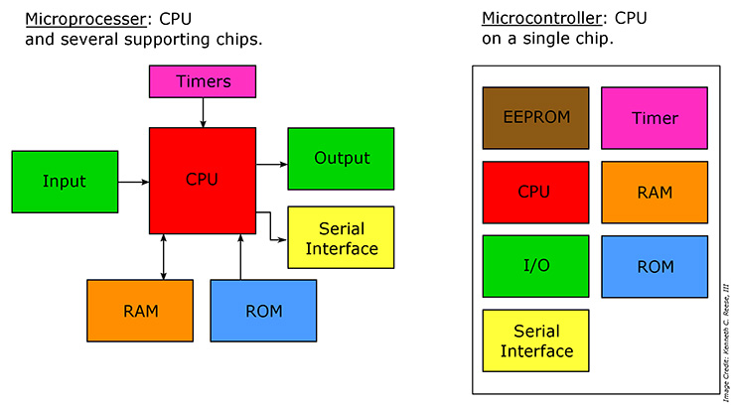

## CISC and RISC

**Special Function Register**

A **Special Function Register** is a [register](http://en.wikipedia.org/wiki/Processor_register) within a [microprocessor](http://en.wikipedia.org/wiki/Microprocessor), which controls or monitors various aspects of the microprocessor's function.

Depending on the [processor architecture](http://en.wikipedia.org/wiki/Comparison_of_CPU_architectures), this can include, but is not limited to:

* **I/O and Peripheral Control**: SFRs allow control and configuration of input/output ports and various peripherals such as serial ports, timers, UART, ADC, and SPI.
* **Bit Manipulation:** SFRs enable access and modification of individual bits within registers for fine-grained control and flags.
* **Stack Pointer**: SFRs manage the stack, which is used for storing temporary data and managing function calls.
* **Stack Limit:** SFRs define the limit of the stack to prevent overflows and ensure proper memory management.
* **Program Counter**: SFRs hold the address of the next instruction to be executed in the program.
* **Subroutine Return Address:** SFRs store the address to return to after executing a subroutine or function.
* **Processor Status:** SFRs store information about the processor's current status, such as whether it is servicing an interrupt or running in protected mode.
* **Condition Codes:** SFRs hold the result of previous comparisons or logical operations, allowing conditional branching in program execution.

**Internal & External Peripherals**

**Peripherals** refer to devices or components that are connected to the system and perform specific functions or provide additional capabilities. Peripherals can be categorized as *internal* or *external* based on their physical connection to the embedded system.

**Internal Peripherals:**

Internal peripherals are integrated directly onto the microcontroller or microprocessor chip of the embedded system. They are typically designed to provide core functionalities and support the system's operation. Some examples of internal peripherals include:

**1. Timers and Counters:** These peripherals provide precise timing and counting capabilities for tasks such as generating delays, measuring time intervals, or synchronizing events.Timer is used to generate delay and counter is for counting external events.

**TIMER:**

* A specialized type of clock used to measure time intervals .
* It can count from zero upwards to measure elapsed time (stopwatch functionality).
* It can also count down from a specified time interval to generate time delays PRECISELY and TRIGGER an activity

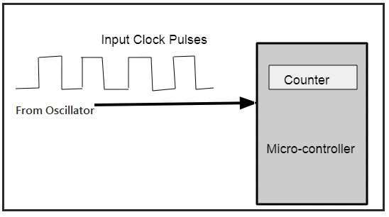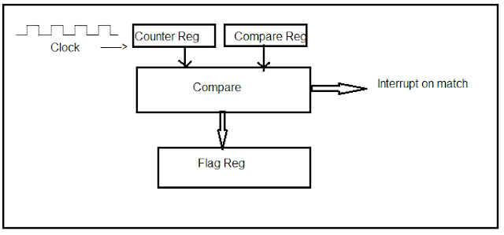

**Timer Working**

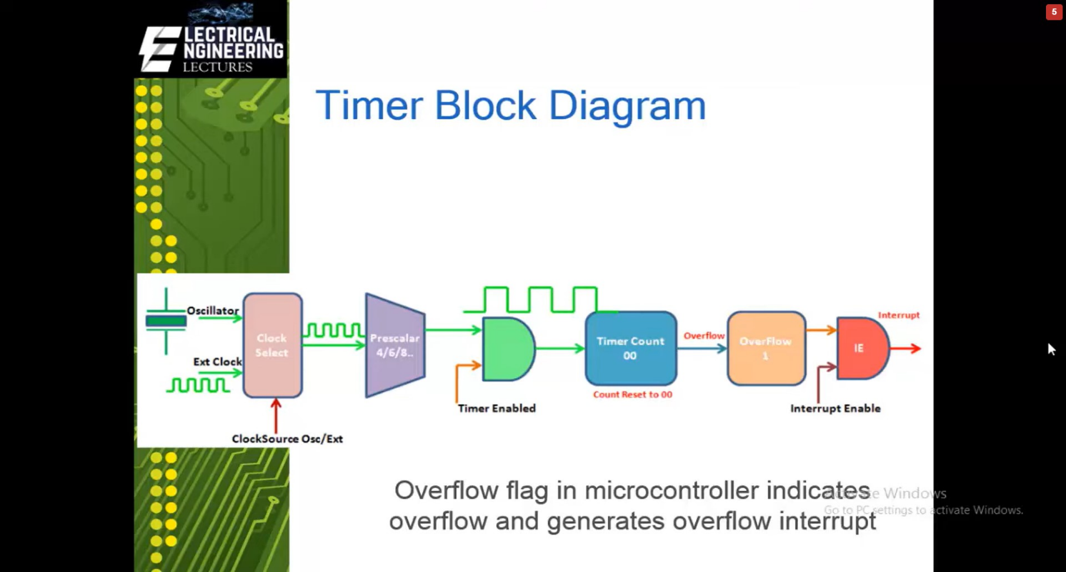

**TIMER MODULES FOR PIC MICROCONTROLLER**

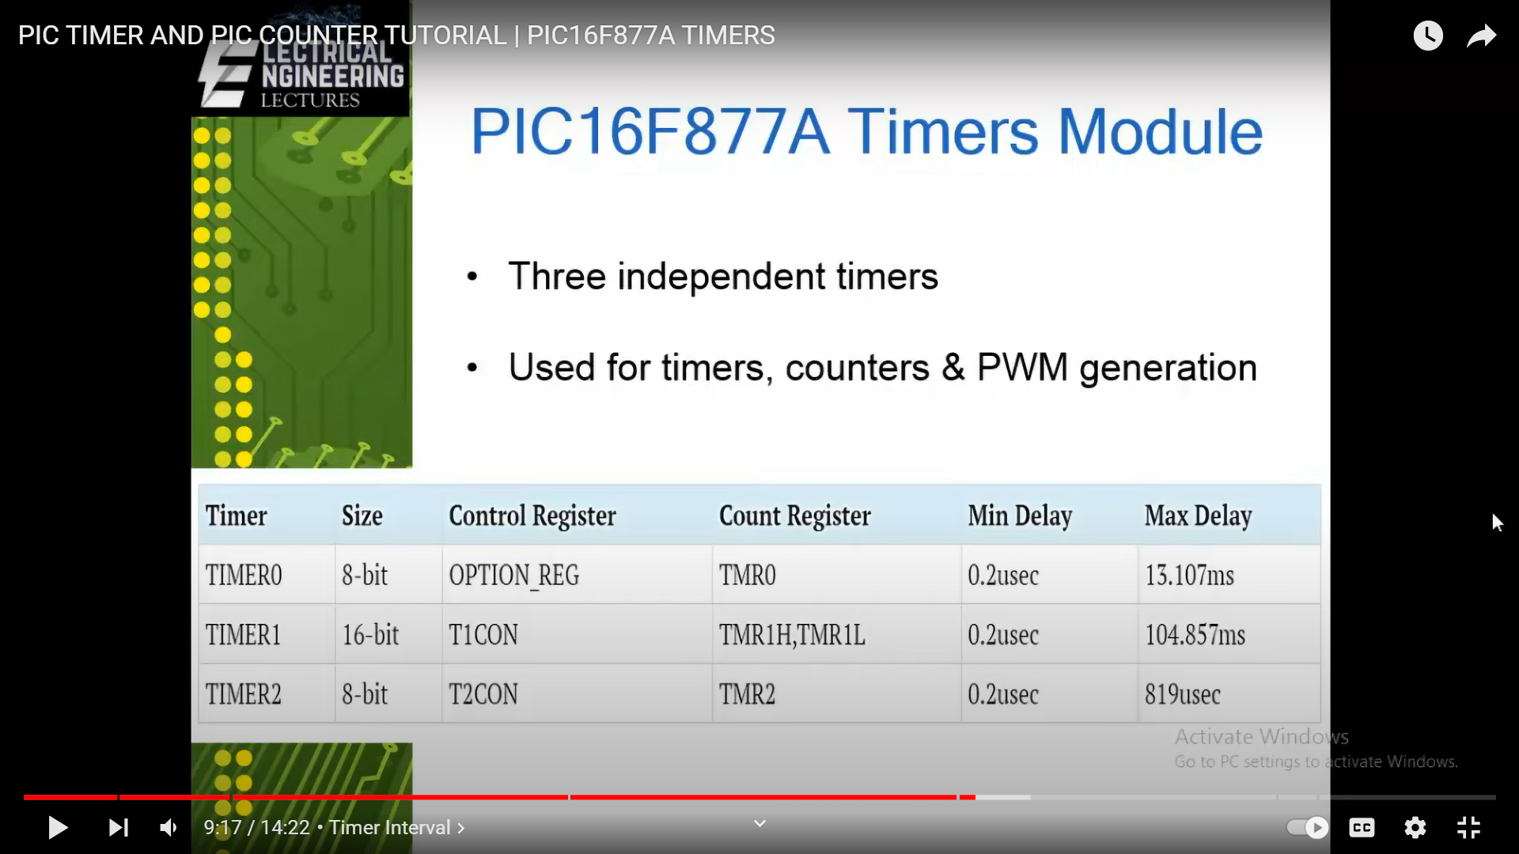

**CALCULATIONS**

TIMER takes internal clock as reference clock

Count increment= 4* *Prescalar* *(256-count)

*f osc*

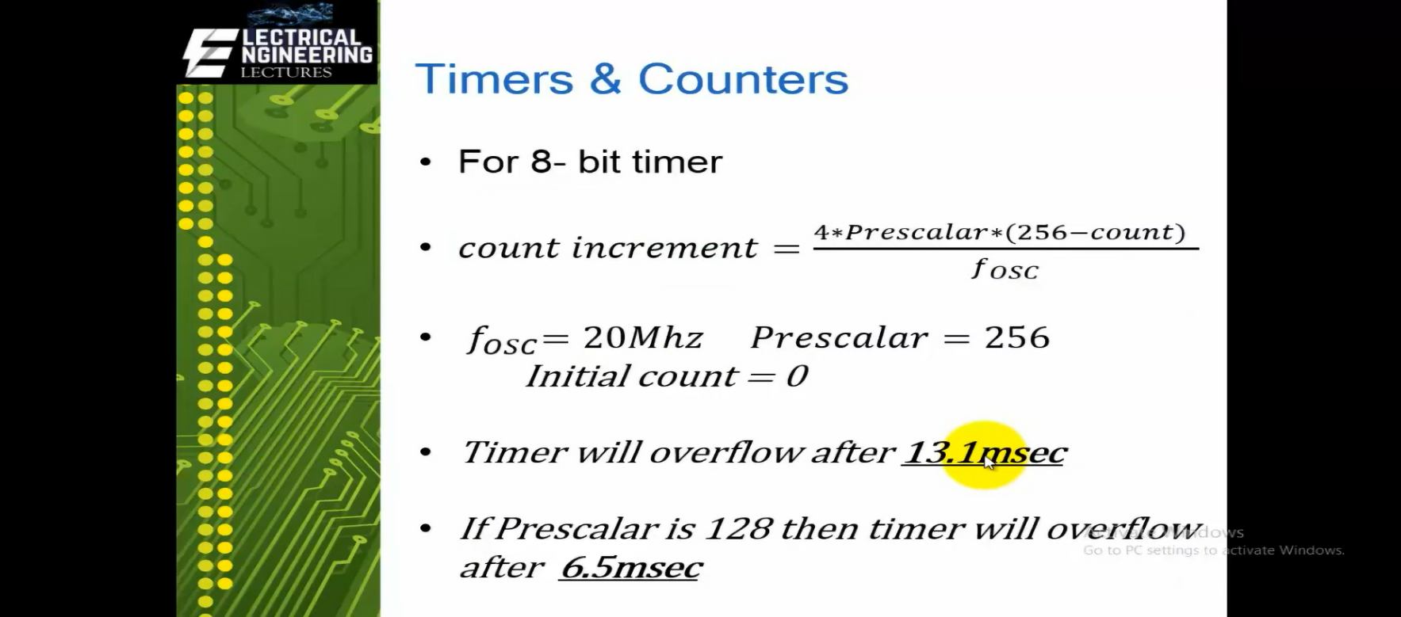

**Counter:**

* A device that stores and often displays the number of occurrences of a specific event or process.
* Counts events based on a clock signal.
* Implemented using register-type circuits like flip-flops.
* Used to track the number of events happening externally to the microcontroller.

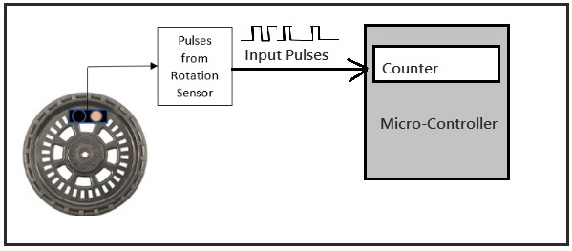

**Counter** counts external clock or pulses through port pins

Count increment*= Prescalar *(256-count)*

*F osc*

**EXTERNAL INTERRUPT**

An interrupt is a signal to the processor emitted by hardware or software indicating an event that needs immediate attention. Whenever an interrupt occurs, the controller completes the execution of the current instruction and starts the execution of an **Interrupt Service Routine** (ISR) or **Interrupt Handler**.

An EXTERNAL INTERRUPT is a computer system interrupt that happens as a result of outside interference, whether that’s from the user, from peripherals, from other hardware devices or through a network. These are different than internal interrupts that happen automatically as the machine reads through program instructions. 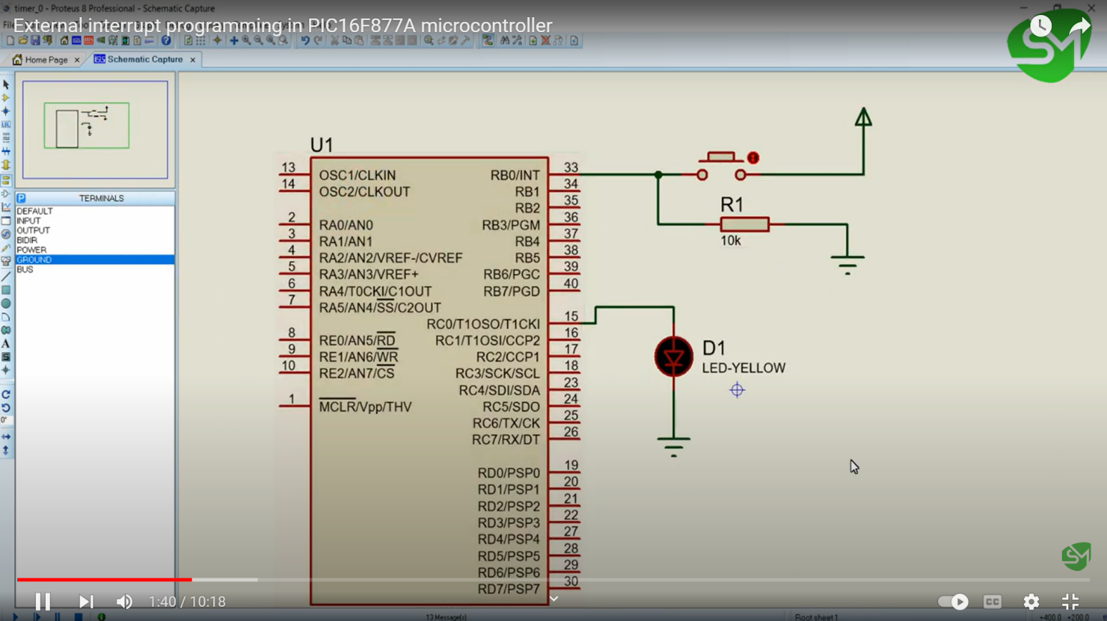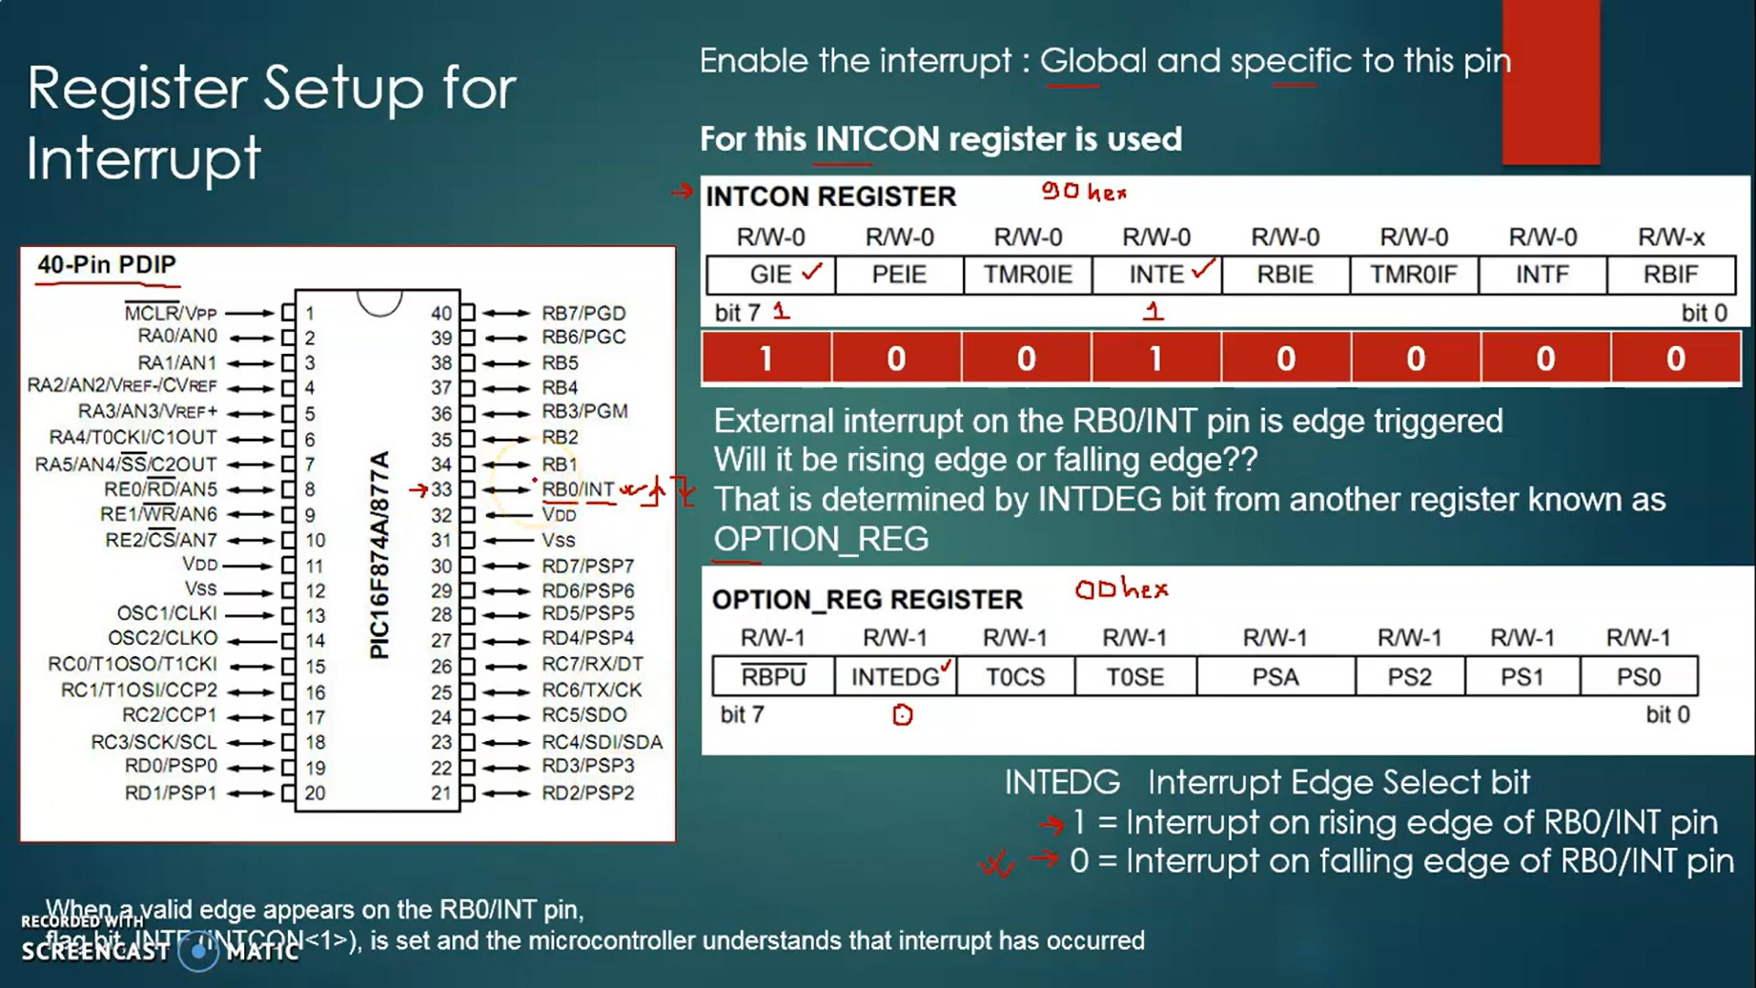

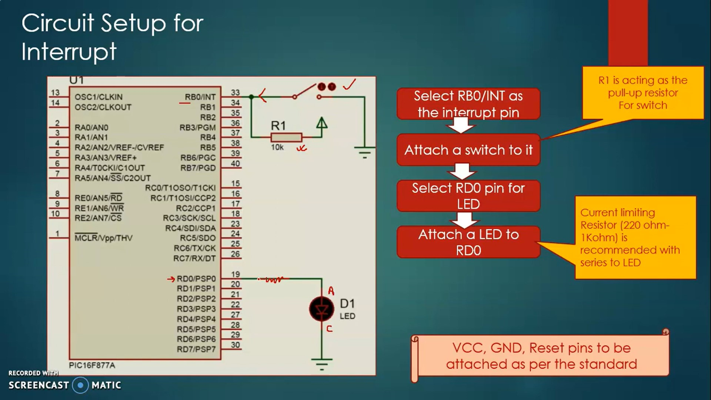

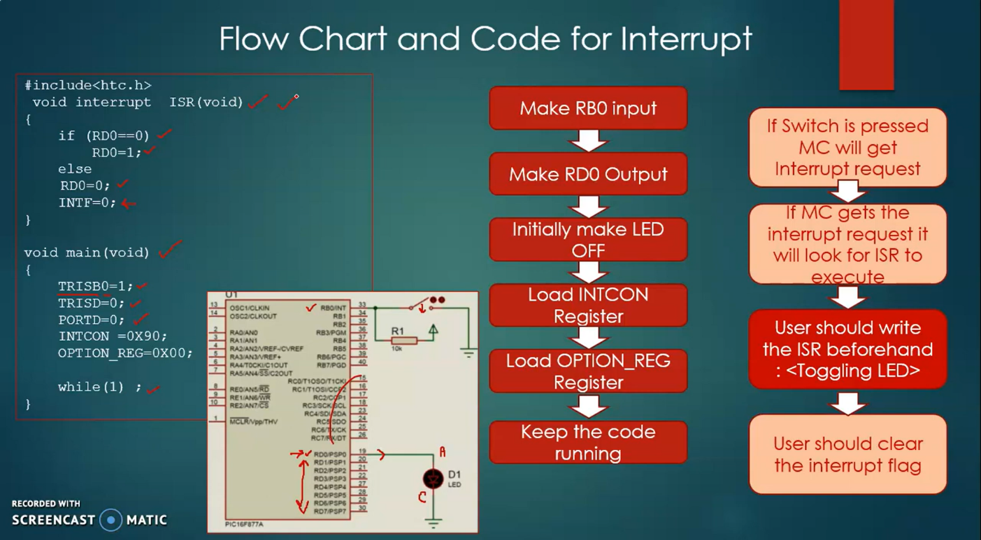



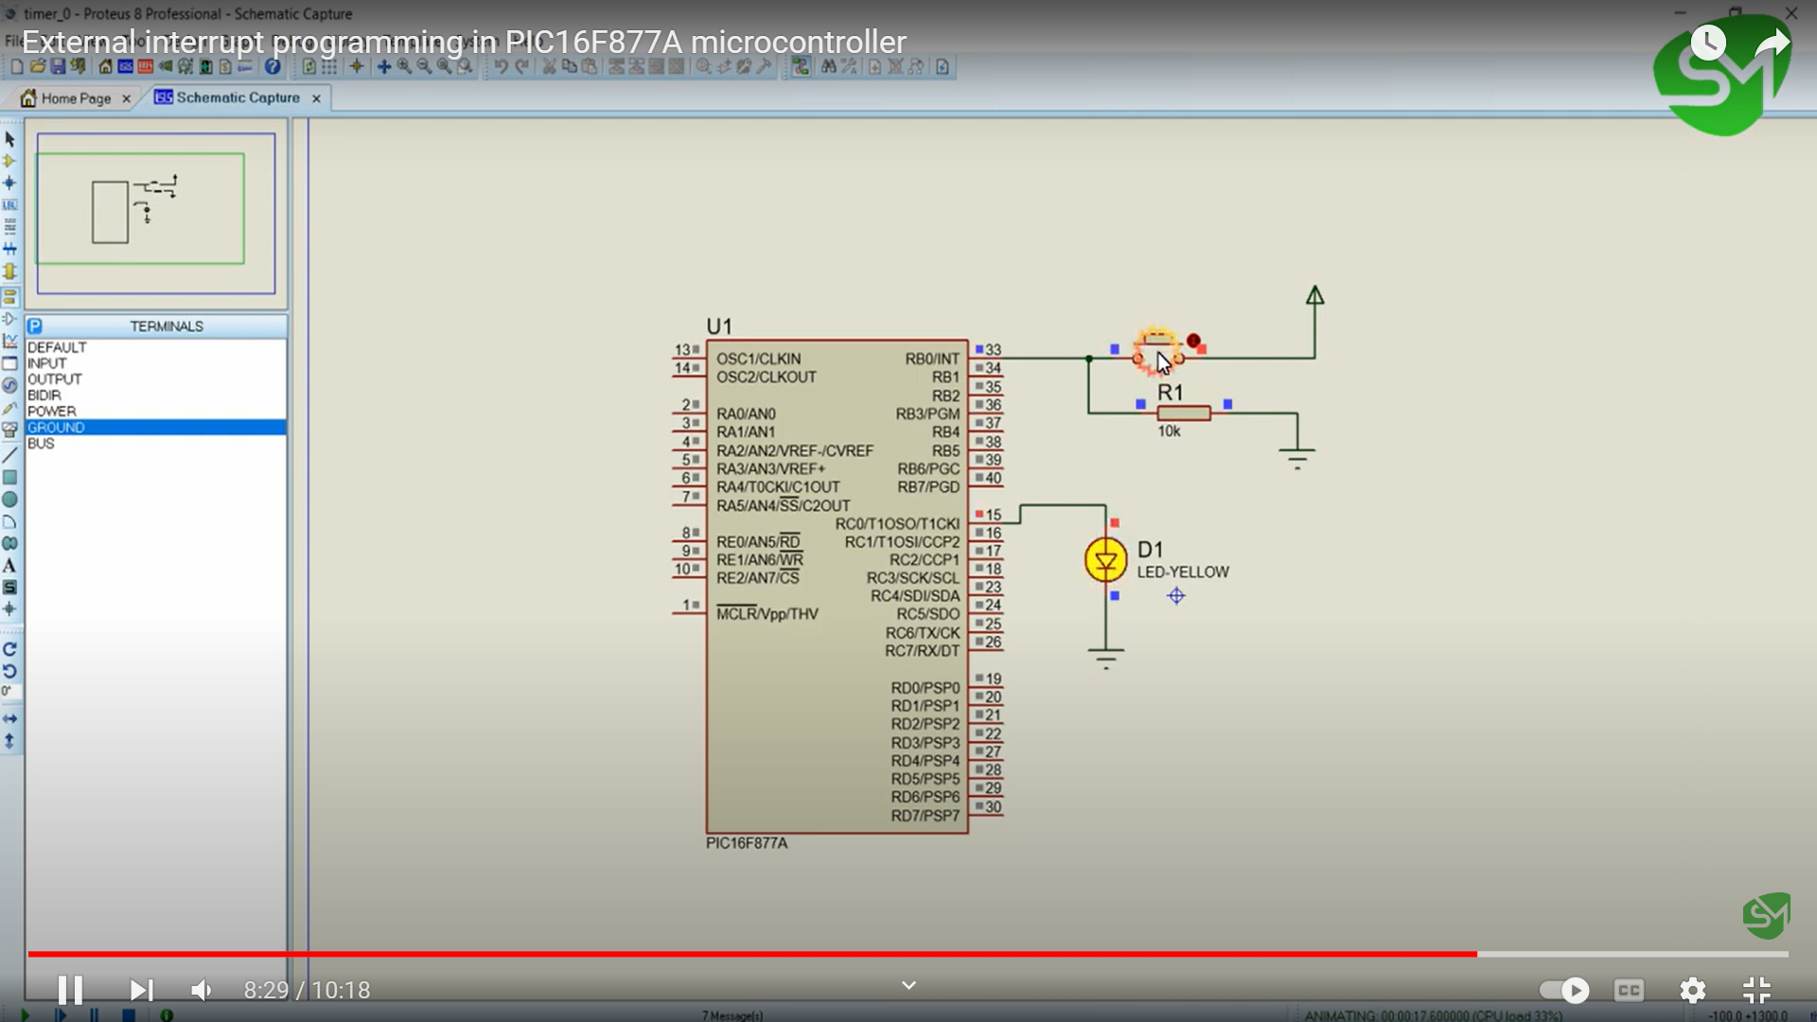

**Pulse Width Modulation (PWM)**

Pulse width modulation (PWM) width of the pulse is varied by keeping period of pulse constant. In the PWM technique, the signal’s energy is distributed through a series of pulses rather than a continuously varying (analogue) signal.

**width of pulse is varied but time T is constant**.

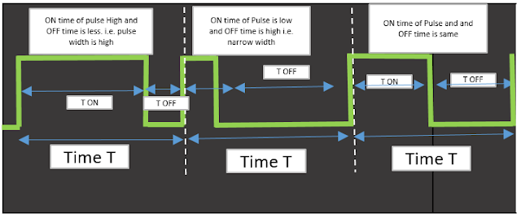

**Basics of PWM:**

Analog Circuits: An analog signal has continuously varying values, while a digital signal has a finite set of predetermined possibilities.

Analog Applications: Analog circuits directly control devices based on the input's linear proportionality, e.g., volume control in a radio.

Digital Control: PWM enables digital control of analog circuits, reducing costs, power consumption, and noise susceptibility.

PWM Signal: PWM encodes analog signal levels digitally using high-resolution counters and modulates the duty cycle of a square wave.

**Duty Cycle**: The duty cycle represents for how much time pulse is high, out of total pulse period and determines the encoded analog value.

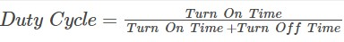

Modulation Frequencies: PWM requires a sufficiently high modulating frequency to control loads effectively and avoid perceptible effects.

***Frequency of PWM*** is calculated *as F pwm = 1/(TON+TOFF).*

**PWM Controllers:**

Microcontroller Integration: Many microcontrollers and DSPs include built-in PWM controllers for easy implementation.

Controller Setup: To initiate PWM operation, the period and on-time are set, the PWM output direction is configured, and the controller is enabled.

**Benefits of PWM:**

* PWM maintains a digital signal path from the processor to the controlled system, minimizing noise susceptibility.
* Noise Immunity: PWM offers increased noise immunity compared to analog control, making it suitable for communication .
* Cost and Power Efficiency: By digitally controlling analog circuits, PWM reduces system costs and power consumption   control the amount of power delivered to a load without dissipating any wasted power.
* PWM technique prevents overheating of LED while maintaining its brightness by varying duty cycle i.e. by varying average out voltage.
* PWM technique is accurate and has a fast response time.
* PWM technique provides a high input power factor.
* PWM technique helps motors generate maximum torque even when they run at lower speeds.

**PWM Generation:**

PWM can be generated using dedicated PWM peripherals available in microcontrollers or by utilizing timers.

Microcontrollers with built-in PWM peripherals simplify the process by setting duty cycle and frequency directly.

By applying PWM pulse to LED, an Average Voltage is applied to LED. Average voltage of PWM wave is shown by dotted line. Average Voltage :

**Vout(Average Voltage) = Vmax*duty cycle**.

Vmax is 5V (maximum output voltage of MCU Pin)

PWM duty cycle kept as 0% then Vout (Average Voltage) = 5*0/100 = 0V

PWM duty cycle kept as 25% then Vout (Average Voltage) = 5*25/100 =1.25V

PWM duty cycle kept as  75%  then Vout (Average Voltage) = 5*75/100 = 3.75V

PWM duty cycle kept as 100% then Vout (Average Voltage) = 5*100/100  = 5V

**Timer-based PWM Generation**: When PWM peripherals are unavailable, timers can be configured to generate PWM signals by controlling the ON and OFF times

* Configure 2 timers. 1st timer is for TON and 2nd timer is for TOFF. (Values of TON and TOFF are depends on value of duty cycle and frequency of PWM )
* Start TON timer (with TON time of pulse) once timer reaches to certain time value, stop 1st timer and start 2nd timer (with TOFF time of pulse). This can be done by using ISR of timers. Once timer 1 ISR executed, start Timer 2 and in timer 2 ISR start timer 1
* When 1st timer is started. set digital out pin to High (logic 1) and when 2nd timer started set same digital out pin to Low (logic 0).

**PWM Duty Cycle and Average Output voltage**

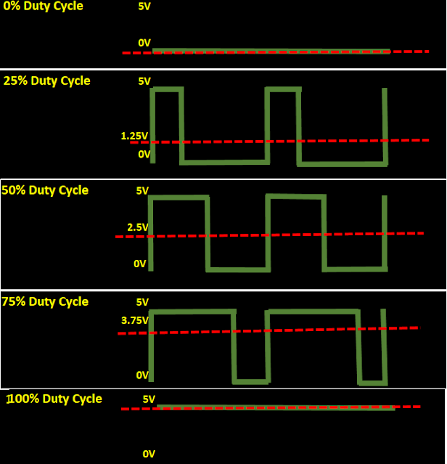

**2. Serial Communication Interfaces:** Serial interfaces like UART (Universal Asynchronous Receiver/Transmitter) or SPI (Serial Peripheral Interface) are often integrated into the microcontroller to enable communication with other devices or systems.

**3. Analog-to-Digital Converters (ADC):** ADCs are used to convert analog signals from sensors or external devices into digital values that can be processed by the embedded system. 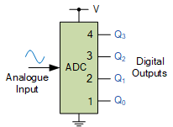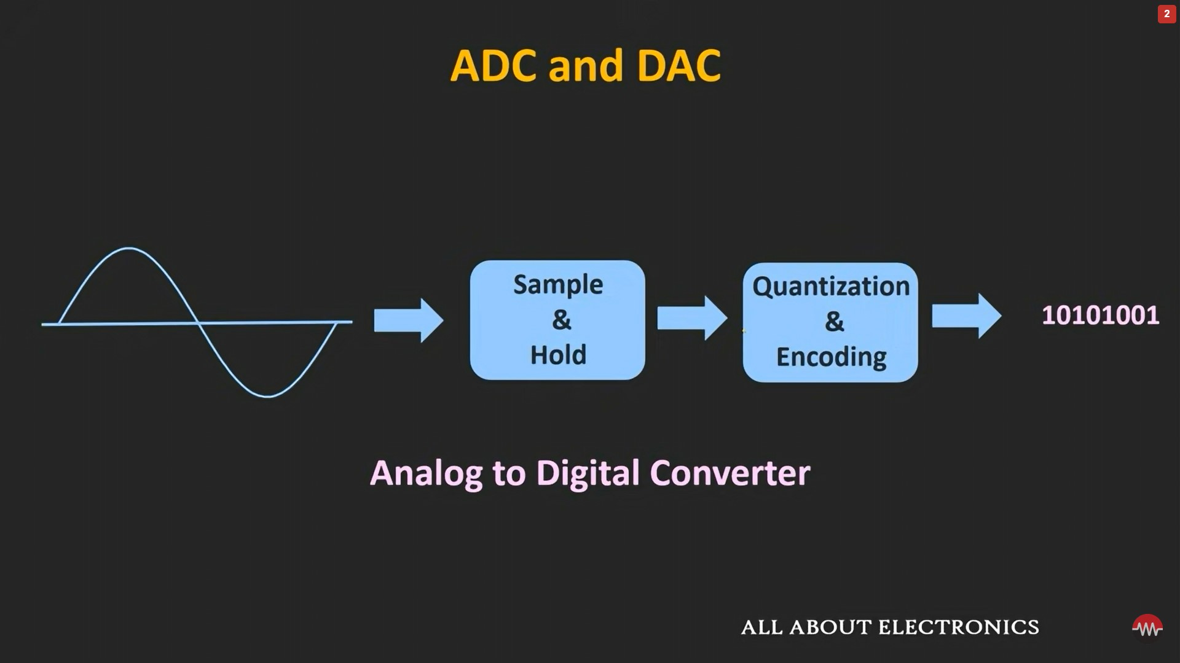

**Calculations in ADC:**

1. **Resolution**: The resolution of an ADC determines the number of discrete digital levels it can represent. It is usually specified in bits. The formula to calculate the resolution is:

**Resolution = (Vref+ - Vref-) / (2^N)**

where Vref+ is the upper reference voltage

Vref- is the lower reference voltage

N is the number of bits of the ADC.

2. **Scaling:** After the analog signal is converted into a digital value, scaling may be required to translate the digital value back to its corresponding physical quantity. This involves applying appropriate scaling factors to map the digital range to the desired physical range.

For example,

if an ADC has a resolution of 10 bits and is operating with a reference voltage range of 0-5V, each digital step represents

5V / 2^10 ≈ 4.88 mV.

If the measured voltage is 2.5V, the corresponding digital value would be 2.5V / 4.88 mV ≈ 512.

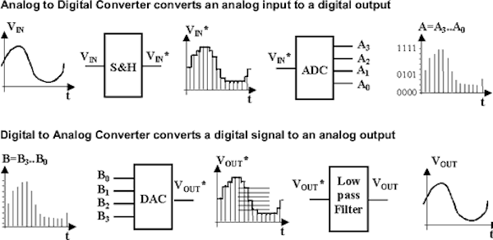

**ADC Types:**

* **Successive Approximation ADC:** It is a widely used and efficient type of ADC. It operates by successively approximating the analog input value and comparing it to a reference voltage using a binary search algorithm.
* **Delta-Sigma ADC**: This type of ADC oversamples the analog input and uses a technique called delta-sigma modulation to convert the analog signal into a digital stream of 1s and 0s. It offers high resolution and is often used in applications demanding high precision.
* **Flash ADC:** Also known as parallel ADC, it is one of the fastest types of ADCs. It uses a large number of comparators to convert the analog input into a digital value directly. Flash ADCs offer high sampling rates but have limited resolution due to the large number of comparators required.
* **Dual-Slope ADC**: This type of ADC measures the time it takes to charge and discharge a capacitor with the analog input signal. It provides good accuracy and is often used in applications where high-resolution conversion is not critical.
* **Sigma-Delta ADC:** It is a type of ADC that oversamples the analog input signal and uses a complex digital filtering technique to convert it into a stream of digital values. Sigma-delta ADCs are commonly used in audio applications due to their ability to achieve high resolution and low noise performance.

**4. Digital-to-Analog Converters (DAC):** DACs are used to convert digital values from the embedded system into analog signals for driving actuators or external devices.

**5. Interrupt Controllers**: These peripherals manage and prioritize interrupts, allowing the system to respond quickly to time-critical events or external stimuli.

**6.Ports:** General Purpose Input/Output (GPIO) pins.

* It allow digital communication between the embedded system and external devices.
* Used for reading input signals or controlling output signals
* Enable interaction with various external components.

**External Peripherals:**

External peripherals are devices or components that are connected to the embedded system externally, often through physical interfaces such as GPIO pins or specialized communication protocols. They expand the functionality and capabilities of the embedded system. Some examples of external peripherals include:

1. **Sensors**

A sensor is a device that measures physical input from its environment and converts it into data .Sensors detect changes in physical quantities or energy and provide an output signal.They are crucial for automation and control systems in various applications.

**Types of Sensors:**

1. Active and Passive Sensors:

* Active sensors use external excitation to generate an output signal.
* Passive sensors generate output without external excitation.

1. Analog and Digital Sensors:

* Analog sensors produce continuous signals proportional to the measured quantity.
* Digital sensors provide discrete output signals in the form of logic 1 or logic 0.

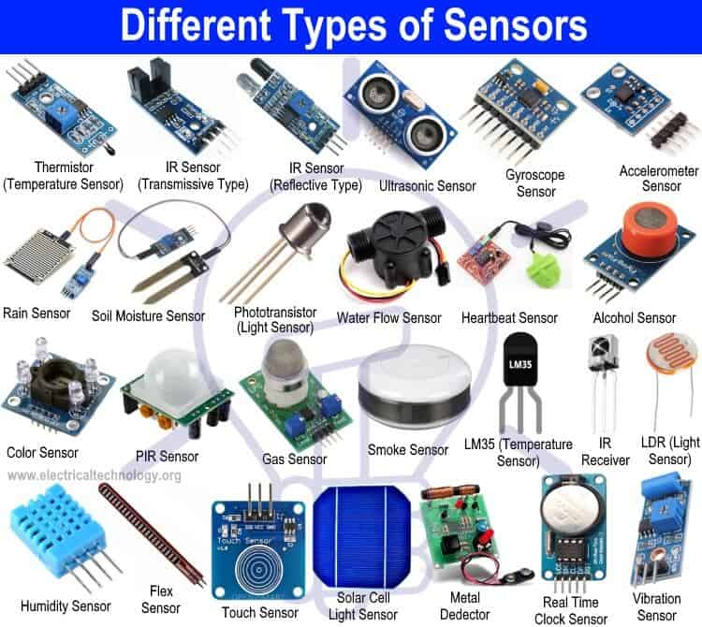

**Types of Sensors and Their Applications:**

* Infrared Sensor (IR Sensor): Used for obstacle detection, thermography cameras, and TV remote controls.
* Temperature and Thermocouple Sensors: Measure temperature changes in various applications.
* Proximity Sensor: Used for object detection, velocity measurement, and reverse parking sensors.
* Ultrasonic Sensor: Measures distance or travel time using ultrasonic waves.
* Accelerometers and Gyroscope Sensors: Detect changes in position, velocity, and orientation.
* Pressure Sensor: Measures pressure and is used in applications like tire pressure monitoring.
* Hall Effect Sensor: Utilizes magnetic fields for position, speed, and rotation detection.
* Load Cell: Measures weight in applications such as industrial machinery and medical devices.
* Light Sensor: Detects light levels and is used in applications like speed measurement.
* Color Sensor: Identifies and distinguishes colors in various applications.
* Touch Sensor: Detects touch or proximity and is used in touchscreens and user interfaces.
* PIR Motion Detector and Vibration Sensor: Used for motion detection and vibration monitoring.
* Flow and Level Sensor: Measures flow rates and liquid levels in tanks and pipes.
* Gas and Alcohol Sensor: Detects gas, ethanol, and alcohol levels for safety applications.
* Humidity and Moisture Sensor: Measures humidity, soil moisture, and rainfall.

**2. Displays**: External displays, such as LCDs (Liquid Crystal Displays) or OLEDs (Organic Light-Emitting Diodes), are used to present information or provide a visual interface for user interaction.

**3. Actuators:** Actuators like motors, solenoids, or LEDs are controlled by the embedded system to perform physical actions or provide feedback.

**4. Communication Modules:** External modules like Ethernet, Wi-Fi, Bluetooth, or cellular modems enable the embedded system to communicate with other devices or connect to networks.

**5. Memory Devices:** External memory devices, such as EEPROM (Electrically Erasable Programmable Read-Only Memory) or Flash memory, provide additional storage capacity for data or program code.

**6. Peripherals for Human Interface:** These peripherals include buttons, switches, keypads, touchscreens, or audio interfaces that allow users to interact with the embedded system.

**UART Communication**

UART stands for **Universal Asynchronous Receiver/Transmitter**. It is a physical circuit found in microcontrollers or stand-alone ICs. UART allows two devices to communicate with each other using only two wires. It converts parallel data from a controlling device (e.g., CPU) into serial form and transmits it to the receiving UART. The receiving UART then converts the serial data back into parallel form.  Data flows from the Tx pin of the transmitting UART to the Rx pin of the receiving UART

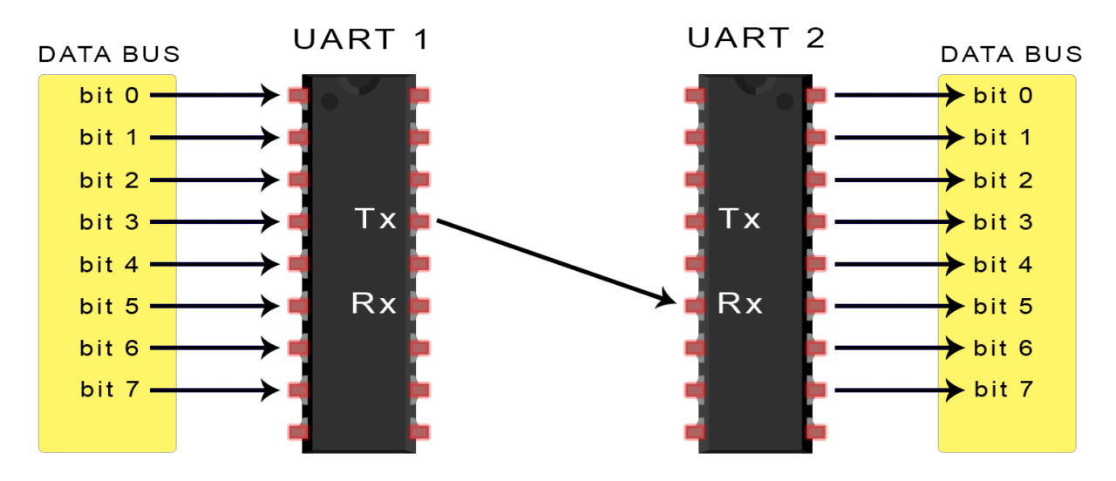

**Asynchronous Communication**

UARTs transmit data asynchronously, meaning there is no clock signal to synchronize the data transfer. Instead, start and stop bits are added to the data packet for synchronization. The receiving UART starts reading the bits upon detecting the start bit and operates at a specific frequency called the **baud rate**, which determines the speed of data transfer expressed in bits per second (bps).

**UART Working**

* The transmitting UART receives parallel data from the data bus.
* The transmitting UART adds a start bit, parity bit, and stop bit(s) to the data frame, creating the data packet.
* The data packet is transmitted serially from the transmitting UART to the receiving UART.
* The receiving UART removes the start bit, parity bit, and stop bit from the data frame. The receiving UART converts the serial data back into parallel and transfers it to the data bus on the receiving end.

**Data Packet Structure**

UART data is organized into packets, which consist of a start bit, 5 to 9 data bits (including an optional parity bit), and 1 or 2 stop bits.

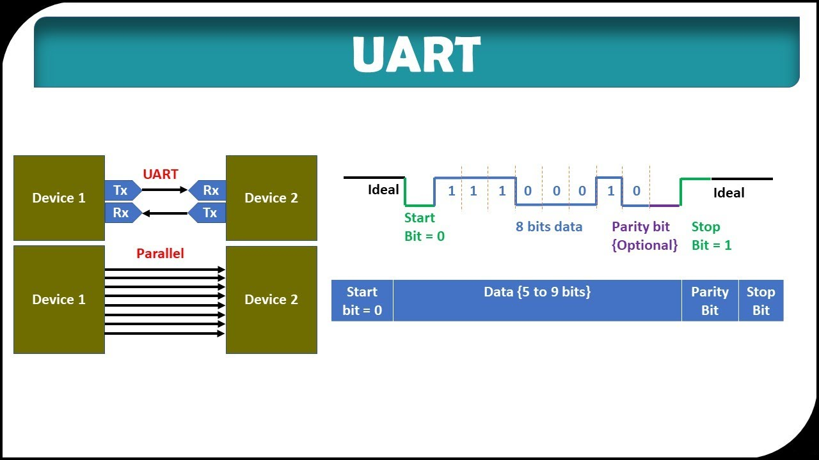

**Advantages of UART**

* + Uses only two wires for communication.
  + No clock signal is required.
  + Includes a parity bit for error checking.
  + The structure of the data packet can be modified as long as both sides are configured accordingly.
  + Well-documented and widely used.

**Disadvantages of UART**

* + Limited data frame size, typically up to 9 bits.
  + Doesn't support multiple slave or multiple master systems.
  + Baud rates between UARTs must be within 10% of each other.

**I2C COMMUNICATION PROTOCOL**

* I2C (Inter-Integrated Circuit) is a serial communication protocol that allows multiple devices to communicate with each other using only two wires: SDA (Serial Data) and SCL (Serial Clock).
* It combines the advantages of SPI and UART, enabling multiple slaves to be connected to a single master, and multiple masters to control single or multiple slaves.
* Like UART, I2C is synchronous, meaning the clock signal is controlled by the master, and the data is transferred bit by bit along the SDA line.

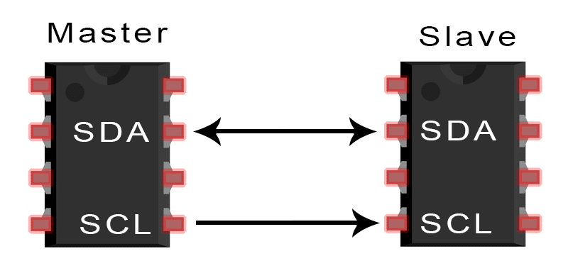

**I2C Communication Process:**

* I2C data transmission occurs in messages, which are divided into frames of data. Each message consists of an address frame and one or more data frames.
* Start and stop conditions indicate the beginning and end of a message. The SDA line transitions from high to low for the start condition and from low to high for the stop condition, while the SCL line controls the clock signal.
* The address frame contains the binary address of the slave device being accessed, and it is followed by a read/write bit indicating the direction of data transfer.
* Each data frame is 8 bits long and is sent with the most significant bit (MSB) first.
* After each data frame, an ACK/NACK (acknowledge/no-acknowledge) bit is sent to confirm successful receipt of the frame.

**Addressing in I2C:**

* I2C uses addressing to identify the intended slave device when communicating. The address frame, consisting of 7 or 10 bits, is sent by the master to all connected slaves.
* Each slave compares the received address to its own address. If there is a match, the slave sends an ACK bit by pulling the SDA line low. If there is no match, the slave leaves the SDA line high.

**Single Master and Multiple Slaves:**

* I2C allows multiple slave devices to be controlled by a single master. The master can communicate with each slave by addressing them individually.
* A 7-bit address provides 128 unique addresses, while a 10-bit address offers 1,024 unique addresses. Pull-up resistors (typically 4.7k Ohm) connect the SDA and SCL lines to Vcc.

**Multiple Masters and Multiple Slaves:**

* I2C also supports multiple masters controlling single or multiple slaves.
* To prevent conflicts, each master needs to check if the SDA line is low (indicating another master's control) before transmitting a message. If the SDA line is high, the master can safely send the message.
* Pull-up resistors (typically 4.7k Ohm) are still used to connect the SDA and SCL lines to Vcc.

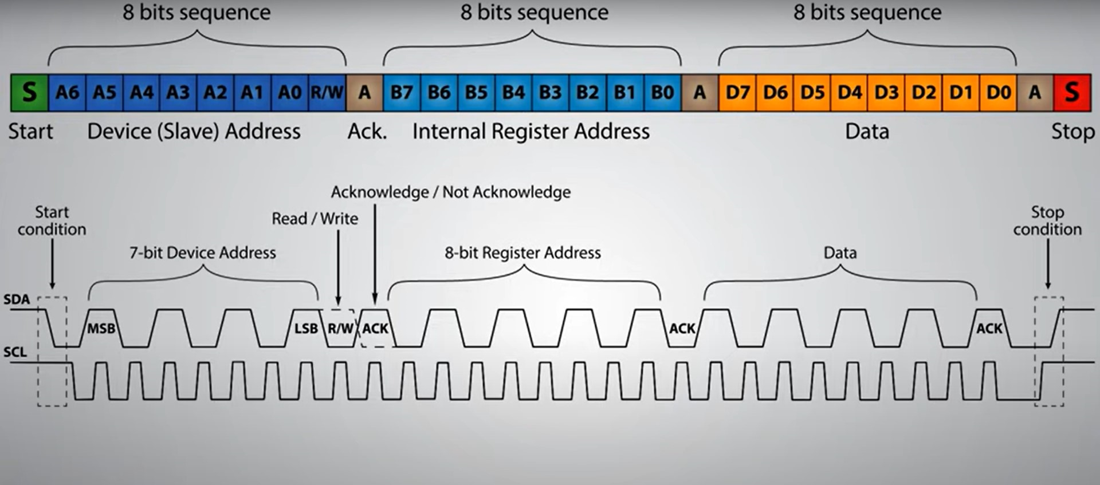

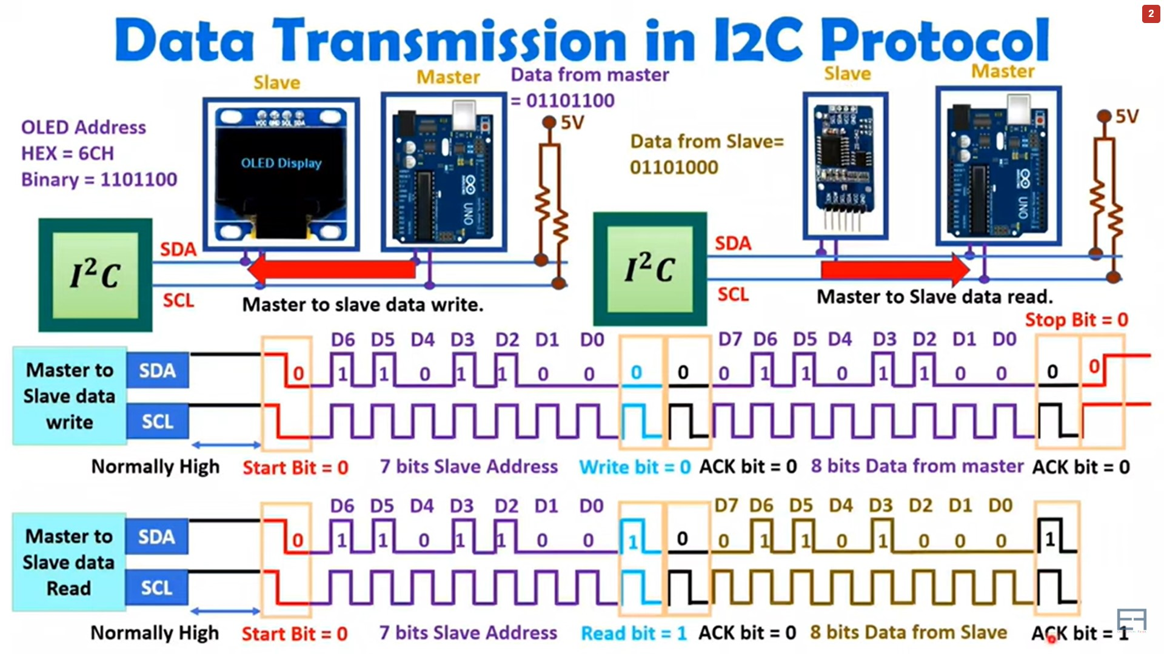

**Advantages of I2C:**

* Uses only two wires, minimizing the number of connections required.
* Supports multiple masters and multiple slaves, allowing complex communication topologies.
* Includes ACK/NACK bits for reliable data transfer.
* Hardware implementation is generally less complicated compared to UART.

**Disadvantages of I2C:**

* Slower data transfer rate compared to SPI.
* Limited data frame size of 8 bits.
* Requires more complicated hardware implementation compared to SPI

**SPI Communication Protocol**

* SPI (Serial Peripheral Interface) is a widely used communication protocol for devices like SD card readers, RFID card readers, and wireless transceivers.
* SPI allows uninterrupted data transfer in a continuous stream.
* In SPI, devices are in a master-slave relationship, where the master controls one or more slaves.

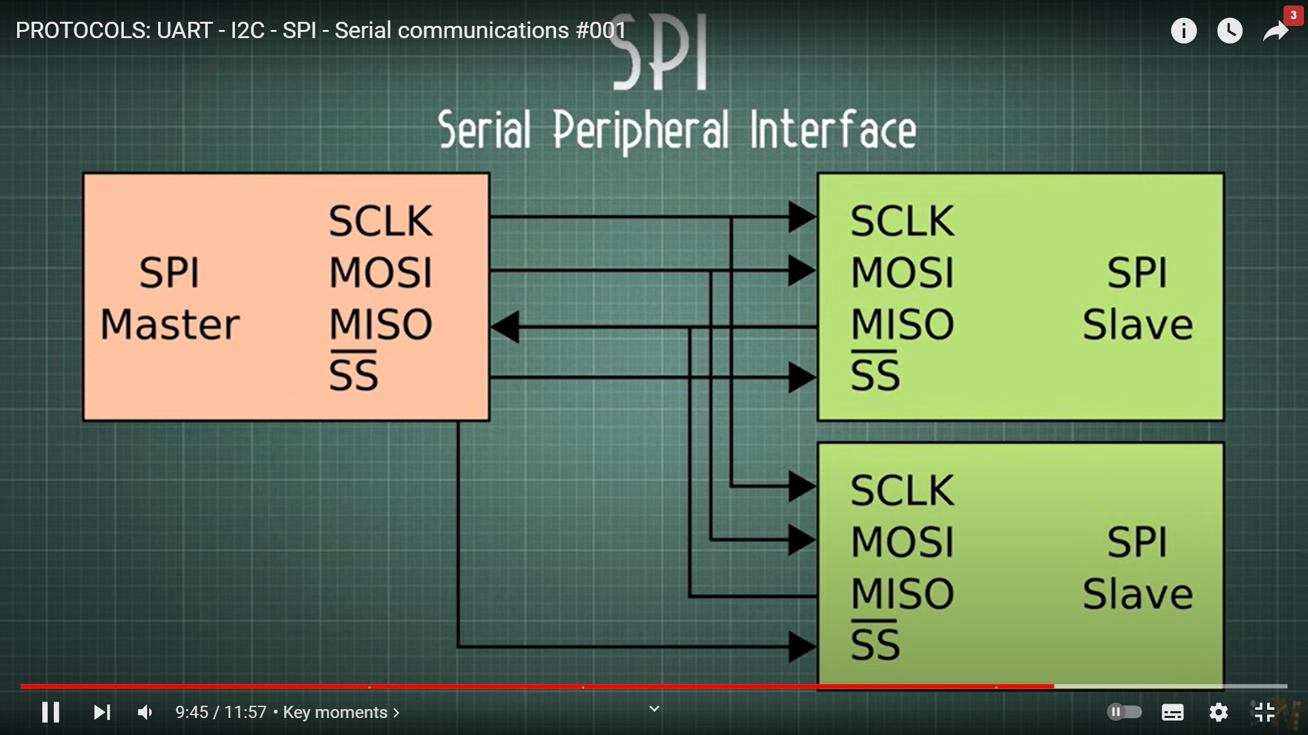

**Master and Slave**

* MOSI (Master Output/Slave Input): The line for the master to send data to the slave.
* MISO (Master Input/Slave Output): The line for the slave to send data to the master.
* SCLK (Clock): The line for the clock signal.
* SS/CS (Slave Select/Chip Select): The line for the master to select which slave to communicate with.

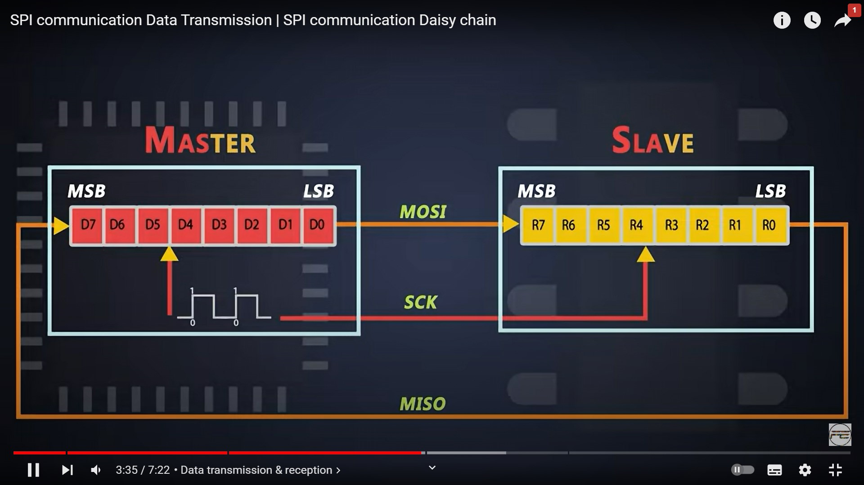

**SPI Communication Basics - Specifications**

* SPI can have multiple slaves, limited by the load capacitance of the system.
* Communication is synchronous, meaning devices share a clock signal.
* Clock polarity and clock phase define when bits are output and sampled.

**Clock**

* The clock signal synchronizes the transfer of data bits.
* Each clock cycle transfers one bit of data.
* The master configures and generates the clock signal.
* Clock speed determines the data transfer rate.

**Slave Select**

* The master selects the slave it wants to communicate with by setting the slave's SS/CS line low.
* Multiple slaves can be connected in parallel if the master has multiple SS/CS pins.
* If only one SS/CS pin is available, slaves can be daisy-chained.

**Multiple Slaves**

* SPI supports single master, single slave, and multiple slaves controlled by a single master.
* Multiple slaves can be wired in parallel or daisy-chained depending on the available SS/CS pins.

**MOSI and MISO**

* The master sends data to the slave through the MOSI line, bit by bit.
* The slave receives the data sent by the master at the MOSI pin.
* Data is usually sent with the most significant bit first.
* The slave can send data back to the master through the MISO line, usually with the least significant bit first.

**Steps of SPI Data Transmission**

* The master outputs the clock signal.
* The master activates the selected slave by setting the SS/CS line low.
* The master sends data to the slave bit by bit along the MOSI line, while the slave reads the received bits.
* If a response is needed, the slave sends data back to the master bit by bit along the MISO line, and the master reads the received bits.

**OPERATING MODES OF SPI PROTOCOL**

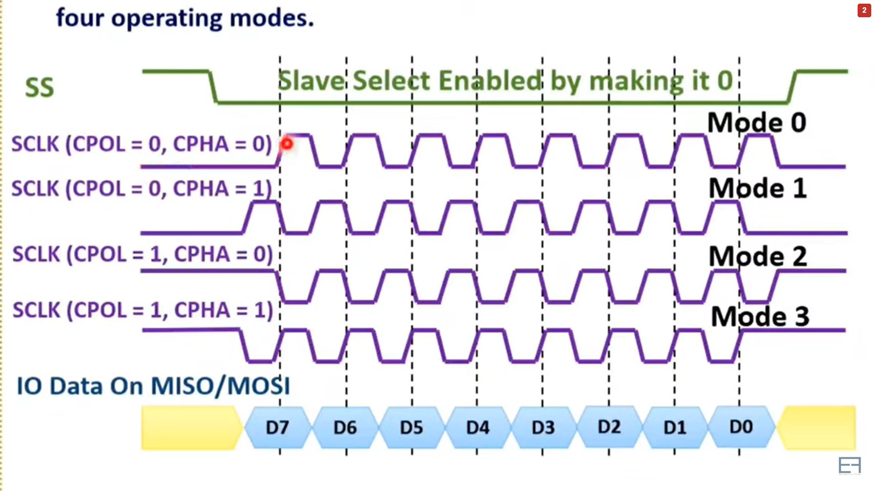

Advantages:

* Continuous streaming of data without interruption.
* No complicated addressing system like I2C.
* Higher data transfer rate compared to I2C.
* Separate lines for sending and receiving data simultaneously.

Disadvantages:

* Requires four wires (more than I2C and UART).
* No acknowledgment of successful data receipt.
* No built-in error checking mechanism like the parity bit.
* Supports only a single master.

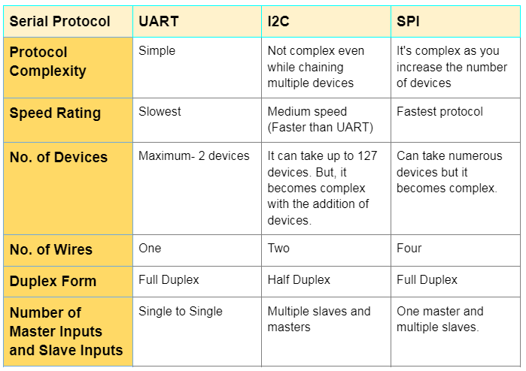

**INTERNET OF THINGS**

* IoT is a system of interrelated computing devices, machines, objects, or people that are uniquely identified and can transfer data over a network without human interaction.
* IoT devices can range from heart monitors and farm animal biochips to automobiles with built-in sensors.
* IoT enables improved efficiency, customer service, decision-making, and business value across various industries.

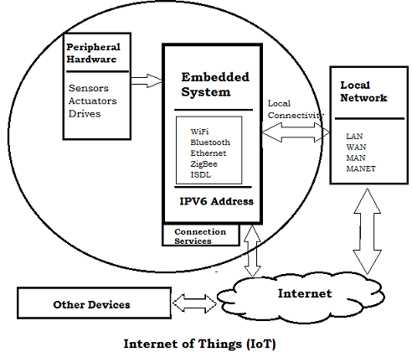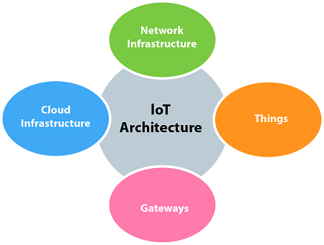

**IOT WORKING**

* IoT devices use embedded systems (processors, sensors, communication hardware) to collect and send data.
* Data is shared with an IoT gateway or edge device, which can analyze the data locally or send it to the cloud for analysis.
* Devices can also communicate with each other and interact with humans for setup, instructions, or data access.

**BENEFITS OF IOT FOR ORGANIZATIONS**

* Monitoring business processes and improving customer experience.
* Time and cost savings, enhanced productivity, and adaptable business models.
* Better decision-making and increased revenue generation.
* IoT facilitates automation, waste reduction, service delivery improvement, and transparency.

**IOT APPLICATIONS**

* Industries using IoT: Manufacturing, transportation, utilities, agriculture, infrastructure, home automation, healthcare, finance, retail, and more.
* Examples: IoT benefits farmers in agriculture, enables infrastructure monitoring, and supports automation in home and smart city environments.

**PROS AND CONS OF IOT**

* Advantages: Access to information anywhere, improved communication, time and cost savings, automation, and improved service quality.
* Disadvantages: Increased security risks, challenges in managing massive device numbers, potential system vulnerabilities, and lack of standard compatibility.

**IoT Standards and Frameworks**

Emerging IoT standards: 6LoWPAN, ZigBee, LiteOS, OneM2M, DDS, AMQP, CoAP, LoRaWAN, etc.

**IoT frameworks**:

AWS IoT, Arm Mbed IoT, Microsoft Azure IoT Suite, Google's Brillo/Weave, Calvin, and more.

**FEATURES AND CAPABILITIES:**

* Device Connectivity: IoT platforms offer protocols and APIs to connect and manage a wide range of IoT devices.
* Data Management: They provide storage, processing, and analytics capabilities to handle large volumes of IoT data.
* Device Management: Platforms assist in provisioning, configuring, monitoring, and updating IoT devices remotely.
* Application Development: Tools and APIs enable developers to build and deploy IoT applications efficiently.
* Security: Platforms incorporate features like authentication, access control, and encryption to ensure data and device security.
* Integration: They enable integration with other systems, applications, and third-party services.

**IOT PLATFORMS**

* IoT platforms are software frameworks or cloud-based services that facilitate the development, deployment, and management of IoT applications and devices.
* They provide tools, services, and infrastructure for connecting, monitoring, controlling, and analyzing IoT data

**AWS IoT:** Amazon Web Services' IoT platform with device management, data analytics, and integration with other AWS services.

**Microsoft Azure IoT:** Microsoft's platform offering IoT services, data storage, analytics, and machine learning capabilities.

**Google Cloud IoT**: Google's cloud-based platform for IoT with device management, data ingestion, and analytics features.

**IBM Watson IoT:** IBM's platform that integrates IoT devices, data analytics, and cognitive computing for advanced insights.

**Salesforce IoT Cloud:** Salesforce's platform combining IoT data with customer data to deliver personalized experiences.

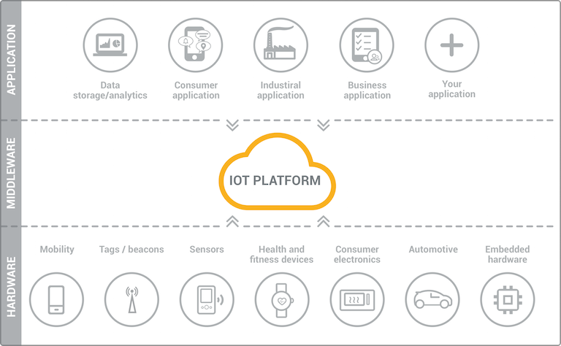

**IoT Data Link Communication Protocols**:

* IoT data link communication protocols define the rules and standards for data exchange between IoT devices and networks.

**TYPES OF IOT DATALINK COMMUNICATION PROTOCOLS:**

* **Wi-Fi (IEEE 802.11):** Commonly used for local wireless communication, offering high data rates and broad device compatibility.
* **Bluetooth:** Suitable for short-range communication between devices, often used in consumer applications and wearable devices.
* **Zigbee:** Low-power, low-data-rate protocol ideal for home automation, industrial control systems, and sensor networks.
* **Z-Wave:** Wireless communication protocol optimized for home automation, enabling devices to communicate over longer distances.
* **LoRaWAN:** Long Range Wide Area Network protocol for low-power devices, facilitating long-range communication with low data rates.
* **MQTT** (Message Queuing Telemetry Transport): Lightweight and efficient protocol for publishing and subscribing to IoT data.
* **CoAP** (Constrained Application Protocol): Designed for resource-constrained IoT devices, allowing efficient data transfer over constrained networks.
* **DDS** (Data Distribution Service) is a middleware protocol for high-performance, real-time data exchange in IoT systems.

It employs a publish-subscribe pattern and consists of two layers: DCPS for delivering information to subscribers and DLRL for sharing distributed data among IoT objects.

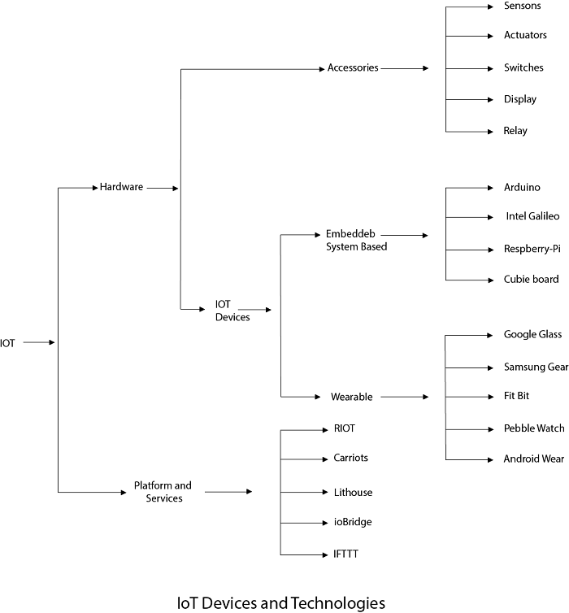

**Selection Considerations:**

* Range and Coverage: Choose a protocol suitable for the required communication range and coverage area.
* Power Consumption: Consider the power constraints of IoT devices and select a protocol that minimizes energy consumption.
* Bandwidth and Data Rate: Evaluate the amount of data to be transmitted and select a protocol that provides sufficient bandwidth.
* Device Compatibility: Ensure the protocol is supported by the IoT devices and platforms being used.
* Security: Consider the security features and encryption capabilities provided by the protocol.

# **Introduction to ESP32**

* The ESP32 is a low-cost System on Chip (SoC) microcontroller developed by Espressif Systems.
* It is the successor to the ESP8266 SoC and offers integrated Wi-Fi and Bluetooth capabilities.
* The ESP32 comes in single-core and dual-core variations of the Tensilica's 32-bit Xtensa LX6 microprocessor.

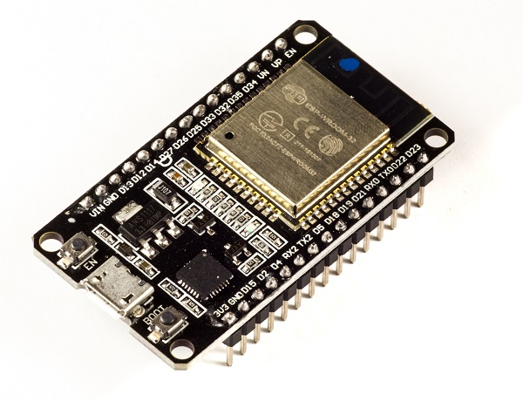

* ESP32 package has a high level of integrations such as:
* Antenna switches
* Balun to control RF
* Power amplifier
* Low noise reception amplifier
* Filters and power management modules

**Manufacturing Technology**:

The ESP32 is manufactured using TSMC's ultra-low-power 40 nm technology, which enables energy-efficient operation. This makes it suitable for battery-operated applications like wearables, audio equipment, smartwatches, etc.

### **Pinout of ESP32 Board:**

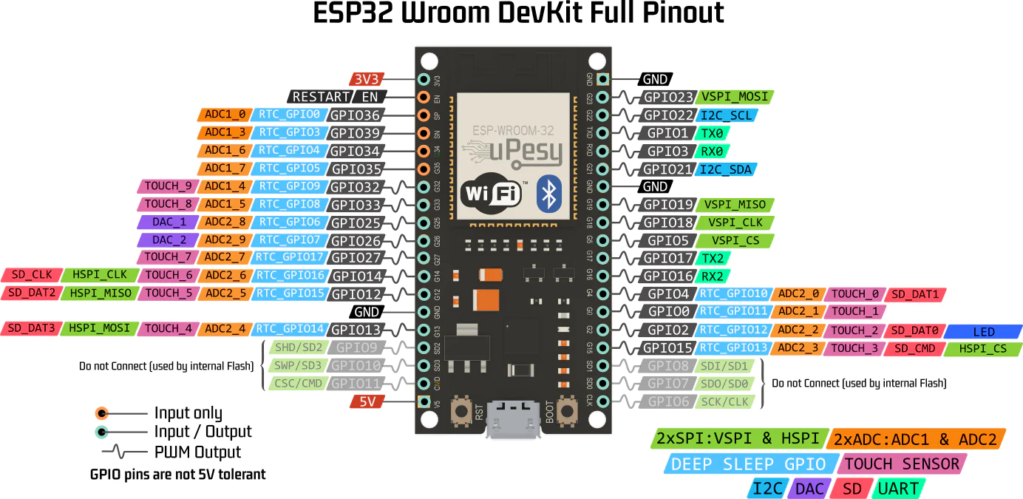

**Specifications of ESP32:**

* Single or Dual-Core 32-bit LX6 Microprocessor: The ESP32 is equipped with a single or dual-core 32-bit LX6 microprocessor with a clock frequency of up to 240 MHz.
* Memory: It has 520 KB of SRAM, 448 KB of ROM, and 16 KB of RTC SRAM.
* Wi-Fi Connectivity: The ESP32 supports 802.11 b/g/n Wi-Fi connectivity with speeds up to 150 Mbps.
* Bluetooth Support: It provides support for both Classic Bluetooth v4.2 and Bluetooth Low Energy (BLE) specifications.
* GPIO Pins: The ESP32 offers 34 programmable GPIO pins.
* Analog Inputs and Outputs: It supports up to 18 channels of 12-bit SAR ADC and 2 channels of 8-bit DAC.
* Serial Connectivity: The ESP32 includes 4 x SPI, 2 x I2C, 2 x I2S, and 3 x UART interfaces for serial communication.
* Ethernet MAC: It features an Ethernet MAC for physical LAN communication, which requires an external PHY (Physical Layer) chip.
* SD/SDIO/MMC Support: The ESP32 has 1 host controller for SD/SDIO/MMC and 1 slave controller for SDIO/SPI.
* PWM: It supports motor PWM and up to 16 channels of LED PWM.
* Security Features: The ESP32 offers secure boot and flash encryption. It also includes cryptographic hardware acceleration for AES, Hash (SHA-2), RSA, ECC, and RNG.

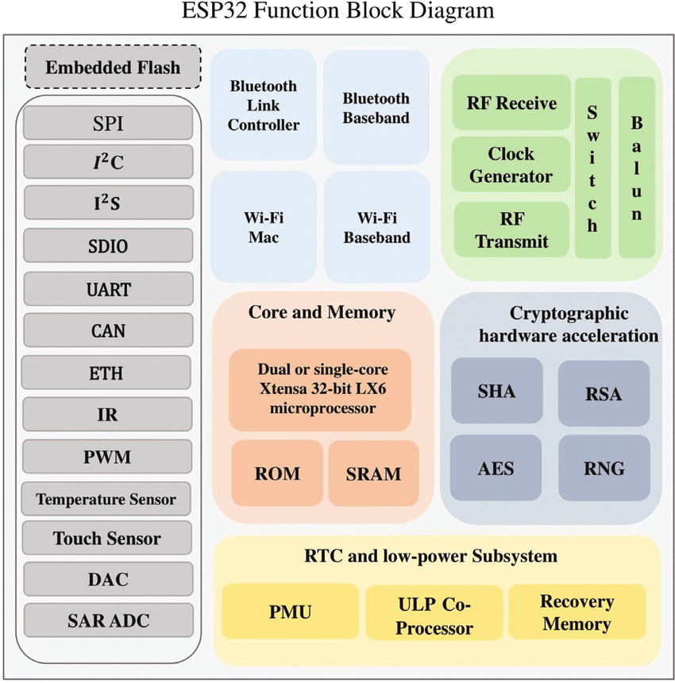

**Different Ways to Program:**

The ESP32 can be programmed using various programming environments, including:

* Arduino IDE
* PlatformIO IDE (VS Code)
* LUA
* MicroPython
* Espressif IDF (IoT Development Framework)
* JavaScript
* ESP32 DevKit - The ESP32 Development Board:

The ESP32 DevKit is a popular development board based on the ESP-WROOM-32 module. It simplifies programming and provides easy access to GPIO pins. The board typically includes the ESP-WROOM-32 module, IO pins, a USB-UART bridge IC (CP2012), a micro-USB connector for power and programming, a 3.3V regulator IC (AMS1117), enable and boot buttons, power and user LEDs, and passive components.

**ESP32 Board Layout:**

The layout of ESP32 development boards may vary, but a typical layout includes the following:

* ESP-WROOM-32 Module
* Two rows of IO Pins (15 pins on each side)
* CP2012 USB-UART Bridge IC
* Micro-USB Connector
* AMS1117 3.3V Regulator IC
* Enable and Boot Buttons
* Power LED (Red)
* User LED (Blue - connected to GPIO2

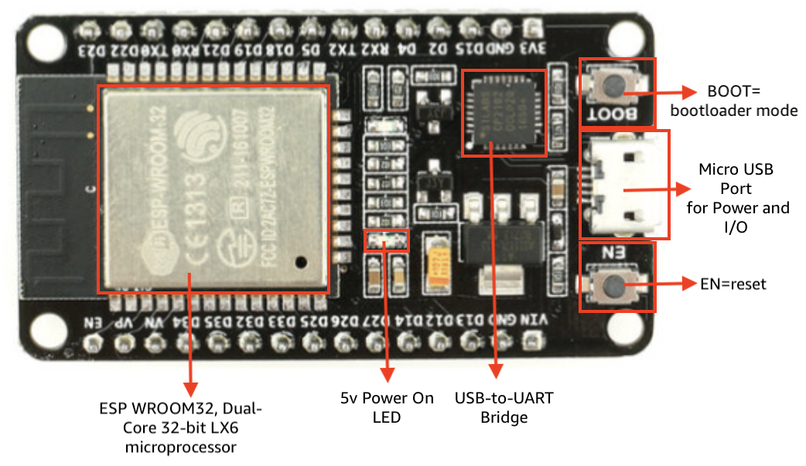

# **PROJECTS**

**BASIC:**

# ESP32 LED BLINKING WITH GPIO

# ESP32 LED BLINK WITH PUSH BUTTON

1. ESP32 LED BLINK BY GPIO INTERRUPTS

# ESP32 ADC WITH ANALOG INPUTS

# ESP32 PWM ESP-IDF LED BRIGHTNESS CONTROL

# ESP32 RTC REAL TIME CLOCK WITH DS3231

# HC-SR04 ULTRASONIC SENSOR WITH ESP32

1. INFRARED SENSOR BASED VISITOR COUNTER PROJECT
2. UART BASED COMMUNICATION ESP32 TO ANOTHER ESP32

# INTERFACE SEVEN SEGMENT DISPLAY WITH ESP32

1. INTERFACE SEVEN SEGMENT DISPLAY WITH ESP32

# INTERFACING 16X2 LCD WITH ESP32 WITH AND WITHOUT I2C MODULE

1. NUMERICAL KEYBOARD INTERFACE WITH ESP32

# ESP32 CONTROL LED IN WIFI – STATION MODE

# **CONTROL LED USING ESP32 WI-FI- AP MODE**

1. RELAY BASED AC FAN ON AND OFF
2. ESP32 TIMER BASED LED BLINK
3. ESP32 LED BLINK IN 2 DIFFERENT TIMING

# ESP32 WITH DC MOTOR AND L289N MOTOR DRIVER USING ESP-IDF

1. ESP32 INTERFACE WITH SERVO MOTOR
2. ESP32 INTERFACE WITH STEPPER MOTOR

**ADVANCED :**

1. ESP32 INTERFACE WITH GSM MODULE
2. ESP32 BLUETOOTH INTERFACE
3. ESP32 GPS INTERFACE
4. RFID ATTENDANCE-BASED SYSTEM USING ESP32
5. TFT DISPLAY INTERFACE WITH ESP32

# **ESP32 GPIO with ESP-IDF with LED Blinking example**

**OBJECTIVE:**

* To connect a 5mm LED with one of the 30 pins available for ESP32, configure that GPIO pin as a digital output pin and then toggle its state after a delay of a few seconds to show a blinking effect

The diagram below shows how the state of the GPIO pin will change:

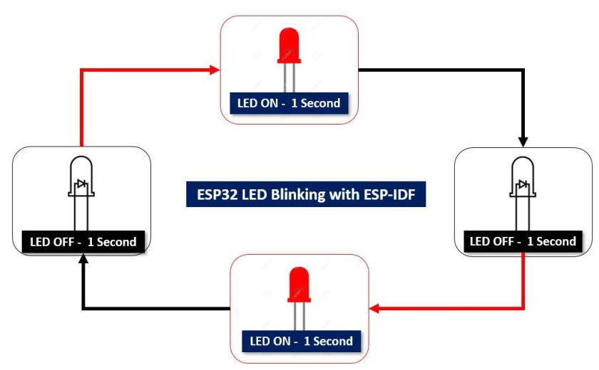

The LED connected to the ESP32 starts in the OFF state (LOW). After 1 second, the GPIO pin switches to HIGH, turning the LED ON. It remains ON for 1 second. Then, the LED goes back to the OFF state (LOW) for another second. This cycle continues, causing the LED to blink, alternating between ON and OFF every second

**COMPONENTS:**

1. ESP32 development board
2. One 5mm LED
3. One 220 ohm current limiting resistor
4. Connecting Wires
5. Breadboard

**CONNECTIONS :**

* GPIO13 is used to connect to the LED's anode pin.
* A 220-ohm current limiting resistor is placed between GPIO13 and the LED's anode pin.
* The cathode pin of the LED is connected to the GND pin of the ESP32.
* You can choose a different digital output pin on the ESP32 to connect with the LED if needed.
* The voltage on GPIO13 determines the LED's state: HIGH turns it on, and LOW turns it off.
* By toggling the GPIO13 state between HIGH and LOW, the LED blinks on and off repeatedly.

**Circuit diagram:**

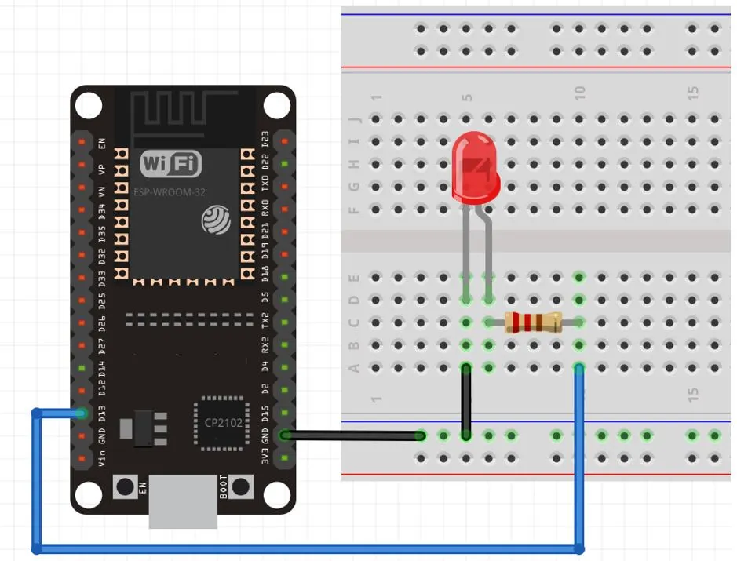

**Setting up the Project:**

* + 1. Open VS Code and go to View > Command Palette.
    2. Type "ESP-IDF: New Project" in the search bar and press enter.
    3. Specify the project name as "LED_BLINK" and choose the desired directory.
    4. Select the custom board option for ESP-IDF board and choose the ESP32 module as the target.
    5. Click the "Choose Template" button to proceed.

**Opening the Project:**

* + 1. In the VS Code Extension, select the ESP-IDF option.
    2. Click on the "sample_project" under the get-started tab.
    3. Choose "Create project using template sample_project."
    4. You will receive a notification that the project has been created. Click "Yes" to open the project in a new window.
    5. The project folder (LED_BLINK) will be visible in the EXPLORER tab, containing various folders, including the main folder where the main.c file is located.

**Programming the ESP32:**

Open main > main.c file to write the program code.

**CODE:**

#include <stdio.h>

#include "driver/gpio.h"

#include "freertos/FreeRTOS.h"

#include "freertos/task.h"

#define LED_PIN 13

void app_main(void)

{

gpio_pad_select_gpio(LED_PIN);

gpio_set_direction(LED_PIN, GPIO_MODE_OUTPUT);

int ON = 0;

while(true)

{

ON = !ON;

gpio_set_level(LED_PIN, ON);

vTaskDelay(1000/ portTICK_PERIOD_MS);

}

}

**WORKING PRINCIPLE OF CODE:**

1. `#include <stdio.h>`

This line includes the standard input/output library for basic input/output operations.

2. `"driver/gpio.h"`

This line includes the GPIO driver library, which provides functions to work with GPIO pins.

3. `"freertos/FreeRTOS.h"`

This line includes the FreeRTOS library, which is a real-time operating system for embedded systems.

4. `"freertos/task.h"`

This line includes the task handling functions from the FreeRTOS library.

5. `#define LED_PIN 13`

This line defines a macro `LED_PIN` and assigns it the value 13. This macro represents the GPIO pin number connected to the LED.

6. `void app_main(void)`

This line declares the main function `app_main`, which is the entry point of the program.

7. `gpio_pad_select_gpio(LED_PIN);`

This line selects the GPIO pin specified by `LED_PIN` for use as a GPIO.

8. `gpio_set_direction(LED_PIN, GPIO_MODE_OUTPUT);`

This line sets the direction of the GPIO pin specified by `LED_PIN` as an output pin.

9. `int ON = 0;`

This line declares an integer variable `ON` and initializes it with the value 0. This variable will be used to control the state of the LED.

10. `while(true)This line starts an infinite loop. The code inside this loop will run repeatedly.

11. `ON = !ON;`

This line toggles the value of the `ON` variable using the logical NOT operator `!`. If `ON` is 0, it becomes 1, and vice versa.

12. `gpio_set_level(LED_PIN, ON);`

This line sets the GPIO pin specified by `LED_PIN` to the value stored in the `ON` variable. If `ON` is 0, the pin is set to a low level (LED OFF), and if `ON` is 1, the pin is set to a high level (LED ON).

13. `vTaskDelay(1000/ portTICK_PERIOD_MS);`

This line adds a delay of 1 second using the `vTaskDelay()` function from the FreeRTOS library. It pauses the execution of the program for the specified duration before continuing to the next iteration of the loop.

The code continues looping indefinitely, alternating the state of the LED between ON and OFF with a delay of 1 second between each state change. This results in the LED blinking at a 1-second interval.

**Compiling and Flashing the Sketch:**

To compile and flash the project code to your ESP32 board, follow these steps:

1. Build the Project:

- Open the terminal or command prompt.

- Navigate to the project directory using the `cd` command.

- Run the following command to build the project:

idf.py build

- This command compiles the project code and generates the firmware binary.

2. Connect the ESP32 Board:

- Ensure that your ESP32 board is properly connected to your computer via a USB cable.

3. Flash the Firmware:

- In the terminal or command prompt, enter the following command to flash the firmware to the ESP32 board:

idf.py -p <COMX> flash

- Replace `<COMX>` with the actual COM port number assigned to your ESP32 board. For example, `COM5`

- This command uploads the firmware binary to the ESP32 board

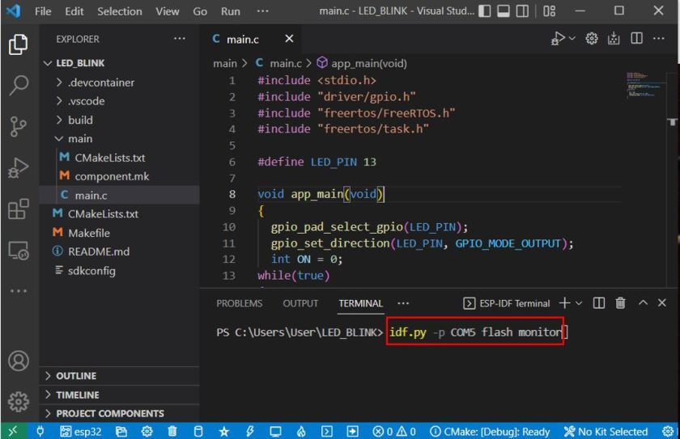

4. Monitor the Output:

- After successful flashing, you can monitor the output of your program by entering the following command in the terminal:

idf.py -p <COMX> monitor

- Again, replace `<COMX>` with the correct COM port number of your ESP32 board.

- This command opens a serial monitor that displays the debug output from your ESP32 board.

Once the code flashes successfully and the monitor is running, the LED connected to GPIO 13 should start blinking with a delay of one second. You can observe the blinking pattern in the serial monitor as well.

**OUTPUT**

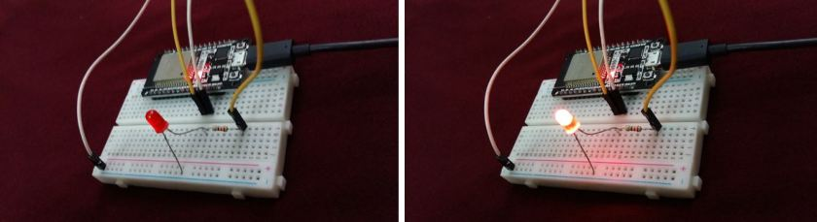

# **ESP32 Push Button with ESP-IDF (Digital Input)**

**OBJECTIVE**

To demonstrate how to interface a push button with the ESP32 microcontroller using the ESP-IDF. The objective is to configure GPIO pins as digital inputs to read the state of the push button and control a digital output, such as an LED. When the push button is pressed, the LED turns ON. When the push button is released, the LED turns OFF.

**Description**

If the logic state of the push button is HIGH, the LED will turn ON. Likewise, if the logic state of the push button is LOW, the LED will turn OFF.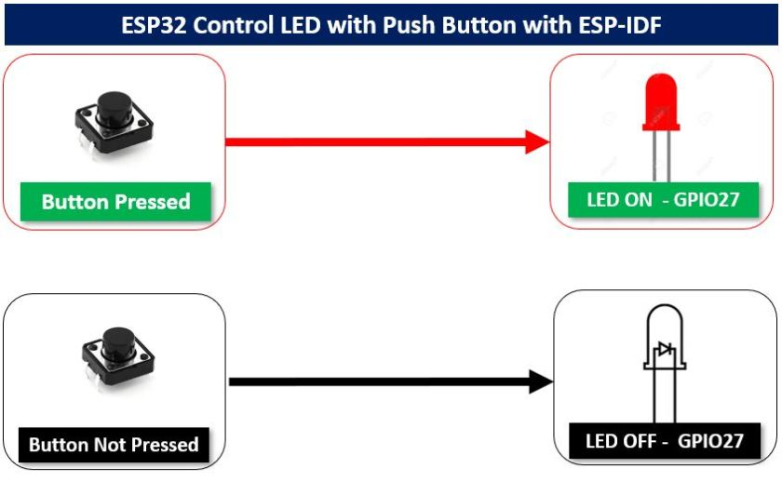 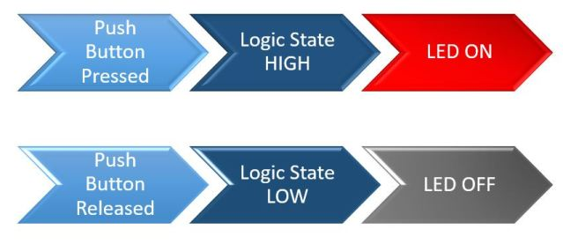

**Components**:

1. ESP32 development board
2. 5mm LED
3. 220 ohm resistor
4. 10k ohm resistor
5. Breadboard
6. Connecting wires

**CONNECTIONS:**

**For the LED:**

* Connect the anode pin of the LED (longer leg) to GPIO27 on the ESP32.
* Place a 220 ohm current limiting resistor between GPIO27 and the anode pin of the LED.
* Connect the cathode pin of the LED (shorter leg) to the GND pin of the ESP32.

**For the push button**:

* The push button has four terminals.
* Connect one terminal of the push button to the 3.3V power supply of the ESP32.
* Connect the second terminal of the push button to GPIO33 on the ESP32.
* To ensure a default low signal when the button is not pressed, connect a 10k ohm pull-down resistor between GPIO33 and the second terminal of the push button.
* Connect the common ground of the push button to the other end of the pull-down resistor.

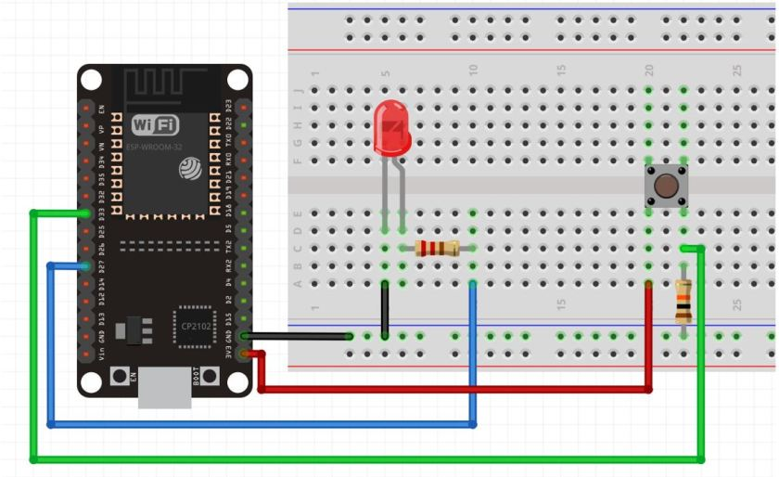

## PROCEDURE

Open your VS Code and create a new ESP-IDF project. Now head over to the main.c file. We will define the functions and the program code here.

### **Code**

### This is the code that we will use to control LED with the push button.

#include "driver/gpio.h"

#include "freertos/FreeRTOS.h"

#include "freertos/task.h"

#define LED_PIN 27

#define PUSH_BUTTON_PIN 33

void app_main(void)

{

gpio_set_direction(LED_PIN, GPIO_MODE_OUTPUT);

gpio_set_direction(PUSH_BUTTON_PIN, GPIO_MODE_INPUT);

while(1) {

if (gpio_get_level(PUSH_BUTTON_PIN) == 1)

{

gpio_set_level(LED_PIN, 1);

}

else

{

gpio_set_level(LED_PIN, 0);

}

vTaskDelay(1);

}

}

**CODE EXPLANATION:**

* #include "driver/gpio.h": This line includes the necessary header file for GPIO operations in ESP-IDF.
* #include "freertos/FreeRTOS.h" and #include "freertos/task.h": These lines include the necessary header files for FreeRTOS, a real-time operating system used in ESP-IDF.
* #define LED_PIN 27 and #define PUSH_BUTTON_PIN 33: These lines define constants for the GPIO pin numbers used for the LED and push button connections, respectively.
* void app_main(void): This line declares the main function of the program.
* gpio_set_direction(LED_PIN, GPIO_MODE_OUTPUT); and gpio_set_direction(PUSH_BUTTON_PIN, GPIO_MODE_INPUT);: These lines set the GPIO pin directions for the LED and push button pins. The LED pin is configured as an output, while the push button pin is configured as an input.
* while(1) { ... }: This line starts an infinite loop that continuously checks the state of the push button and controls the LED accordingly.
* if (gpio_get_level(PUSH_BUTTON_PIN) == 1) { ... } else { ... }: This conditional statement checks the level or state of the push button pin. If the push button is pressed and the pin level is high (logic level 1), it sets the LED pin level to high as well, turning on the LED. Otherwise, if the push button is not pressed and the pin level is low (logic level 0), it sets the LED pin level to low, turning off the LED.
* gpio_set_level(LED_PIN, 1); and gpio_set_level(LED_PIN, 0);: These lines set the level of the LED pin to either high (1) or low (0) based on the state of the push button.
* vTaskDelay(1);: This line introduces a delay of 1 system tick before the loop repeats. It allows for a short pause between each iteration of the loop.
* **Compiling and Flashing the Sketch:**

1. Build the Project:

- Open the terminal or command prompt.

- Navigate to the project directory using the `cd` command.

- Run the following command to build the project: idf.py build

2. Connect the ESP32 Board: - Ensure that your ESP32 board is properly connected to your computer via a USB cable.

3. Flash the Firmware:

- In the terminal or command prompt, enter the following command to flash the firmware to the ESP32 board:

idf.py -p <COMX> flash

4. Monitor the Output:

- After successful flashing, you can monitor the output of your program by entering the following command in the terminal:

idf.py -p <COMX> monitor

After the code flashes successfully, press the push button to turn the LED on. When the push button is released, the LED turns off.

**OUTPUT:**

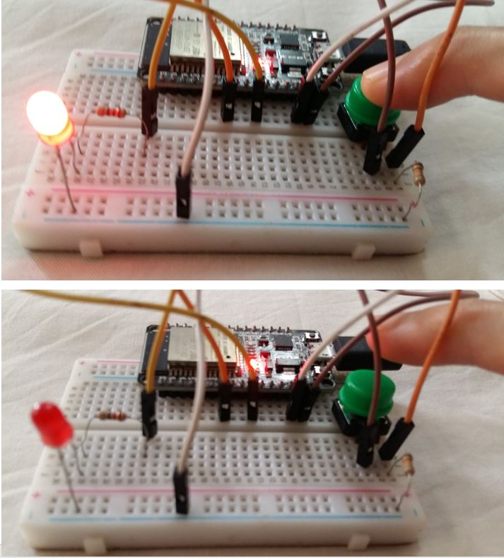

# **ESP32 GPIO Interrupts using ESP-IDF**

**AIM:**

The aim of this project is to control an LED using an external interrupt. When the interrupt is triggered, the LED will turn on, and when the interrupt is triggered again, the LED will turn off.

**COMPONENTS REQUIRED:**

ESP32 development board: It provides the necessary hardware platform for the project.

Push button: An external push button switch used to trigger the interrupt

**CONNECTIONS:**

1. Connect one terminal of the push button to the GPIO15 pin of the ESP32.

2. Connect the other terminal of the push button to the 3.3V pin of the ESP32.

3. Configure the GPIO15 pin as an input pin with a built-in pulldown resistor in the code.

4. Use the onboard LED of the ESP32 as the digital output for indicating the state.

5. No additional physical LED is required, as the onboard LED will be controlled.

6. The cathode (shorter leg) of the onboard LED is already connected to the GND pin of the ESP32 internally.

**CIRCUIT DIAGRAM:**

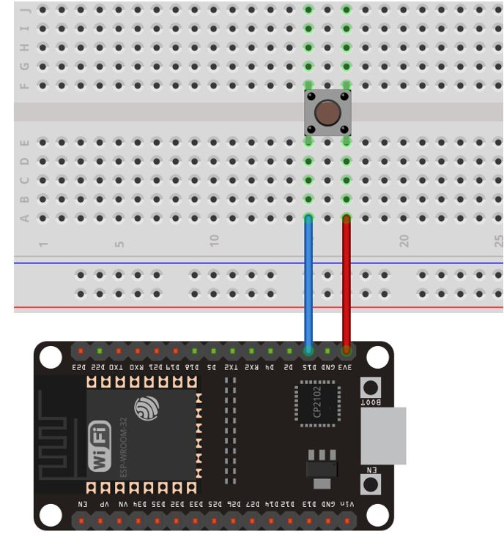

## PROCEDURE :

## Open your VS Code and create a new ESP-IDF project. Now head over to the main.c file. We will define the functions and the program code here.

**CODE:**

#include <stdio.h>

#include "freertos/FreeRTOS.h"

#include "freertos/task.h"

#include "freertos/queue.h"

#include "driver/gpio.h"

#define INPUT_PIN 15

#define LED_PIN 2

int state = 0;

xQueueHandle interputQueue;

static void IRAM_ATTR gpio_interrupt_handler(void *args)

{

int pinNumber = (int)args;

xQueueSendFromISR(interputQueue, &pinNumber, NULL);

}

void LED_Control_Task(void *params)

{

int pinNumber, count = 0;

while (true)

{

if (xQueueReceive(interputQueue, &pinNumber, portMAX_DELAY))

{

printf("GPIO %d was pressed %d times. The state is %d\n", pinNumber, count++, gpio_get_level(INPUT_PIN));

gpio_set_level(LED_PIN, gpio_get_level(INPUT_PIN));

}

}

}

void app_main()

{

gpio_pad_select_gpio(LED_PIN);

gpio_set_direction(LED_PIN, GPIO_MODE_OUTPUT);

gpio_pad_select_gpio(INPUT_PIN);

gpio_set_direction(INPUT_PIN, GPIO_MODE_INPUT);

gpio_pulldown_en(INPUT_PIN);

gpio_pullup_dis(INPUT_PIN);

gpio_set_intr_type(INPUT_PIN, GPIO_INTR_POSEDGE);

interputQueue = xQueueCreate(10, sizeof(int));

xTaskCreate(LED_Control_Task, "LED_Control_Task", 2048, NULL, 1, NULL);

gpio_install_isr_service(0);

gpio_isr_handler_add(INPUT_PIN,gpio_interrupt_handler,(void*)INPUT_PIN);

}

**CODE EXPLANATION:**

1. The necessary header files are included for FreeRTOS, GPIO operations, and queues.

2. Constants are defined for the input pin (GPIO15) and the LED pin (GPIO2).

3. A variable "state" is initialized to 0 to track the LED state.

4. A queue handle "interruptQueue" is declared for storing interrupt events.

5. The "gpio_interrupt_handler" function is defined. It is an interrupt handler that will be triggered when a rising edge (button press) occurs on the input pin. It receives the pin number as an argument and sends it to the interrupt queue from the interrupt context.

6. The "LED_Control_Task" function is responsible for controlling the LED based on button presses. It waits for an item in the interrupt queue, receives the pin number, and then prints the number of button presses, the current state of the input pin, and sets the LED state accordingly.

7. In the "app_main" function:

- GPIO pins for the LED and input button are configured as output and input, respectively.

- The input pin is configured with a pull-down resistor to establish a default state.

- The interrupt type is set to trigger on a positive edge (button press).

- An interrupt queue is created to store the interrupt events.

- The "LED_Control_Task" is created as a FreeRTOS task.

- The GPIO ISR service is installed, and the interrupt handler is registered for the input pin..

* Build the code ,flash and monitor it after connecting the esp32 board through the USB
* After the code flashes successfully press the push button connected with GPIO5. Its state changes from LOW to HIGH and the interrupt occurs. This causes the onboard LED to turn ON. The ESP-IDF terminal displays the number of times the GPIO was pressed and its current state.

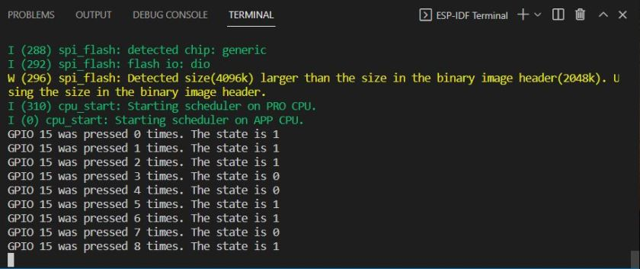

**OUTPUT:**

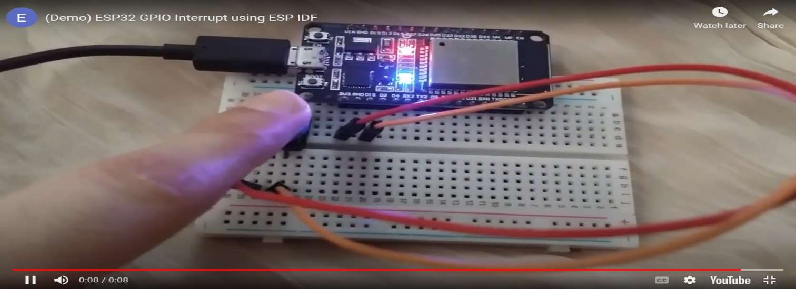

# **ESP32 ADC with ESP-IDF Measure Analog Inputs**

**OBJECTIVE:**

The aim of the project is to learn how to use the ADC (Analog-to-Digital Converter) of ESP32 to read analog voltage values. Specifically, the project focuses on interfacing a potentiometer with the ESP32 board and reading its analog value using the ADC.

**COMPONENTS :**

1. ESP32 board
2. Breadboard
3. Potentiometer
4. Connecting Wire

**THEORY:**

The ESP32 board has 8 channels for ADC1 but the DEVKIT V1 only supports 6 of them. ADC2 has 10 analog channels. The analog pins of both of these channels are listed below: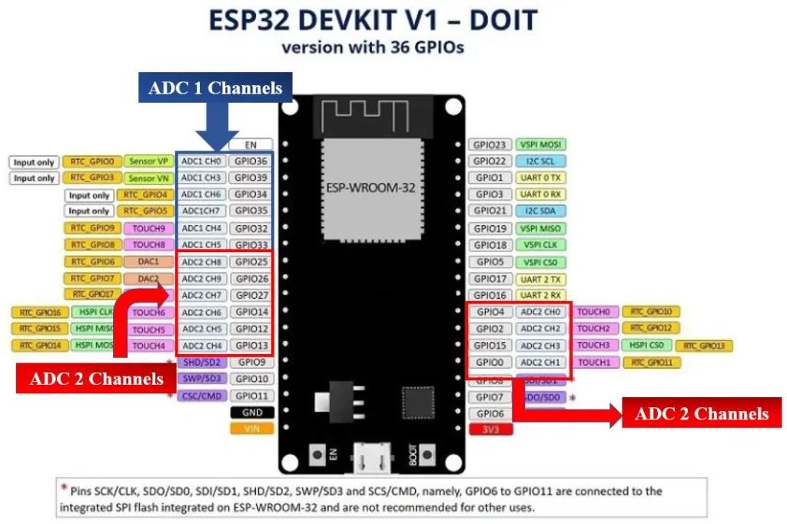

.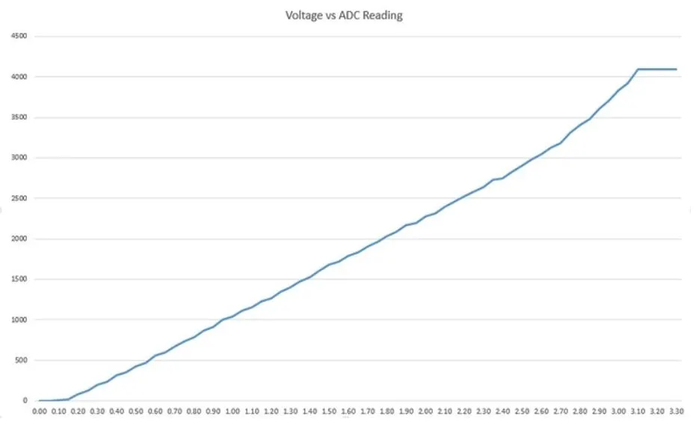

ADC Converts analog signals into digital values.The potentiometer will be connected to an analog channel on our ESP32 board, and its voltage will then be measured. Varying input voltages could be generated by rotating the potentiometer’s top knob, and the ADC module in our ESP32 board would then convert those variable input voltages to corresponding digital Values.

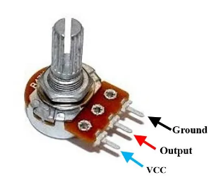

**CONNECTIONS:**

* VCC (3.3V) of ESP32 board -> One end of the potentiometer
* GND of ESP32 board -> Other end of the potentiometer
* Analog input pin( ADC1_CH4 -GPIO32)->Middle terminal

**CIRCUIT DIAGRAM:**

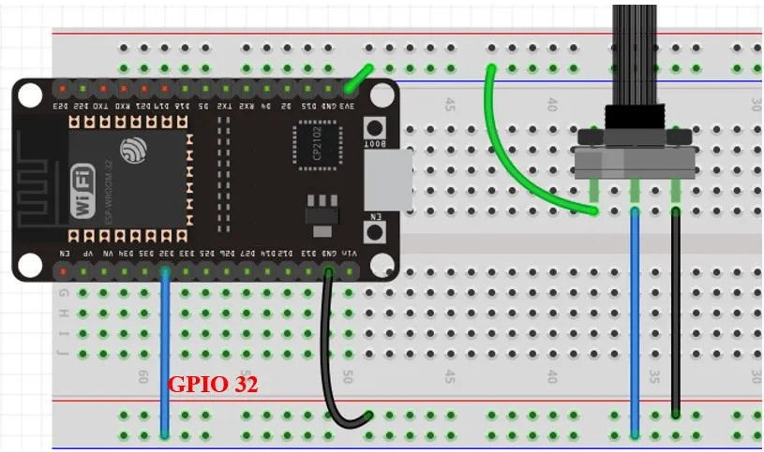

**PROCEDURE:**

Open your VS Code and create a new ESP-IDF project. Now head over to the main.c file.

**CODE:**

#include <stdio.h>

#include <stdlib.h>

#include "freertos/FreeRTOS.h"

#include "freertos/task.h"

#include "driver/adc.h"

#include "esp_adc_cal.h"

static esp_adc_cal_characteristics_t adc1_chars;

void app_main(void)

{

esp_adc_cal_characterize(ADC_UNIT_1, ADC_ATTEN_DB_11, ADC_WIDTH_BIT_DEFAULT, 0, &adc1_chars);

adc1_config_width(ADC_WIDTH_BIT_DEFAULT);

adc1_config_channel_atten(ADC1_CHANNEL_4, ADC_ATTEN_DB_11);

while (1)

{

int adc_value = adc1_get_raw(ADC1_CHANNEL_4);

printf("ADC Value: %d", adc_value);

printf("\n");

vTaskDelay(500/ portTICK_PERIOD_MS);

}

}

**CODE EXPLANATION:**

* The header files stdio.h, stdlib.h, and the required FreeRTOS headers are included.
* The adc1_chars variable of type esp_adc_cal_characteristics_t is declared. This structure holds the ADC calibration data.
* In the app_main() function, esp_adc_cal_characterize() is called to characterize ADC Unit 1 with attenuation of 11 dB, default bit width, and a reference voltage of 0. This function sets up the ADC calibration data using the provided characteristics structure.
* adc1_config_width() is called to configure the bit width of ADC Unit 1 with the default bit width.
* adc1_config_channel_atten() is called to configure ADC1_CHANNEL_4 with an attenuation of 11 dB. This sets up the specific ADC channel to be used for reading analog values.
* The code enters a continuous loop using while (1).
* Inside the loop, adc1_get_raw() is called to read the raw ADC value from ADC1_CHANNEL_4. The raw value represents the digital equivalent of the analog voltage measured by the ADC.
* The ADC value is printed using printf().
* vTaskDelay() is used to introduce a delay of 500 milliseconds before the next ADC reading.

->Build the code ,flash and monitor it after connecting the esp32 board through the USB

->After the code flashes successfully, the Voltage readings in millivolts will appear on the Terminal. Rotate the potentiometer knob to see how the analog voltage varies.

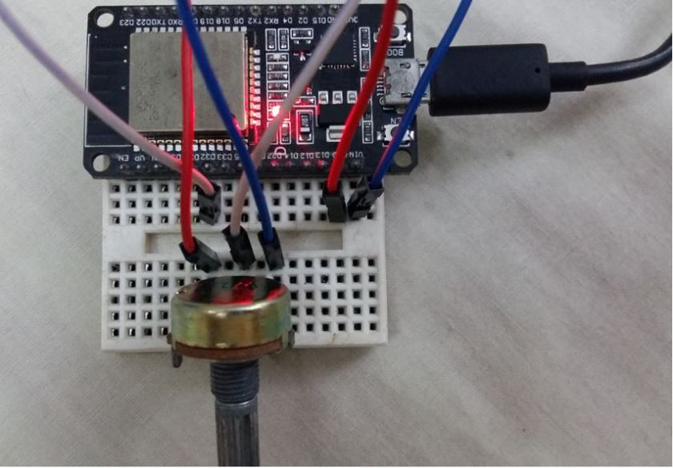

**OUTPUT:**

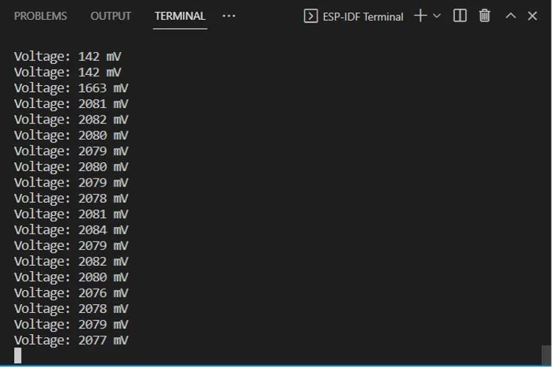

# **ESP32 PWM ESP-IDF LED Brightness Control Example**

**AIM:**

The aim of this project is to control the brightness of an LED using PWM signals generated by the ESP32, with the help of a potentiometer to vary the duty cycle**.**

**COMPONENTS:**

* ESP32 board
* 5mm LED
* 220 ohm current limiting resistor
* Breadboard
* Potentiometer
* Connecting Wire

**CONNECTIONS:**

Potentiometer:

* Center terminal: GPIO32 (ADC1_CH4)
* One terminal: 3.3V power supply
* Other terminal: GND

LED:

* Anode: GPIO27 (connected through a 220-ohm resistor)
* Cathode: GND

**CIRCUIT DIAGRAM:**

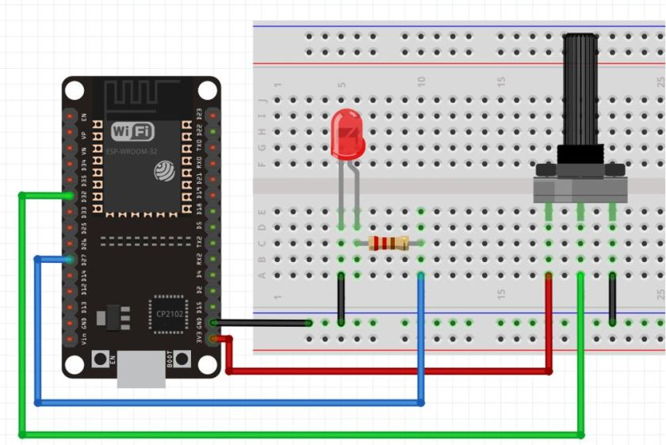

**PROCEDURE:**

Open your VS Code and create a new ESP-IDF project. Now head over to the main.c file. We will define the functions and the program code here.

**CODE:**

#include <stdio.h>

#include <stdlib.h>

#include "freertos/FreeRTOS.h"

#include "freertos/task.h"

#include "driver/adc.h"

#include "driver/ledc.h"

#define SAMPLE_CNT 32

static const adc1_channel_t adc_channel = ADC_CHANNEL_4;

#define LEDC_GPIO 27

static ledc_channel_config_t ledc_channel;

static void init_hw(void)

{

adc1_config_width(ADC_WIDTH_BIT_10);

adc1_config_channel_atten(adc_channel, ADC_ATTEN_DB_11);

ledc_timer_config_t ledc_timer = {

.duty_resolution = LEDC_TIMER_10_BIT,

.freq_hz = 1000,

.speed_mode = LEDC_HIGH_SPEED_MODE,

.timer_num = LEDC_TIMER_0,

.clk_cfg = LEDC_AUTO_CLK,

};

ledc_timer_config(&ledc_timer);

ledc_channel.channel = LEDC_CHANNEL_0;

ledc_channel.duty = 0;

ledc_channel.gpio_num = LEDC_GPIO;

ledc_channel.speed_mode = LEDC_HIGH_SPEED_MODE;

ledc_channel.hpoint = 0;

ledc_channel.timer_sel = LEDC_TIMER_0;

ledc_channel_config(&ledc_channel);

}

void app_main()

{

init_hw();

while (1)

{

uint32_t adc_val = 0;

for (int i = 0; i < SAMPLE_CNT; ++i)

{

adc_val += adc1_get_raw(adc_channel);

}

adc_val /= SAMPLE_CNT;

ledc_set_duty(ledc_channel.speed_mode, ledc_channel.channel, adc_val);

ledc_update_duty(ledc_channel.speed_mode, ledc_channel.channel);

vTaskDelay(500 / portTICK_RATE_MS);

}

}

**CODE EXPLANATION:**

* + The necessary header files are included: <stdio.h> for standard input/output functions, <stdlib.h> for standard library functions, and various other headers for FreeRTOS, ADC, and LEDC drivers.
  + SAMPLE_CNT is defined as 32, representing the number of ADC samples to be averaged.
  + The ADC channel to be used is defined as adc_channel and set to ADC_CHANNEL_4.
  + The LEDC GPIO pin to control the LED is defined as LEDC_GPIO and set to GPIO 27.
  + A variable ledc_channel of type ledc_channel_config_t is declared to configure the LEDC channel.
  + The init_hw() function is defined to initialize the hardware components. Within this function:
  + The ADC width is configured to be 10 bits using adc1_config_width(ADC_WIDTH_BIT_10).
  + The ADC attenuation is set to 11 dB using adc1_config_channel_atten(adc_channel, ADC_ATTEN_DB_11).
  + A LEDC timer configuration structure ledc_timer is defined and initialized.
  + The LEDC timer is configured with ledc_timer_config(&ledc_timer).
  + The ledc_channel structure is initialized with the LEDC channel, duty, GPIO pin, speed mode, timer, and hpoint values.
  + The LEDC channel is configured with ledc_channel_config(&ledc_channel).
  + The app_main() function is defined, which serves as the entry point for the program.
  + The init_hw() function is called to initialize the hardware.
  + An infinite loop is started using while (1) to continuously perform ADC and LED control operations.
  + A variable adc_val is declared to store the averaged ADC value.
  + The ADC is sampled SAMPLE_CNT times, and the values are summed up in adc_val.
  + The average ADC value is computed by dividing adc_val by SAMPLE_CNT.
  + The LEDC duty cycle is set to the average ADC value using ledc_set_duty().
  + The LEDC duty cycle update is triggered using ledc_update_duty().
  + A delay of 500 milliseconds is introduced using vTaskDelay() from FreeRTOS.
  + The program continuously reads ADC values, calculates the average, and adjusts the LEDC duty cycle accordingly to control the brightness of an LED connected to GPIO 27. The delay between iterations is 500 milliseconds, resulting in a periodic update of the LED brightness based on the ADC readings.

->Build the code ,flash and monitor it after connecting the esp32 board through the USB

->After the code flashes successfully, rotate the potentiometer knob to vary the duty cycle of the PWM signal fed to GPIO27. As the ADC readings increase from 0-1023, the brightness of the LED increases. Similarly, rotating the knob in the opposite direction causes the ADC readings to decrease from 1023-0, hence the LED fades.

**OUTPUT:**

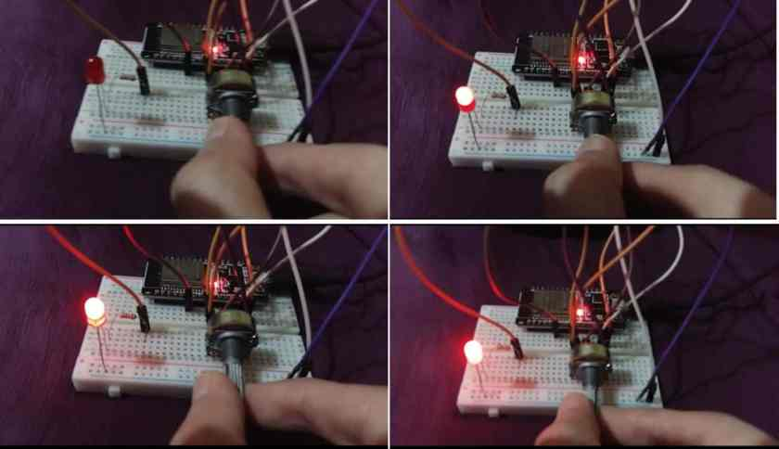

# **ESP32 RTC Real Time Clock with DS3231**

**AIM:**

The aim of this project is to interface the DS3231 RTC Module with an ESP32 board using ESP-IDF, collect real-time data including the current date, time, and possibly other parameters, and store or process the data for further analysis or application-specific requirements.

**COMPONENTS:**

1. ESP32 board
2. DS3231 Module
3. Connecting Wires
4. Breadboard

**CONNECTIONS**:

| **DS3231 Module** | **ESP32** |
| --- | --- |
| GND | GND |
| VCC | 3.3V |
| SDA | GPIO21(I2C SDA) |
| SCL | GPIO22 (I2C SCL) |

**CIRCUIT DIAGRAM:**

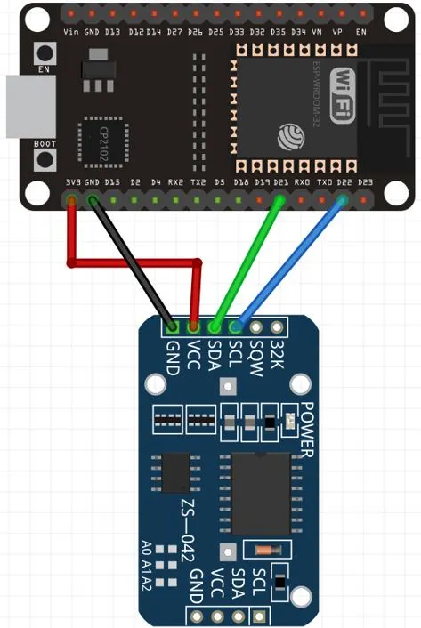

**PROCEDURE:**

Open your VS Code and create a new ESP-IDF project. Now head over to the main.c file.

Add the necessary header files for the libraries required for this project. Create a new folder called ‘components’ and add the following three sub-folders under it:

1. esp_idf_lib_helpers
2. i2cdev
3. ds3231

Add ds3231, esp_idf_lib_helpers, and i2cdev folders in ‘components’ folder by copying from this as listed below:

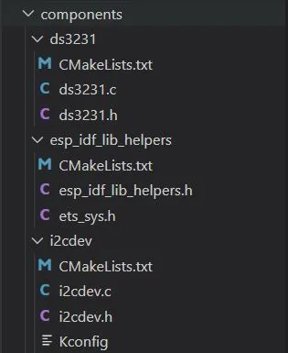

**CODE:**

#include <stdio.h>

#include <freertos/FreeRTOS.h>

#include <freertos/task.h>

#include <ds3231.h>

#include <string.h>

void ds3231_test(void *pvParameters)

{

i2c_dev_t dev;

memset(&dev, 0, sizeof(i2c_dev_t));

ESP_ERROR_CHECK(ds3231_init_desc(&dev, 0, 21, 22));

struct tm time = {

.tm_year = 122, // (2022 - 1900)

.tm_mon = 11, // 0-based

.tm_mday = 15,

.tm_hour = 0,

.tm_min = 50,

.tm_sec = 10 };

ESP_ERROR_CHECK(ds3231_set_time(&dev, &time));

while (1)

{

float temp;

vTaskDelay(pdMS_TO_TICKS(250));

if (ds3231_get_temp_float(&dev, &temp) != ESP_OK)

{

printf("Could not get temperature\n");

continue;

}

if (ds3231_get_time(&dev, &time) != ESP_OK)

{

printf("Could not get time\n");

continue;

}

printf("%04d-%02d-%02d %02d:%02d:%02d, %.2f deg Cel\n", time.tm_year + 1900 /*Add 1900 for better readability*/, time.tm_mon + 1,time.tm_mday, time.tm_hour, time.tm_min, time.tm_sec, temp);

}

}

void app_main()

{

ESP_ERROR_CHECK(i2cdev_init());

xTaskCreate(ds3231_test, "ds3231_test", configMINIMAL_STACK_SIZE * 3, NULL, 5, NULL);

}

**CODE EXPLANATION:**

* + The necessary header files are included, which provide the required functions and definitions for the DS3231 RTC module, FreeRTOS, and standard input/output.
  + The function ds3231_test() is defined, which serves as the task that will run on a FreeRTOS task. It retrieves the current time and temperature from the DS3231 RTC module.
* An i2c_dev_t structure named dev is declared and initialized. This structure holds the information about the I2C device used to communicate with the DS3231 module.
* ds3231_init_desc() function is called to initialize the dev structure with the appropriate I2C bus and GPIO pins
* A struct tm variable named time is declared and initialized with a specific date and time.
  + The ds3231_set_time() function is called to set the time on the DS3231 module using the dev structure and the time variable.
  + Inside the infinite while loop, the temperature is retrieved from the DS3231 module using the ds3231_get_temp_float() function and stored in the temp variable.
  + The time is retrieved from the DS3231 module using the ds3231_get_time() function and stored in the time variable.
  + The current time and temperature are printed to the console using printf(), with the temperature displayed in degrees Celsius.
  + The task waits for 250 milliseconds using vTaskDelay() to introduce a delay between temperature and time readings.
  + If there is an error in retrieving the temperature or time from the DS3231 module, an error message is printed to the console.
  + The app_main() function is defined as the entry point of the program.
  + The i2cdev_init() function is called to initialize the I2C driver.
* The ds3231_test() task is created using xTaskCreate(), which executes the ds3231_test() function as a FreeRTOS task.

->Build the code ,flash and monitor it after connecting the esp32 board through the USB

->After the code flashes successfully,you can view the current date and time along with the internal chip temperature on the console.

**OUTPUT:**

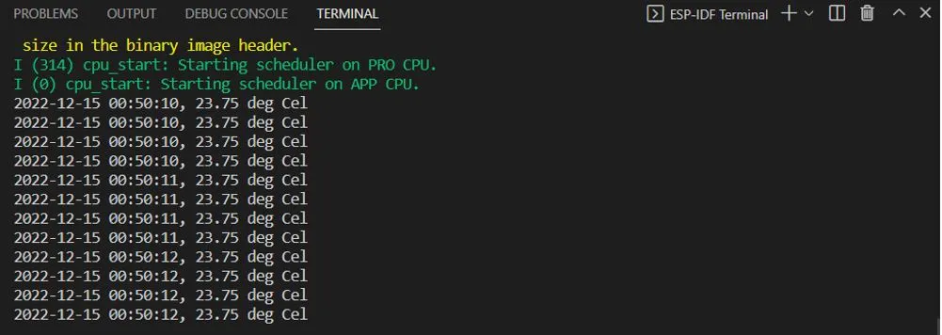

# **HC-SR04 Ultrasonic Sensor with ESP32 ESP-IDF**

**AIM:**

The aim of this project is to interface the HC-SR04 ultrasonic sensor with an ESP32 board using ESP-IDF and measure distances using contactless ultrasound technology. The distance readings will be displayed on the ESP-IDF console and an SSD1306 OLED for visual representation.

**COMPONENTS :**

1. ESP32 board
2. HC-SR04 ultrasonic sensor
3. Breadboard
4. Connecting Wires

**CIRCUIT DIAGRAM:**

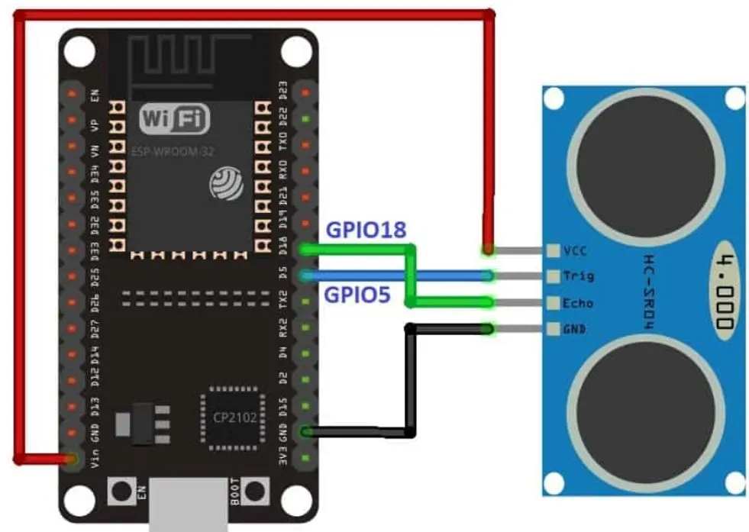

**CONNECTIONS:**

| **HC-SR04 Pin** | **ESP32** |
| --- | --- |
| VCC | The VCC pin will be connected with Vin (5V) pin of the ESP32 board. |
| Trigger | This pin is connected with a digital input pin of ESP32. We will use GPIO5. |
| Echo | This pin is connected with a digital output pin of ESP32. We will use GPIO18. |
| GND | Common ground with ESP32. |

### **WORKING OF THE ULTRASONIC SENSOR:**

### The ultrasonic sensor works based on the principle of sound waves. It emits high-frequency ultrasonic waves, typically at a frequency of 40kHz, which are inaudible to humans. These waves travel through the air and when they encounter an object, they bounce back or get reflected. The sensor has a receiver that detects the reflected waves.

### To measure the distance, the sensor first sends a short trigger pulse, typically 10µs, to initiate the measurement. This pulse activates the transmitter, which generates a burst of eight ultrasonic pulses. These pulses travel towards the object and get reflected back.

The receiver detects the reflected waves and the time it takes for the waves to return to the sensor is measured. This time measurement is based on the duration the sensor's echo pin remains in a high state. The longer it takes for the echo pin to go from high to low, the greater the distance between the sensor and the object.

By calculating the time of flight of the ultrasonic waves and knowing the speed of sound in air, the distance between the sensor and the object can be determined. This distance measurement can be used for various applications such as proximity sensing, obstacle detection, and distance ranging.

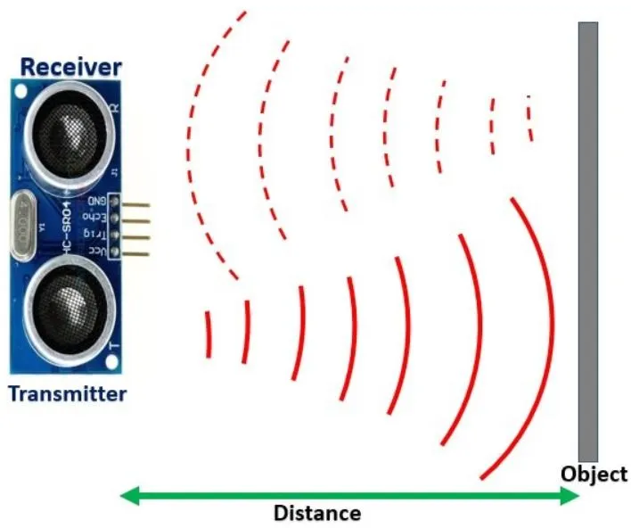

**PROCEDURE:**

Open your VS Code and create a new ESP-IDF project. Now head over to the main.c file.

**CODE:**

#include <stdio.h>

#include <stdbool.h>

#include <freertos/FreeRTOS.h>

#include <freertos/task.h>

#include <ultrasonic.h>

#include <esp_err.h>

#define MAX_DISTANCE_CM 500 // 5m max

#define TRIGGER_GPIO 5

#define ECHO_GPIO 18

void ultrasonic_test(void *pvParameters)

{

ultrasonic_sensor_t sensor = {

.trigger_pin = TRIGGER_GPIO,

.echo_pin = ECHO_GPIO

};

ultrasonic_init(&sensor);

while (true)

{

float distance;

esp_err_t res = ultrasonic_measure(&sensor, MAX_DISTANCE_CM, &distance);

if (res != ESP_OK)

{ printf("Error %d: ", res);

switch (res)

{

case ESP_ERR_ULTRASONIC_PING:

printf("Cannot ping (device is in invalid state)\n");

break;

case ESP_ERR_ULTRASONIC_PING_TIMEOUT:

printf("Ping timeout (no device found)\n");

break;

case ESP_ERR_ULTRASONIC_ECHO_TIMEOUT:

printf("Echo timeout (i.e. distance too big)\n");

break;

default:

printf("%s\n", esp_err_to_name(res));

}

}

else

printf("Distance: %0.04f cm\n", distance*100);

vTaskDelay(pdMS_TO_TICKS(500));

}

}

void app_main()

{

xTaskCreate(ultrasonic_test, "ultrasonic_test", configMINIMAL_STACK_SIZE * 3, NULL, 5, NULL);

}

**CODE EXPLANATION:**

* The necessary header files are included, such as stdio.h, stdbool.h, freertos/FreeRTOS.h, freertos/task.h, ultrasonic.h, and esp_err.h.
* Constants are defined for the maximum distance (MAX_DISTANCE_CM) the sensor can measure, and the GPIO pins used for trigger and echo (TRIGGER_GPIO and ECHO_GPIO).

->Build the code ,flash and monitor it after connecting the esp32 board through the USB

->After the code is successfully flashed, you can view the distance values in centimeters. Align the HC-SR04 sensor parallel to the object whose distance you want to measure. Move the object/sensor at various distances to see the readings changing.

**OUTPUT:** 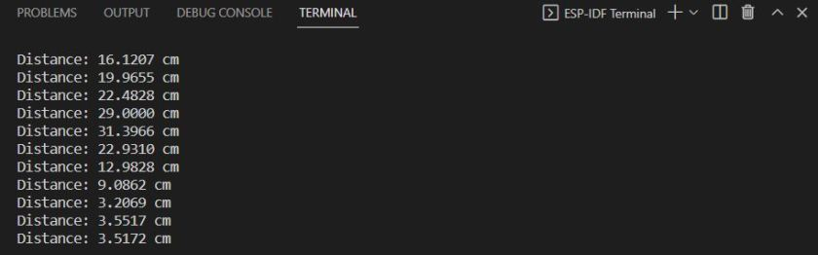

**Infrared sensor based visitor counter project**

**AIM:**

The aim of the project is to create a visitor counter using an infrared (IR) sensor. The IR sensor will detect the presence of visitors passing through a specific area, and the counter will keep track of the number of visitors. The project will utilize an LED to display the visitor count.

**COMPONENTS:**

* Infrared (IR) Sensor Module
* Microcontroller (e.g., Arduino, ESP32, Raspberry Pi)
* LED (Light-Emitting Diode)
* Resistors
* Breadboard or PCB (Printed Circuit Board)
* Power Supply
* Connecting Wires

**CONNECTIONS:**

|  |  |
| --- | --- |
| **IR Sensor Pin** | **ESP32 Pin** |
| VCC | VIN/5V/3.3V |
| GND | GND |
| OUT | D14 |

**CIRCUIT DIAGRAM:**

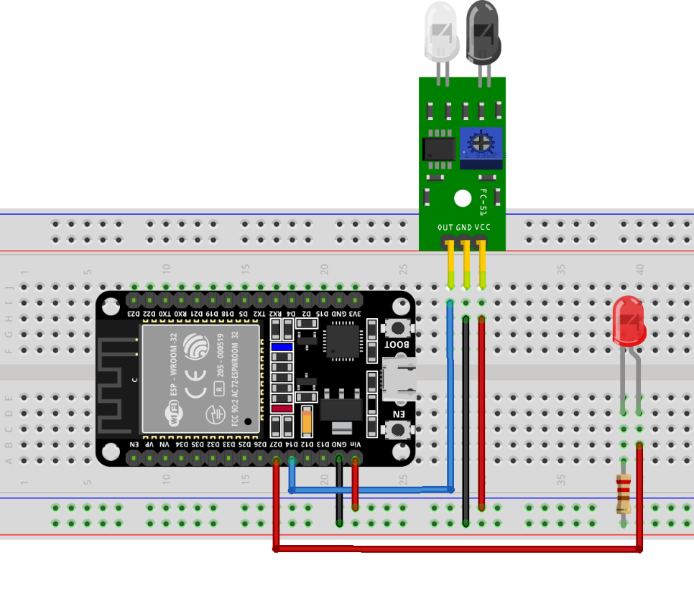

**WORKING OF IR SENSOR:**

* An **IR** or Infrared sensor is a device that measures the infrared radiations around its surrounding by emitting the IR rays and then receiving the reflected ray back
* An IR sensor works by emitting a beam of infrared radiation and detecting when the beam is reflected to the sensor. When the beam is interrupted, the sensor will output a **digital** signal. This signal can be used to trigger an action or event, such as turning on a light or activating a motor.
* IR sensor feature two main components:
* **IR Transmitter:** An infrared LED as a transmitter.
* **IR Receiver:** A photodiode is used as a receiver which after receiving reflected rays generates output.

 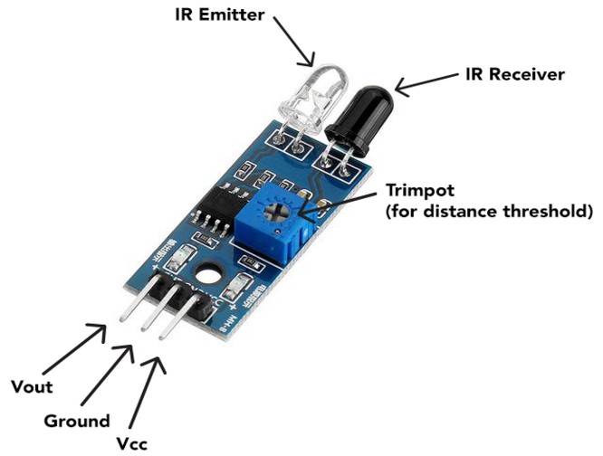

**CODE:**

#include <stdio.h>

#include "freertos/FreeRTOS.h"

#include "freertos/task.h"

#include "driver/gpio.h"

#define PIR_PIN GPIO_NUM_27

#define LED_PIN GPIO_NUM_18

int visitor_count = 0;  // Global variable to keep track of visitor count

void motion_detected_task(void *pvParameters) {

    gpio_set_direction(PIR_PIN, GPIO_MODE_INPUT);

    gpio_set_direction(LED_PIN, GPIO_MODE_OUTPUT);

    while (1) {

        if (gpio_get_level(PIR_PIN)) {

            gpio_set_level(LED_PIN, 1);  // Turn on the LED

            visitor_count++;  // Increment visitor count

            printf("Visitor count: %d\n", visitor_count);  // Display visitor count

            vTaskDelay(5000 / portTICK_PERIOD_MS);  // Delay for 5 seconds

        }

else {

            gpio_set_level(LED_PIN, 0);  // Turn off the LED

            visitor_count = 0;  // Reset visitor count when no object is detected

            printf("No object detected\n");

            vTaskDelay(100 / portTICK_PERIOD_MS);  // Delay for 100 milliseconds

        }

    }

}

void app_main() {

    xTaskCreate(motion_detected_task, "motion_task", 2048, NULL, 5, NULL);

}

**CODE EXPLANATION:**

* The code includes the necessary header files for FreeRTOS, GPIO driver, and standard input/output operations.
* The PIR_PIN constant is defined as GPIO_NUM_27, representing the GPIO pin connected to the PIR sensor's output.
* The LED_PIN constant is defined as GPIO_NUM_18, representing the GPIO pin connected to the LED.
* The visitor_count variable is initialized to 0. This global variable is used to keep track of the visitor count.
* The motion_detected_task function is defined as the task that runs continuously. It is created as a separate task in the app_main function.
* Inside the motion_detected_task, the direction of the PIR_PIN is set as an input and the direction of the LED_PIN is set as an output using gpio_set_direction().
* The task enters an infinite loop where it continuously checks the level of the PIR_PIN using gpio_get_level().
* If the PIR_PIN level is high (indicating motion detection), the LED_PIN is set to high using gpio_set_level() to turn on the LED. The visitor_count is incremented and displayed using printf(). Then, the task delays for 5 seconds using vTaskDelay().
* If the PIR_PIN level is low (no motion detected), the LED_PIN is set to low to turn off the LED. The visitor_count is reset to 0, indicating no object is detected. A message "No object detected" is printed using printf(). The task then delays for 100 milliseconds.
* The app_main function is the entry point of the program. It creates the motion_detected_task using xTaskCreate() and passes the necessary parameters.

->Build the code ,flash and monitor it after connecting the esp32 board through the USB

->After the code flashes successfully,you can view the Visitor count displayed in the terminal and parallely led glows indicating there is an object /visitor present

**OUTPUT:**

Below given image shows LED is **OFF** as IR radiations are not reflected by any of the objects. Sensor is not triggered which means it will send a **HIGH** signal at its output pin.

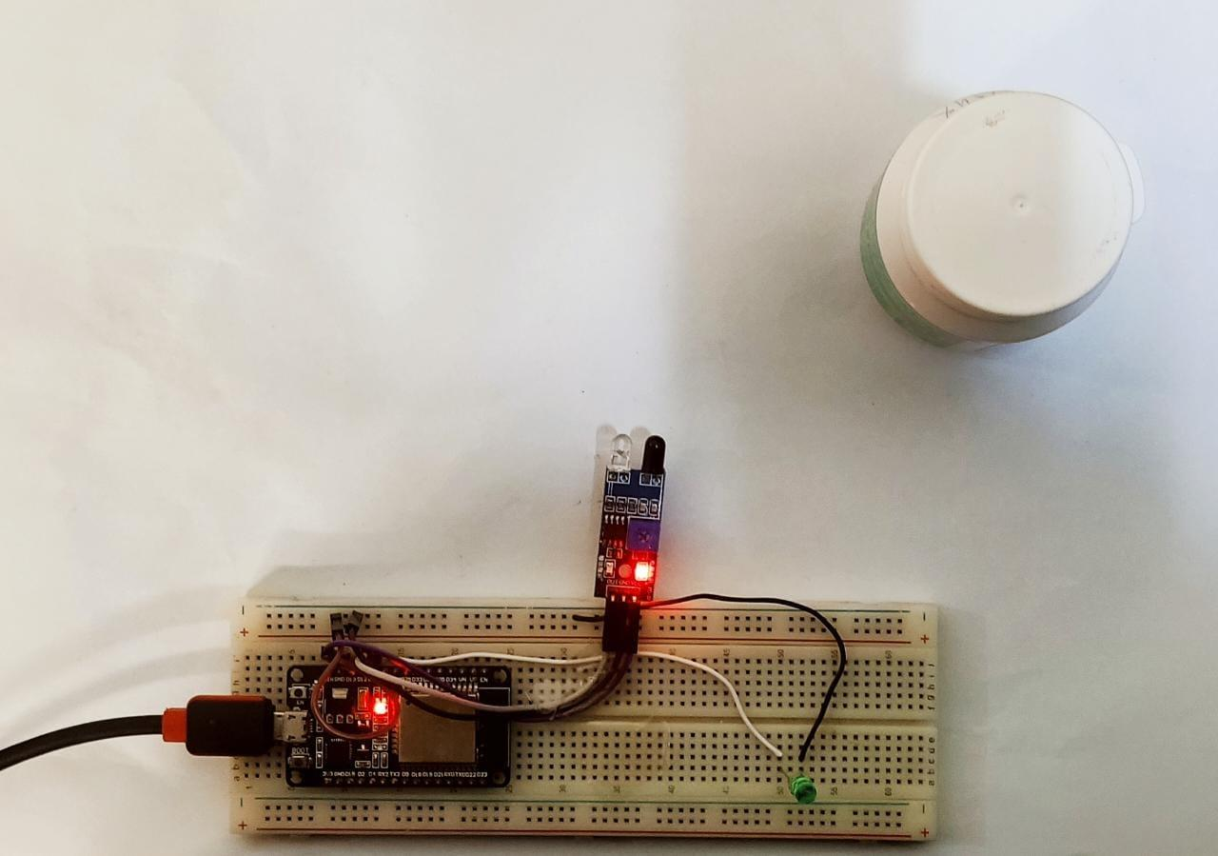

Now as the object is in front of the IR sensor, radiation gets reflected and received by the photodiode on the IR sensor, so the LED is turned **ON**. In this case a **LOW** signal will be generated by an IR sensor.

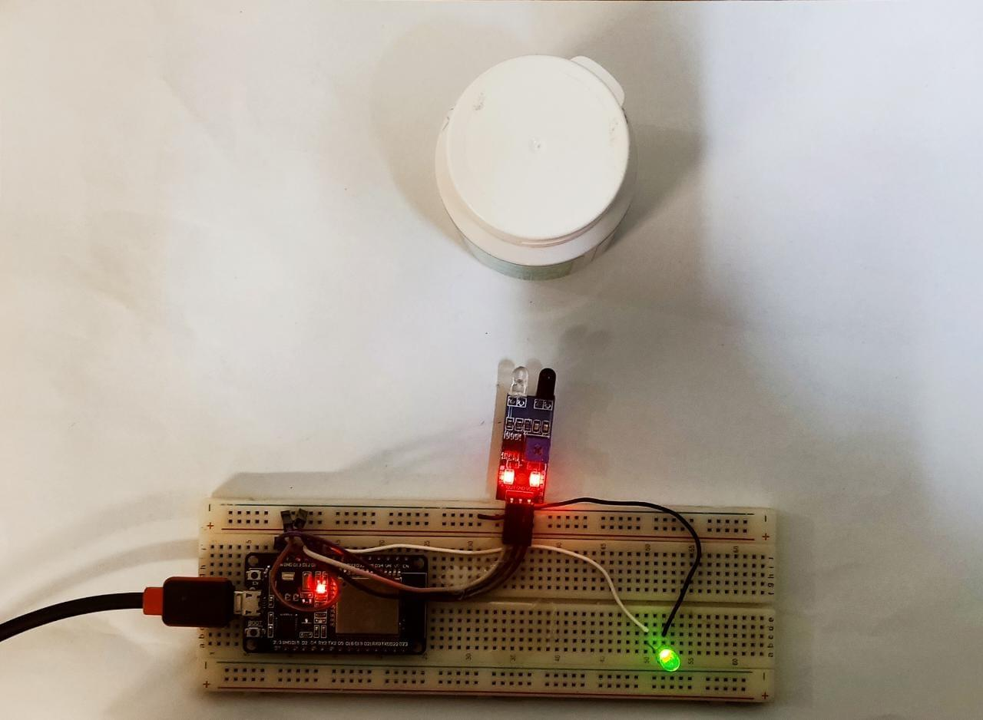

**UART based communication esp32 to another esp32**

**AIM:**

The aim of the project is to establish a simple data transfer mechanism between the two ESP32 microcontrollers using UART (Universal Asynchronous Receiver-Transmitter) communication.

**COMPONENTS:**

* Two ESP32 Development Boards.
* USB Cable
* Breadboard
* Jumper Wires
* Power Supply
* One 220 ohm resistor

## ESP32 UART Pins

ESP32 provides three universal asynchronous receivers and transmitter (UART) ports such as UART0, UART1, and UART2 that work at 3.3V TTL level. These three serial interfaces are hardware supported. Each of them exposes 4 pins: RX, TX, RTS and CTS.The table below specifies the RX and TX pins for each of the three UART ports available in ESP32.

| **UART Port** | **Rx** | **Tx** | **Useable** |
| --- | --- | --- | --- |
| UART0 | GPIO3 | GPIO1 | Yes |
| UART1 | GPIO9 | GPIO10 | Yes but requires the reassignment of pins |
| UART2 | GPIO16 | GPIO17 | Yes |

**CONNECTIONS:**

| **Master ESP32** | **Slave ESP32** |
| --- | --- |
| TX2 | RX2 |
| RX2 | TX2 |
| Digital Pin (e.g., 15) | Anode of LED (with 220-ohm resistor) |
| Ground | Ground |

**CIRCUIT DIAGRAM:**

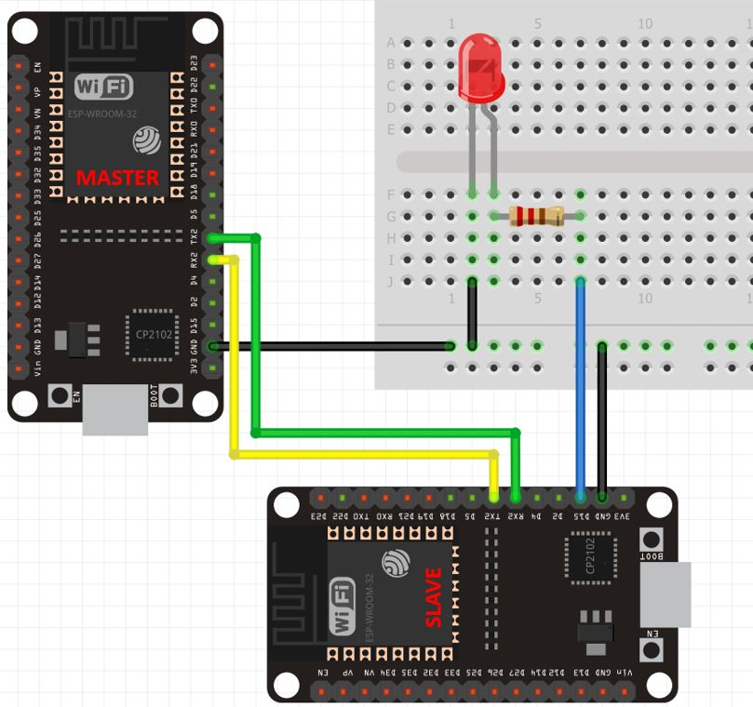

**CODE:**

ESP32 Board 1 (Transmitter):

#include <stdio.h>

#include "freertos/FreeRTOS.h"

#include "freertos/task.h"

#include "driver/uart.h"

#include "driver/gpio.h"

#include <string.h>

#define TXD_PIN (GPIO_NUM_17)  // UART TX pin

#define BAUD_RATE 115200       // UART baud rate

void uart_transmitter_task(void *pvParameters) {

    uart_config_t uart_config = {

        .baud_rate = BAUD_RATE,

        .data_bits = UART_DATA_8_BITS,

        .parity    = UART_PARITY_DISABLE,

        .stop_bits = UART_STOP_BITS_1,

        .flow_ctrl = UART_HW_FLOWCTRL_DISABLE

    };

    uart_param_config(UART_NUM_0, &uart_config);

    uart_set_pin(UART_NUM_0, TXD_PIN, UART_PIN_NO_CHANGE, UART_PIN_NO_CHANGE, UART_PIN_NO_CHANGE);

    uart_driver_install(UART_NUM_0, 256, 0, 0, NULL, 0);

    while (1) {

        const char* message = "Hello from ESP32 Board 1!\n";

        uart_write_bytes(UART_NUM_0, message, strlen(message));

        vTaskDelay(2000 / portTICK_PERIOD_MS);

    }

}

void app_main() {

    xTaskCreate(uart_transmitter_task, "uart_transmitter_task", 2048, NULL, 5, NULL);

}

ESP32 Board 2 (Receiver):

#include <stdio.h>

#include "freertos/FreeRTOS.h"

#include "freertos/task.h"

#include "driver/uart.h"

#include "driver/gpio.h"

#define RXD_PIN (GPIO_NUM_16)  // UART RX pin

#define BAUD_RATE 115200       // UART baud rate

void uart_receiver_task(void *pvParameters) {

    uart_config_t uart_config = {

        .baud_rate = BAUD_RATE,

        .data_bits = UART_DATA_8_BITS,

        .parity    = UART_PARITY_DISABLE,

        .stop_bits = UART_STOP_BITS_1,

        .flow_ctrl = UART_HW_FLOWCTRL_DISABLE

    };

    uart_param_config(UART_NUM_1, &uart_config);

    uart_set_pin(UART_NUM_1, UART_PIN_NO_CHANGE, RXD_PIN, UART_PIN_NO_CHANGE, UART_PIN_NO_CHANGE);

    uart_driver_install(UART_NUM_1, 256, 0, 0, NULL, 0);

    uint8_t data;

    while (1) {

        int len = uart_read_bytes(UART_NUM_1, &data, 1, portMAX_DELAY);

        if (len > 0) {

            printf("Received data: %c\n", data);

        }

    }

}

void app_main() {

    xTaskCreate(uart_receiver_task, "uart_receiver_task", 2048, NULL, 5, NULL);

}

->Build the code ,flash and monitor it after connecting the esp32 board through the USB

->After the code is successfully flashed, The LED will turn ON and stay ON for 5 seconds before turning OFF for 5 seconds. This continues as the master keeps on sending 1/0 to the slave**.**

**OUTPUT :**

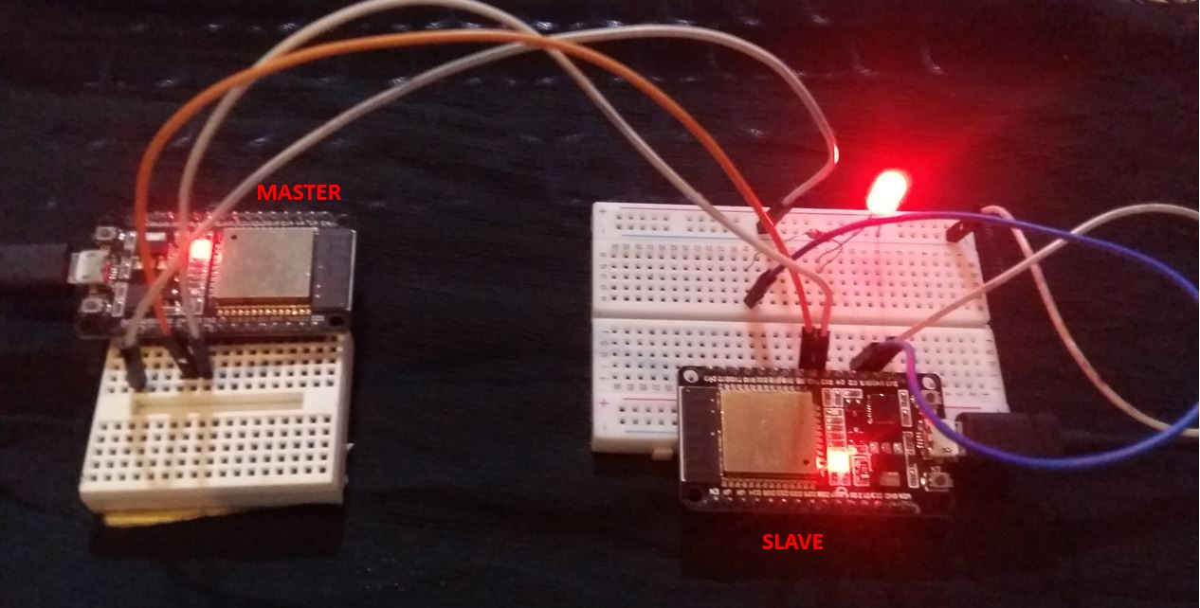

# **Interface Seven Segment Display with ESP32**

**AIM:**

The aim of the 7-segment display interface project is to showcase the ESP32's capability to control a 7-segment display by displaying numbers using individual segments controlled by GPIO pins.

**COMPONENTS:**

* An ESP32 microcontroller
* A seven-segment display
* A breadboard
* Jumper wires

## **THEORY**

## **Introduction to Seven Segment:**

A seven-segment can display numerical information using a microcontroller program. It consists of seven individual segments, each of which can be lit up or turned off independently to create various numerical characters. When using an ESP32 microcontroller to control a seven-segment display, the ESP32 sends signals to the specific pins on the seven-segment display, telling it which segments to turn on or off in order to display a specific numerical character. Each segment is labeled as a, b, c, d, e, f and g. The common pin is typically used to control all the segments at once. T

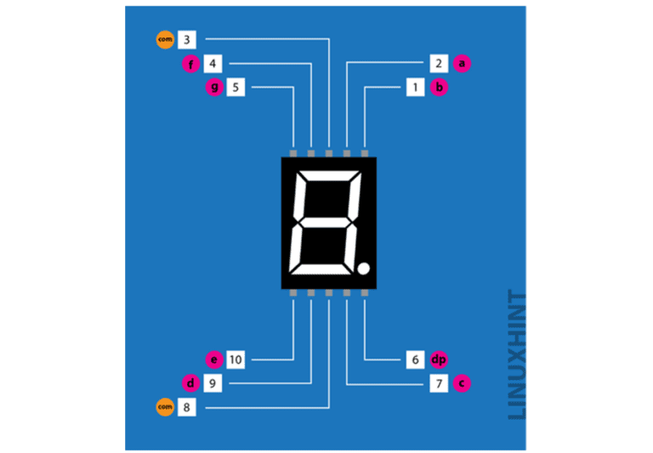****

## **Seven Segment Pinout**

The seven-segment display typically has **10** pins, with one pin for each segment, one for the decimal and two common pins.

**CONNECTIONS:**

|  |  |  |  |
| --- | --- | --- | --- |
| **Pin Number** | **Pin Name** | **Description** | **ESP32 Pin** |
| **1** | b | Top Right LED Pin | D2 |
| **2** | a | Topmost LED Pin | D15 |
| **3** | VCC/GND | GND/VCC Depends on Configuration – Common Cathode/Anode | GND/VCC |
| **4** | f | Top Left LED Pin | D19 |
| **5** | g | Middle LED Pin | D21 |
| **6** | dp | Dot LED Pin | Dot LED Pin |
| **7** | c | Bottom Right LED Pin | D4 |
| **8** | VCC/GND | GND/VCC Depends on Configuration – Common Cathode/Anode | GND/VCC |
| **9** | d | Bottom LED Pin | D5 |
| **10** | e | Bottom Left LED Pin | D18 |

**CIRCUIT DIAGRAM:**

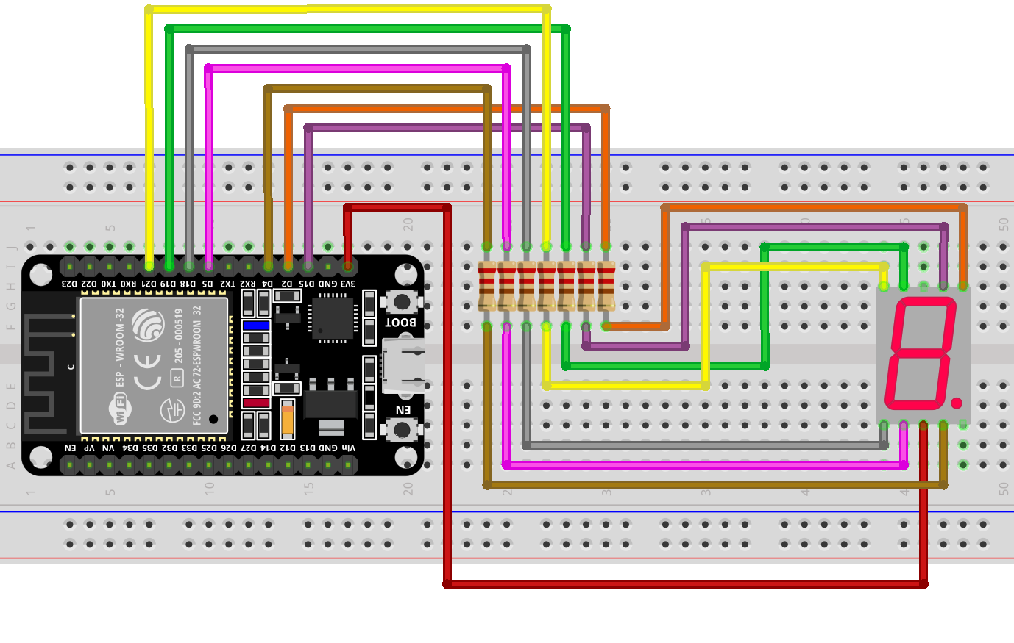

**CODE:**

#include <stdio.h>

#include <stdbool.h>

#include "freertos/FreeRTOS.h"

#include "freertos/task.h"

#include "driver/gpio.h"

#define SEG_A_PIN GPIO_NUM_15

#define SEG_B_PIN GPIO_NUM_2

#define SEG_C_PIN GPIO_NUM_4

#define SEG_D_PIN GPIO_NUM_5

#define SEG_E_PIN GPIO_NUM_18

#define SEG_F_PIN GPIO_NUM_19

#define SEG_G_PIN GPIO_NUM_21

#define SEG_DP_PIN GPIO_NUM_6

// Define the pins of the 7-segment display

const gpio_num_t segmentPins[] = {

    SEG_A_PIN, SEG_B_PIN, SEG_C_PIN, SEG_D_PIN,

    SEG_E_PIN, SEG_F_PIN, SEG_G_PIN, SEG_DP_PIN

};

// Define the mapping of each digit on the display

const uint8_t digitMapping[] = {

    0x3F, 0x06, 0x5B, 0x4F, 0x66,

    0x6D, 0x7D, 0x07, 0x7F, 0x6F

};

// Function to set the segments for a given digit

void setSegments(uint8_t segments) {

    for (int i = 0; i < 8; i++) {

        gpio_set_level(segmentPins[i], (segments >> i) & 1);

    }

}

// Function to display a digit on the 7-segment display

void displayDigit(uint8_t digit) {

    if (digit < sizeof(digitMapping)) {

        setSegments(digitMapping[digit]);

    }

}

// Task to continuously display digits from 0 to 9

void displayTask(void *pvParameters) {

    uint8_t digit = 0;

    while (true) {

        displayDigit(digit);

        digit = (digit + 1) % 10;

        vTaskDelay(pdMS_TO_TICKS(1000));

    }

}

void app_main(void) {

    // Configure the segment pins as outputs

    for (int i = 0; i < 8; i++) {

        gpio_set_direction(segmentPins[i], GPIO_MODE_OUTPUT);

    }

    // Create a task to display the digits

    xTaskCreate(&displayTask, "display_task", configMINIMAL_STACK_SIZE, NULL, 5, NULL);

}

->Build the code ,flash and monitor it after connecting the esp32 board through the USB

->After the code is successfully flashed, the output would be a continuously cycling display of digits from 0 to 9 on the 7-segment display. Each digit will be displayed for a duration of 1 second before transitioning to the next digit.

**OUTPUT:**

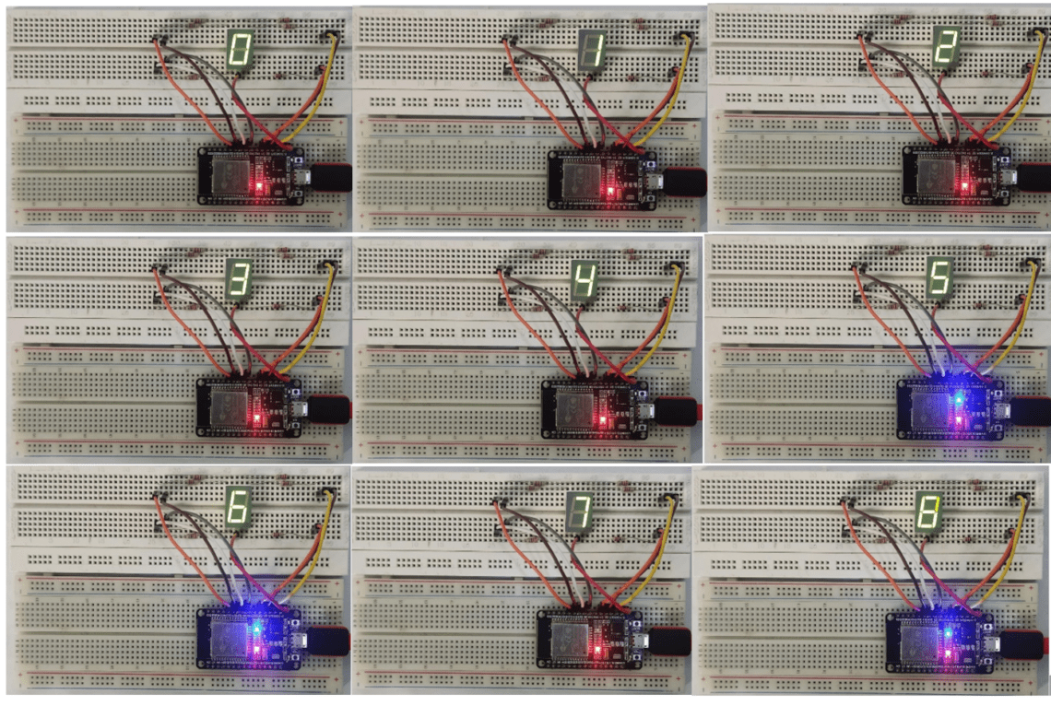

# **Interfacing 16X2 LCD Module with ESP32 with and without I2C**

**AIM:**

The aim of the project is to interface a 16x2 LCD display with an ESP32 microcontroller using ESP-IDF. The LCD display will be used to display text and provide a user interface for the ESP32-based system.

1. By connecting directly to LCD module with out using I2C module.
2. By connecting with the help of I2C adapter.

**COMPONENTS:**

* ESP32 board
* I2C adapter
* 16x2 LCD Display
* Connecting Wires
* Breadboard
* Power Supply

## **Method 1:** Interfacing 16X 2 LCD module with ESP 32 without using I2C adapter

In this method we are connecting the LCD module to ESP by using 12 connecting wires from 16 pins on the LCD Display. This method is relatively complex as it includes bunch of connecting wires which allocates more number of pins on ESP32

### **CIRCUIT DIAGRAM:**

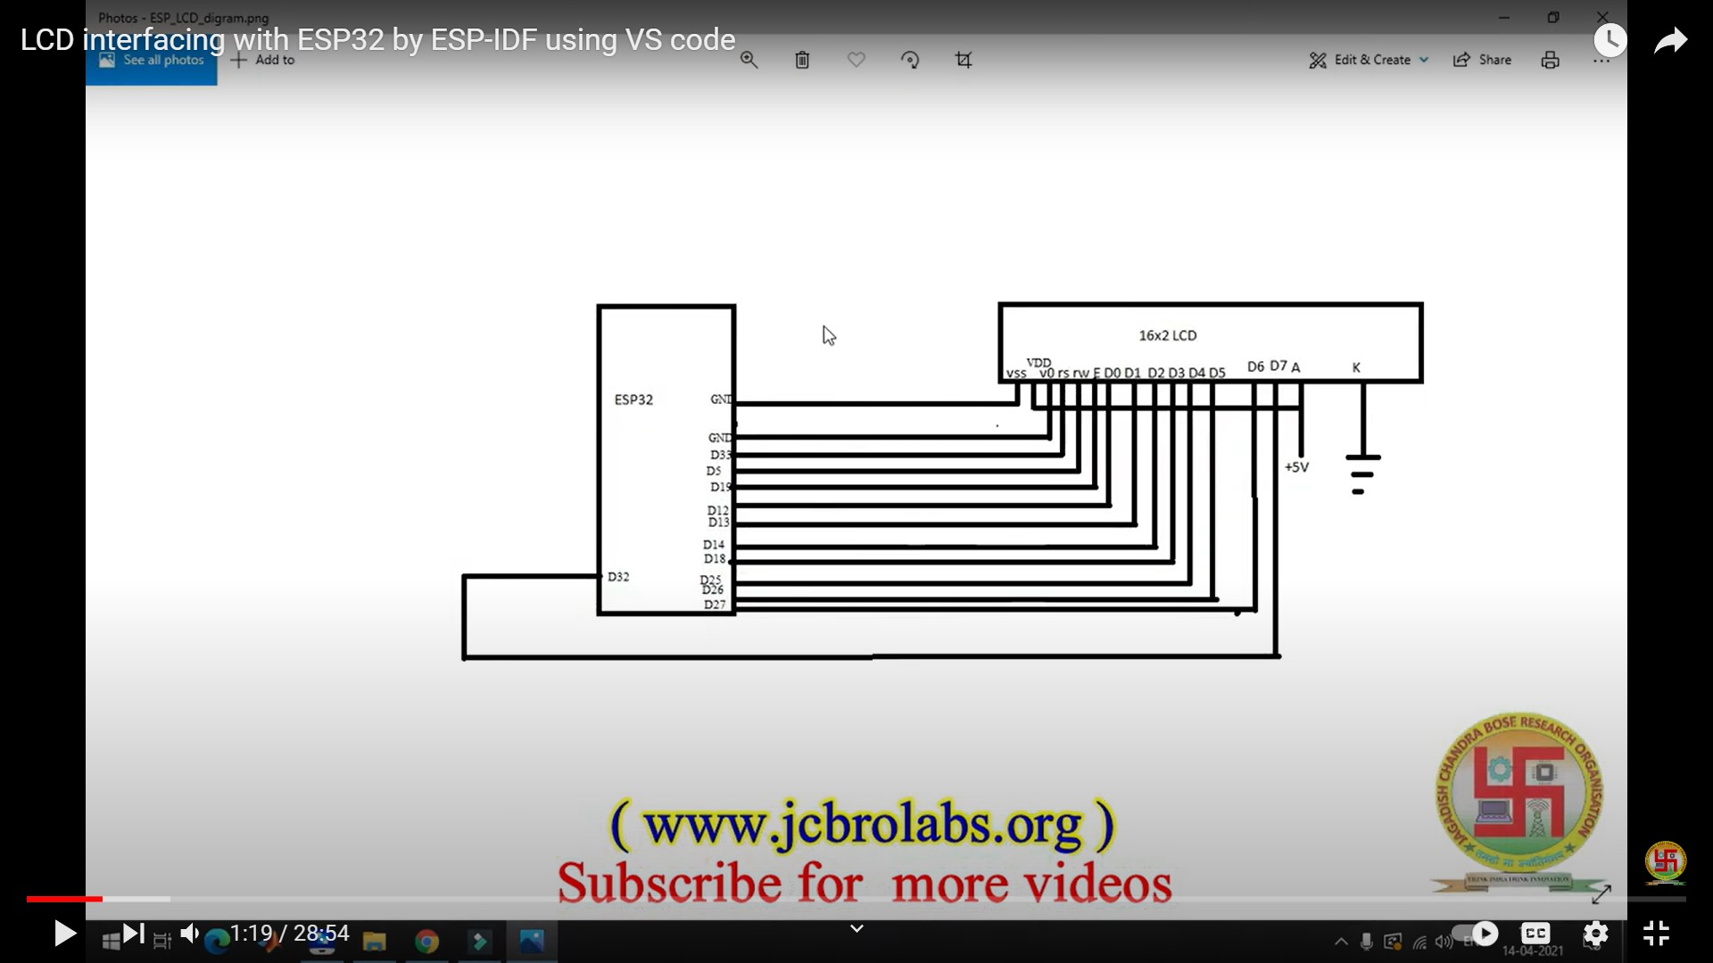

**CONNECTIONS:**

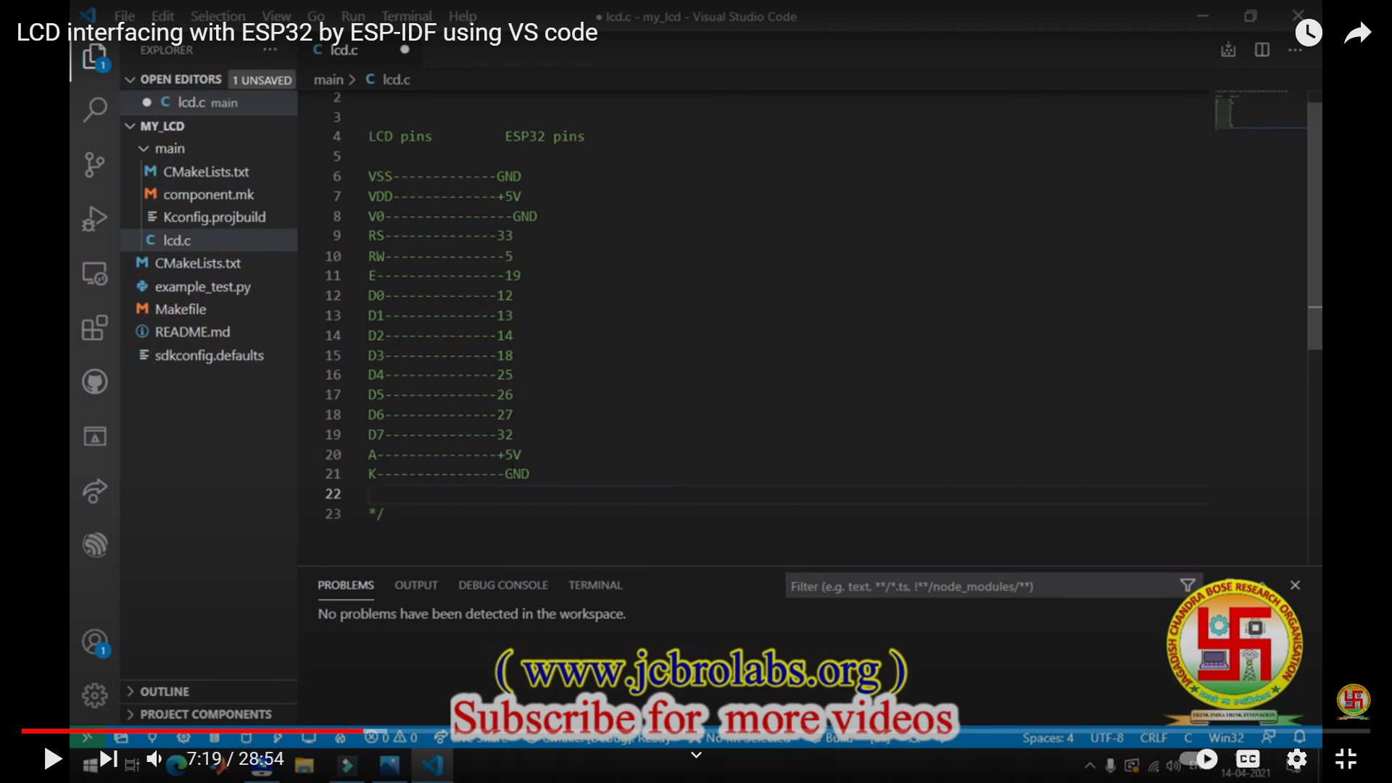

### **PROGRAM CODE:**

#include <stdio.h>

#include <freertos/FreeRTOS.h>

#include <freertos/task.h>

#include "driver/gpio.h"

#include "sdkconfig.h"

#include <math.h>

#include <string.h>

void lcd_init();

void lcd_cmd(unsigned char);

void lcd_data(unsigned char);

void lcd_decode(unsigned char);

void lcd_string(unsigned char*);

int lcd_pins[11] = {12, 13, 14, 18, 25, 26, 27, 32, 33, 5, 19};

unsigned char msg[] = "Hello World!";

void app_main(void)

{

    printf("code is going to in while loop\n");

    while (1)

    {

        printf("code is running\n");

        lcd_init();

    }

}

void lcd_init()

{

    for (int i = 0; i < 11; i++)

    {

        gpio_set_direction(lcd_pins[i], GPIO_MODE_OUTPUT);

    }

lcd_cmd(0x38);

    lcd_cmd(0x01);

    lcd_cmd(0x0E);

    lcd_cmd(0x80);

    lcd_string(msg);

}

void lcd_decode(unsigned char info)

{

    unsigned char temp;

    for (int i = 0; i < 8; i++)

    {

        temp = pow(2, i);

        gpio_set_level(lcd_pins[i], (info & temp));

    }

}

void lcd_cmd(unsigned char cmd)

{

    lcd_decode(cmd);

    gpio_set_level(lcd_pins[8], 0);

    gpio_set_level(lcd_pins[9], 0);

    gpio_set_level(lcd_pins[10], 1);

    vTaskDelay(10 / portTICK_PERIOD_MS);

    gpio_set_level(lcd_pins[10], 0);

    vTaskDelay(10 / portTICK_PERIOD_MS);

}

void lcd_data(unsigned char data)

{

    lcd_decode(data);

    gpio_set_level(lcd_pins[8], 1);

    gpio_set_level(lcd_pins[9], 0);

    gpio_set_level(lcd_pins[10], 1);

    vTaskDelay(10 / portTICK_PERIOD_MS);

    gpio_set_level(lcd_pins[10], 0);

    vTaskDelay(10 / portTICK_PERIOD_MS);

}

void lcd_string(unsigned char *p)

{

    while (*p != '\0')

    {

        lcd_data(*p);

        p = p + 1;

    }

}

->Build the code ,flash and monitor it after connecting the esp32 board through the USB

->After the code is successfully flashed ,program will start, you will see the message "code is started" printed in the console.

* The program will continuously execute the following steps in an infinite loop:
* Print the message "printing message on LCD" in the console.
* Initialize the LCD display by executing the lcd_init() function.
* The LCD will be cleared (lcd_cmd(0x01)), and the cursor will be set to the beginning of the first line (lcd_cmd(0x80)).
* The message "Hello World!" will be displayed on the LCD.
* The output will be displayed on the connected 16x2 LCD display, showing the message "Hello World!".

**Output:**

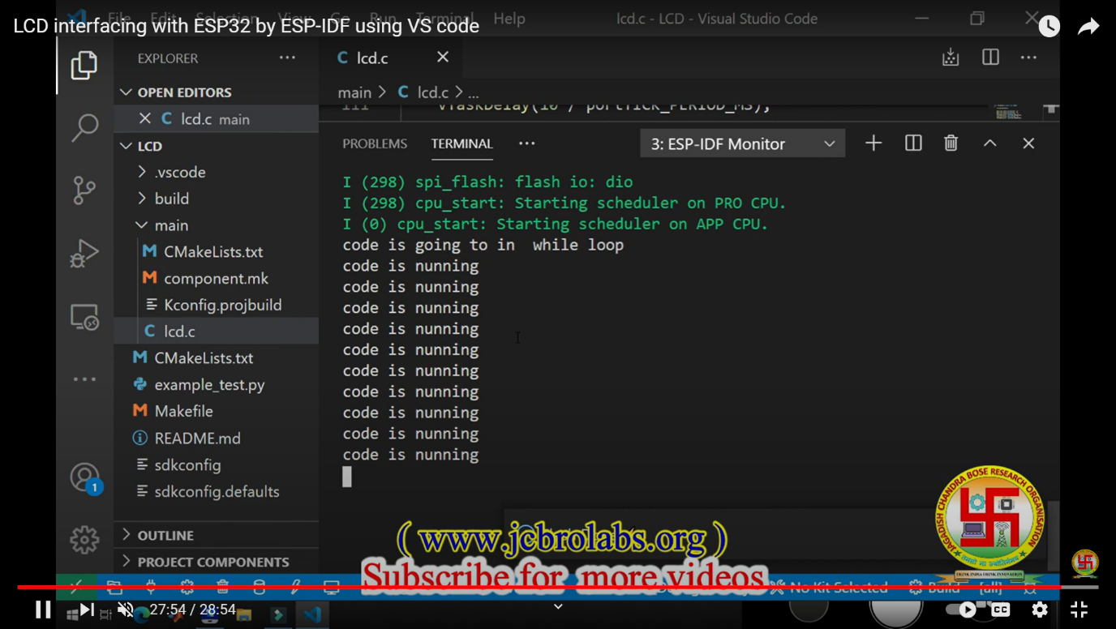

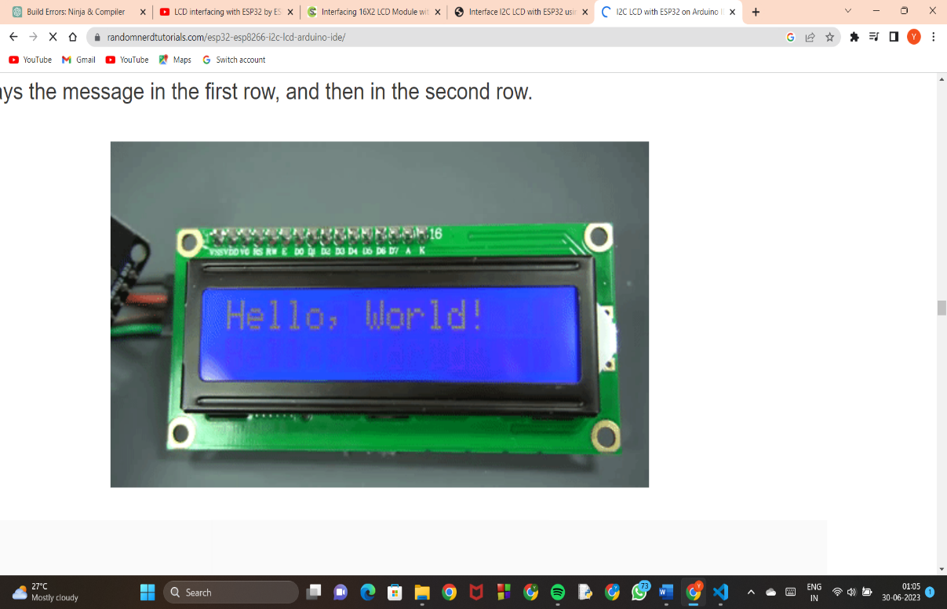 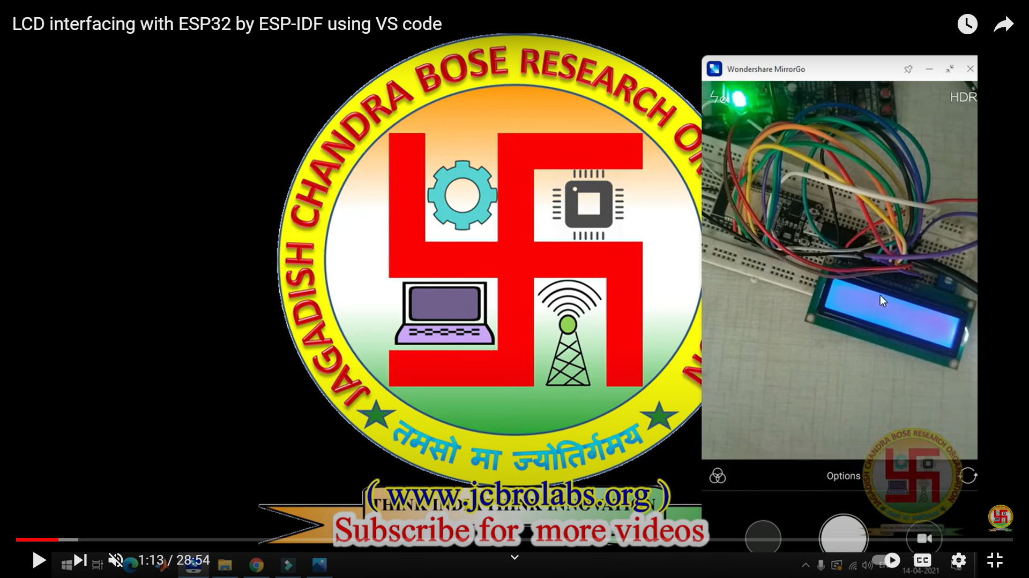



## **Method 2:** Interfacing 16X2 LCD module with ESP 32 using I2C adapter

In this method we are using an [I2C adapter](https://www.circuitschools.com/connect-lcd-display-to-arduino-with-only-two-pins-i2c-adapter/) which is connected to LCD display with 16 pins and outputs only 4 pins, 2 for data and another 2 for power and ground. The **I2C adapter has inbuilt potentiometer** where we can adjust the contrast of the display and also has a jumper to turn on/off the LCD backlight.

In ESP32, the default I2C pin for SDA is GPIO21 and for SCL is GPIO22.

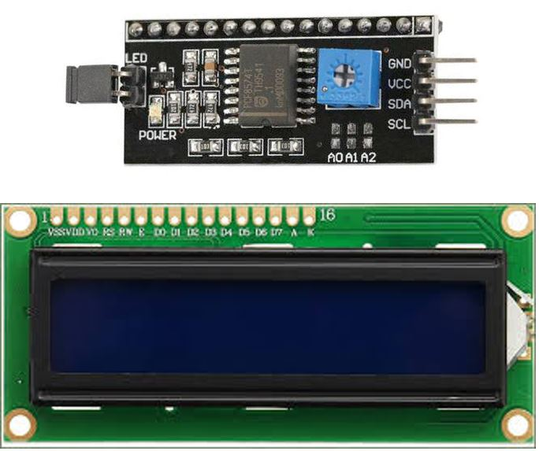

**CONNECTIONS:**

| **I2C LCD** | **ESP32** |
| --- | --- |
| GND | GND |
| VCC | VIN |
| SDA | GPIO21(I2C SDA) |
| SCL | GPIO22 (I2C SCL) |

**CIRCUIT DIAGRAM:**

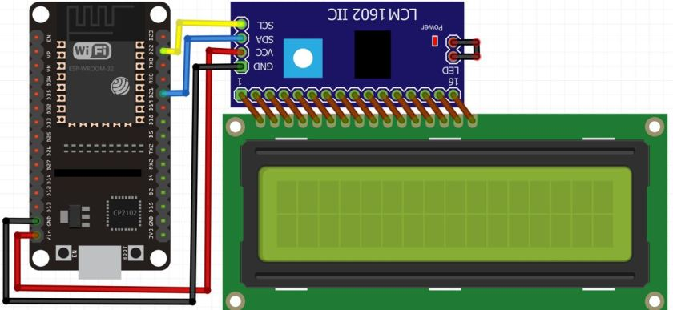

Open your VS Code and create a new ESP-IDF project. Now head over to the main.c file.

**CODE:**

#include <driver/i2c.h>

#include <freertos/FreeRTOS.h>

#include <freertos/task.h>

#include <stdio.h>

#include "sdkconfig.h"

#include "HD44780.h"

#define LCD_ADDR 0x27

#define SDA_PIN 21

#define SCL_PIN 22

#define LCD_COLS 16

#define LCD_ROWS 2

void LCD_DemoTask(void* param)

{

char num[20];

while (true) {

LCD_home();

LCD_clearScreen();

LCD_writeStr("16x2 I2C LCD");

vTaskDelay(3000 / portTICK_RATE_MS);

LCD_clearScreen();

LCD_writeStr("Lets Count 0-10!");

vTaskDelay(3000 / portTICK_RATE_MS);

LCD_clearScreen();

for (int i = 0; i &lt;= 10; i++) {

LCD_setCursor(8, 2);

sprintf(num, "%d", i);

LCD_writeStr(num);

vTaskDelay(1000 / portTICK_RATE_MS);

}

}

}

void app_main(void)

{

LCD_init(LCD_ADDR, SDA_PIN, SCL_PIN, LCD_COLS, LCD_ROWS);

xTaskCreate(&amp;LCD_DemoTask, "Demo Task", 2048, NULL, 5, NULL); }

**CODE EXPLANATION:**

* The code begins by including the necessary libraries for I2C communication, FreeRTOS tasks, standard input/output, and the HD44780 library.
* Several macros are defined to configure the LCD display's I2C address, SDA and SCL pin numbers, and the number of columns and rows on the LCD.
* The code defines a task function called LCD_DemoTask which will be executed in a separate FreeRTOS task. This task demonstrates some basic operations on the LCD.
* Within the LCD_DemoTask function, the LCD is initialized by calling LCD_init with the specified I2C address, SDA and SCL pin numbers, and the number of columns and rows.
* The task enters an infinite loop where it performs the following actions:
* Clears the LCD screen (LCD_clearScreen).
* Writes the string "16x2 I2C LCD" on the first line of the LCD (LCD_writeStr).
* Delays for 3 seconds using the FreeRTOS vTaskDelay function.
* Clears the LCD screen again.
* Writes the string "Lets Count 0-10!" on the first line of the LCD.
* Enters a loop to count from 0 to 10:
* Sets the cursor position to the eighth column of the second row (LCD_setCursor).
* Converts the current count value to a string using sprintf.
* Writes the count string on the LCD (LCD_writeStr).
* Delays for 1 second.
* The loop repeats until the program is terminated.
* In the app_main function, the LCD initialization function (LCD_init) is called to set up the LCD with the specified parameters.
* A FreeRTOS task is created (xTaskCreate) to run the LCD_DemoTask function. The task is given a name, stack size, and priority.

->Build the code ,flash and monitor it after connecting the esp32 board through the USB

->After the code is successfully flashed , the I2C LCD will start displaying the messages

**OUTPUT:**

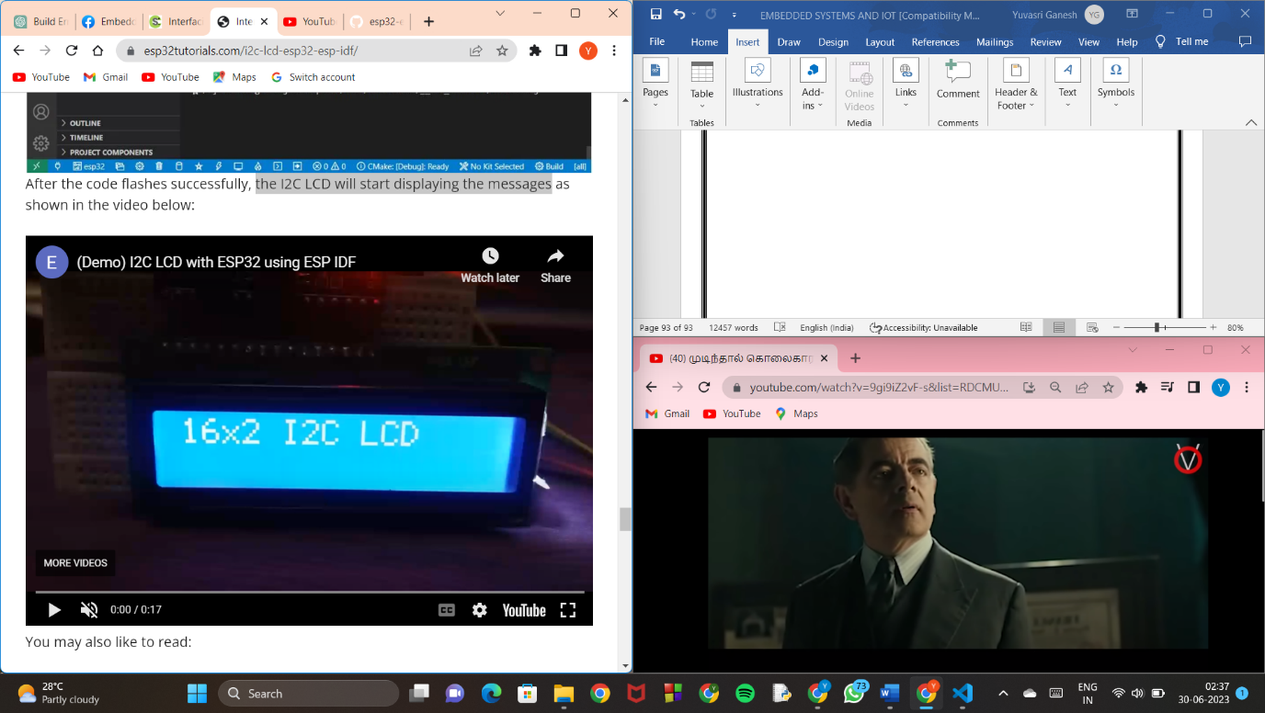

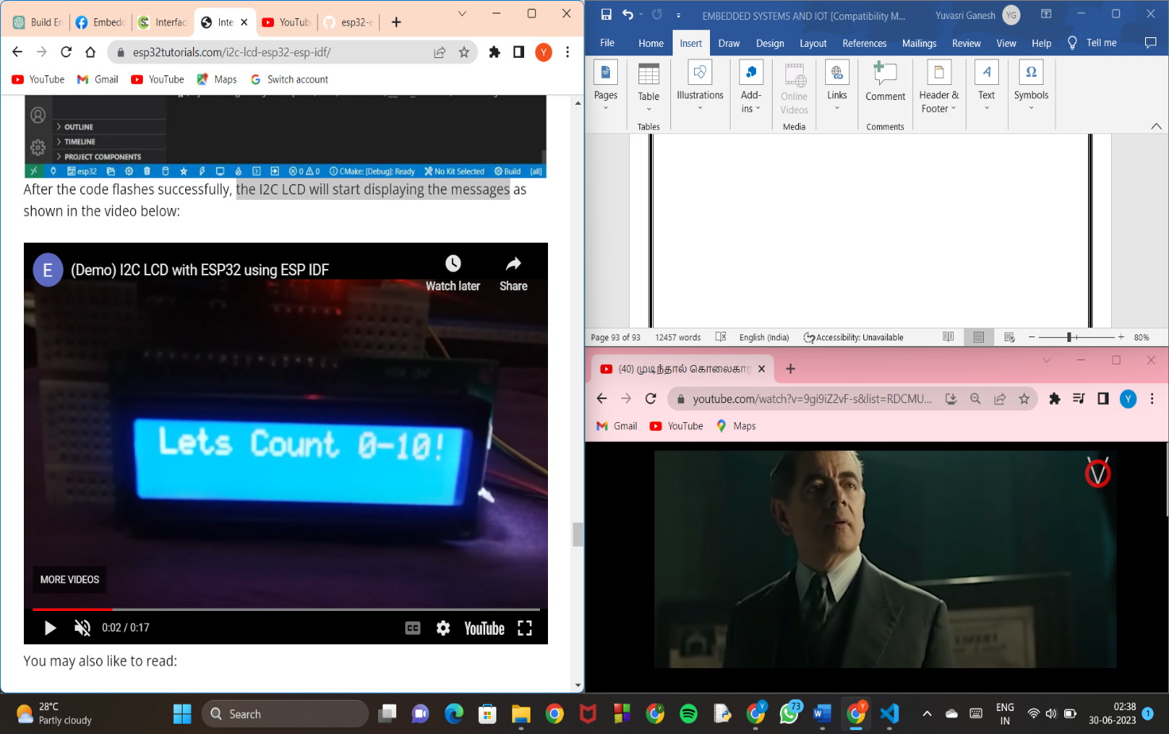

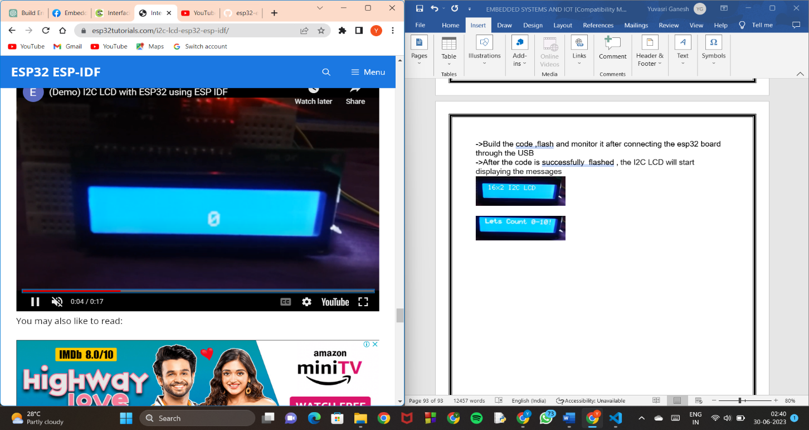

TO

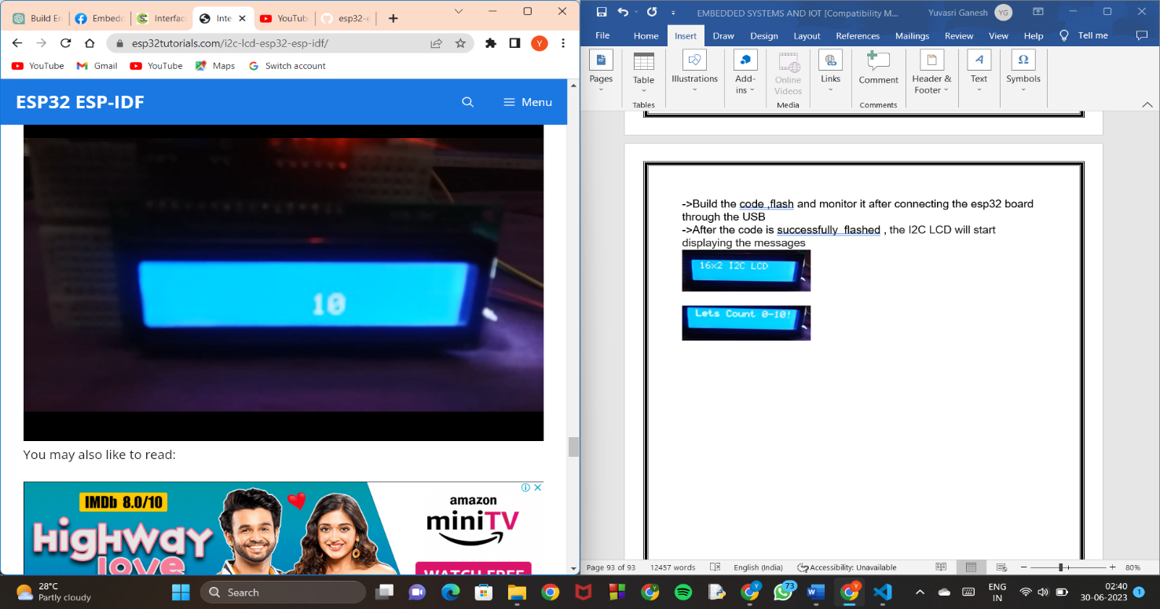

**Numerical Keyboard Interface with ESP32**

**AIM:**

The aim of this project is to interface a numerical keyboard with an ESP32 microcontroller and read the key presses. The project enables the ESP32 to detect and respond to user input from the numerical keyboard.

**COMPONENTS:**

1. ESP32 Development Board
2. Numerical Keypad (4x4 matrix)

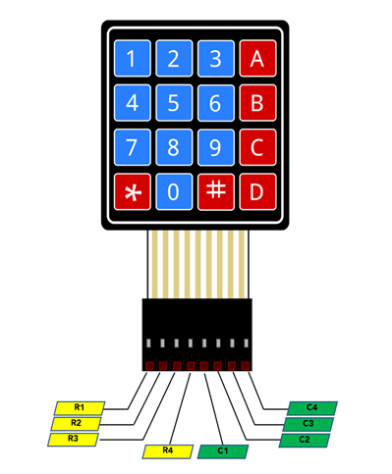

A 4×4 keypad is a type of input device that consists of 16 buttons arranged in a 4×4 grid. These buttons can be used to input numerical or alphanumeric data

1. Jumper wires for connections
2. Breadboard

**CIRCUIT DIAGRAM:**

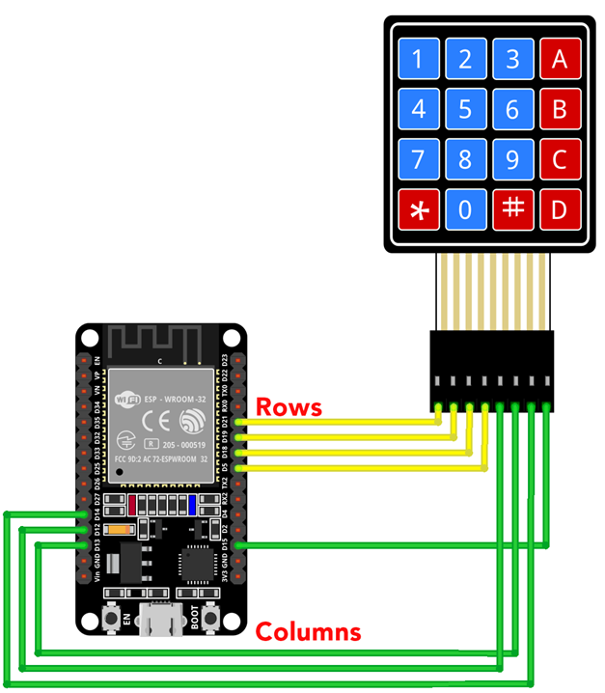

**CONNECTIONS:**

|  |  |
| --- | --- |
| Row 1 | D21 |
| Row 2 | D19 |
| Row 3 | D18 |
| Row 4 | D5 |
| Column 1 | D12 |
| Column 2 | D13 |
| Column 3 | D14 |
| Column 4 | D15 |

Open your VS Code and create a new ESP-IDF project. Now head over to the main.c file.

**CODE:**

#include <stdio.h>

#include <freertos/FreeRTOS.h>

#include <freertos/task.h>

#include "driver/gpio.h"

#include "sdkconfig.h"

#define ROW1_PIN GPIO_NUM_21

#define ROW2_PIN GPIO_NUM_19

#define ROW3_PIN GPIO_NUM_18

#define ROW4_PIN GPIO_NUM_5

#define COL1_PIN GPIO_NUM_12

#define COL2_PIN GPIO_NUM_13

#define COL3_PIN GPIO_NUM_14

#define COL4_PIN GPIO_NUM_15

void keypad_init();

int keypad_scan();

void app_main(void)

{

    keypad_init();

    while (1)

    {

        int key = keypad_scan();

        if (key != -1)

        {

            printf("Key Pressed: %d\n", key);

        }

        vTaskDelay(100 / portTICK_PERIOD_MS);

    }

}

void keypad_init()

{

    gpio_set_direction(ROW1_PIN, GPIO_MODE_OUTPUT);

    gpio_set_direction(ROW2_PIN, GPIO_MODE_OUTPUT);

    gpio_set_direction(ROW3_PIN, GPIO_MODE_OUTPUT);

    gpio_set_direction(ROW4_PIN, GPIO_MODE_OUTPUT);

    gpio_set_direction(COL1_PIN, GPIO_MODE_INPUT);

    gpio_set_direction(COL2_PIN, GPIO_MODE_INPUT);

    gpio_set_direction(COL3_PIN, GPIO_MODE_INPUT);

    gpio_set_direction(COL4_PIN, GPIO_MODE_INPUT);

    gpio_set_pull_mode(COL1_PIN, GPIO_PULLUP_ONLY);

    gpio_set_pull_mode(COL2_PIN, GPIO_PULLUP_ONLY);

    gpio_set_pull_mode(COL3_PIN, GPIO_PULLUP_ONLY);

    gpio_set_pull_mode(COL4_PIN, GPIO_PULLUP_ONLY);

}

int keypad_scan()

{

    int key = -1;

    // Set Row 1 Low and check columns

    gpio_set_level(ROW1_PIN, 0);

    if (gpio_get_level(COL1_PIN) == 0)

        key = 1;

    else if (gpio_get_level(COL2_PIN) == 0)

        key = 2;

    else if (gpio_get_level(COL3_PIN) == 0)

        key = 3;

    else if (gpio_get_level(COL4_PIN) == 0)

        key = 4;

    gpio_set_level(ROW1_PIN, 1);

    // Set Row 2 Low and check columns

    gpio_set_level(ROW2_PIN, 0);

    if (gpio_get_level(COL1_PIN) == 0)

        key = 5;

    else if (gpio_get_level(COL2_PIN) == 0)

        key = 6;

    else if (gpio_get_level(COL3_PIN) == 0)

        key = 7;

    else if (gpio_get_level(COL4_PIN) == 0)

        key = 8;

    gpio_set_level(ROW2_PIN, 1);

    // Set Row 3 Low and check columns

    gpio_set_level(ROW3_PIN, 0);

    if (gpio_get_level(COL1_PIN) == 0)

        key = 9;

    else if (gpio_get_level(COL2_PIN) == 0)

        key = 10;

    else if (gpio_get_level(COL3_PIN) == 0)

        key = 11;

    else if (gpio_get_level(COL4_PIN) == 0)

        key = 12;

    gpio_set_level(ROW3_PIN, 1);

    // Set Row 4 Low and check columns

    gpio_set_level(ROW4_PIN, 0);

    if (gpio_get_level(COL1_PIN) == 0)

        key = 13;

    else if (gpio_get_level(COL2_PIN) == 0)

        key = 14;

    else if (gpio_get_level(COL3_PIN) == 0)

        key = 15;

    else if (gpio_get_level(COL4_PIN) == 0)

        key = 16;

    gpio_set_level(ROW4_PIN, 1);

    return key;

}

->Build the code ,flash and monitor it after connecting the esp32 board through the USB

->After the code is successfully flashed , Whenever a key is pressed on the numerical keypad, the code will detect the key and print the corresponding value to the console.

For example, if you press the key '1' and then on the keypad, the output will be:

**Key Pressed: 1**

**Key Pressed: 5**

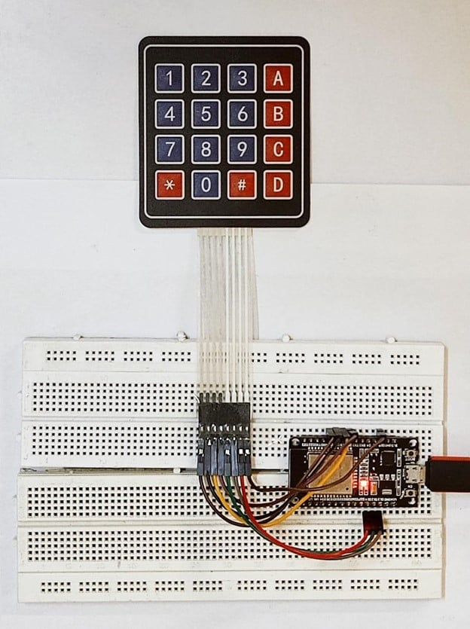

# **ESP32 ESP-IDF Connect with**

# **WiFi – Station Mode**

**AIM:**

The project aims to interface an ESP32 with Wi-Fi and control an LED. It involves programming the ESP32 using the ESP-IDF framework in VS Code, without Arduino or PlatformIO. The LED indicates the Wi-Fi connection status. The project provides hands-on experience with ESP32, Wi-Fi connectivity, and ESP-IDF development**.**

**COMPONENTS:**

1. ESP32 development board or module
2. LED
3. Resistor (220 ohms or higher)
4. Breadboard
5. Jumper wires

**CIRCUIT DIAGRAM:**

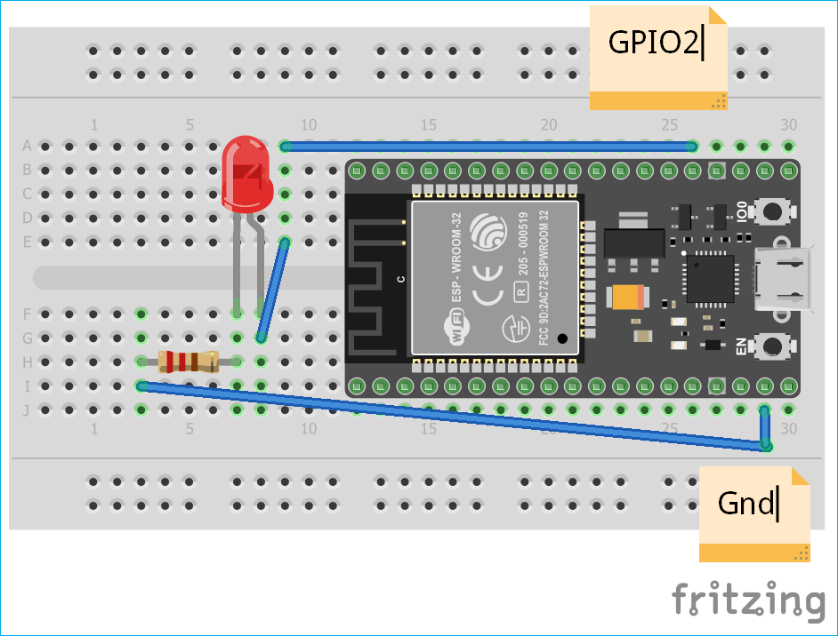



**CONNECTIONS:**

|  |  |
| --- | --- |
| **Component** | **ESP32 Pin** |
| LED Anode (+) | GPIO 21 |
| LED Cathode (-) | Resistor |
| Resistor | GND |

**CODE:**

#include <string.h>

#include "freertos/FreeRTOS.h"

#include "freertos/task.h"

#include "freertos/event_groups.h"

#include "esp_system.h"

#include "esp_wifi.h"

#include "esp_event.h"

#include "esp_log.h"

#include "nvs_flash.h"

#include "esp_http_server.h"

#include "driver/gpio.h"

#define EXAMPLE_ESP_WIFI_SSID      CONFIG_ESP_WIFI_SSID

#define EXAMPLE_ESP_WIFI_PASS      CONFIG_ESP_WIFI_PASSWORD

#define EXAMPLE_ESP_MAXIMUM_RETRY  CONFIG_ESP_MAXIMUM_RETRY

static EventGroupHandle_t s_wifi_event_group;

#define WIFI_CONNECTED_BIT BIT0

#define WIFI_FAIL_BIT      BIT1

static const char *TAG = "wifi station";

static int s_retry_num = 0;

static bool led_state = false;

#define LED_GPIO_PIN 21

#define URI_ROOT "/"

#define URI_LED_CONTROL "/led"

#define URI_LED_STATUS "/led/status"

static esp_err_t root_get_handler(httpd_req_t *req)

{

    const char *html_response =

        "<html>"

        "<head><title>ESP32 LED Control</title></head>"

        "<body>"

        "<h1>ESP32 WiFi LED Control</h1>"

        "<p>LED Status: <span id=\"led-status\">%s</span></p>"

        "<p><a href=\"/led?state=on\"><button style=\"background-color: green;\">Turn On</button></a></p>"

        "<p><a href=\"/led?state=off\"><button style=\"background-color: red;\">Turn Off</button></a></p>"

        "<script>"

        "   fetch('/led/status')"

        "       .then(response => response.text())"

        "       .then(status => document.getElementById('led-status').innerText = status);"

        "</script>"

        "</body>"

        "</html>";

    char led_status[16];

    snprintf(led_status, sizeof(led_status), "%s", led_state ? "ON" : "OFF");

    char formatted_html_response[512];

    snprintf(formatted_html_response, sizeof(formatted_html_response), html_response, led_status);

    httpd_resp_send(req, formatted_html_response, strlen(formatted_html_response));

    return ESP_OK;

}

static esp_err_t led_control_get_handler(httpd_req_t *req)

{

    char query[100];

    if (httpd_req_get_url_query_str(req, query, sizeof(query)) == ESP_OK)

    {

        char param[32];

        if (httpd_query_key_value(query, "state", param, sizeof(param)) == ESP_OK)

        {

            if (strcmp(param, "on") == 0)

            {

                gpio_set_level(LED_GPIO_PIN, 1);  // Turn on LED

                led_state = true;

            }

            else if (strcmp(param, "off") == 0)

            {

                gpio_set_level(LED_GPIO_PIN, 0);  // Turn off LED

                led_state = false;

            }

        }

    }

    httpd_resp_set_status(req, "303 See Other");

    httpd_resp_set_hdr(req, "Location", URI_ROOT);

    httpd_resp_send(req, NULL, 0);

    return ESP_OK;

}

static esp_err_t led_status_get_handler(httpd_req_t *req)

{

    char led_status[16];

    snprintf(led_status, sizeof(led_status), "%s", led_state ? "ON" : "OFF");

    httpd_resp_send(req, led_status, strlen(led_status));

    return ESP_OK;

}

httpd_uri_t root = {

    .uri = URI_ROOT,

    .method = HTTP_GET,

    .handler = root_get_handler,

    .user_ctx = NULL

};

httpd_uri_t led_control = {

    .uri = URI_LED_CONTROL,

    .method = HTTP_GET,

    .handler = led_control_get_handler,

    .user_ctx = NULL

};

httpd_uri_t led_status = {

    .uri = URI_LED_STATUS,

    .method = HTTP_GET,

    .handler = led_status_get_handler,

    .user_ctx = NULL

};

static void register_http_handlers(httpd_handle_t server)

{

    httpd_register_uri_handler(server, &root);

    httpd_register_uri_handler(server, &led_control);

    httpd_register_uri_handler(server, &led_status);

}

static void event_handler(void *arg, esp_event_base_t event_base,

                          int32_t event_id, void *event_data)

{

    if (event_base == WIFI_EVENT && event_id == WIFI_EVENT_STA_START)

    {

        esp_wifi_connect();

    }

    else if (event_base == WIFI_EVENT && event_id == WIFI_EVENT_STA_DISCONNECTED)

    {

        if (s_retry_num < EXAMPLE_ESP_MAXIMUM_RETRY)

        {

            esp_wifi_connect();

            s_retry_num++;

            ESP_LOGI(TAG, "retry to connect to the AP");

        }

        else

        {

            xEventGroupSetBits(s_wifi_event_group, WIFI_FAIL_BIT);

        }

        ESP_LOGI(TAG, "connect to the AP fail");

    }

    else if (event_base == IP_EVENT && event_id == IP_EVENT_STA_GOT_IP)

    {

        ip_event_got_ip_t *event = (ip_event_got_ip_t *)event_data;

        ESP_LOGI(TAG, "got ip:" IPSTR, IP2STR(&event->ip_info.ip));

        s_retry_num = 0;

        xEventGroupSetBits(s_wifi_event_group, WIFI_CONNECTED_BIT);

    }

}

void wifi_init_sta(void)

{

    s_wifi_event_group = xEventGroupCreate();

    ESP_ERROR_CHECK(esp_netif_init());

    ESP_ERROR_CHECK(esp_event_loop_create_default());

    esp_netif_create_default_wifi_sta();

    wifi_init_config_t cfg = WIFI_INIT_CONFIG_DEFAULT();

    ESP_ERROR_CHECK(esp_wifi_init(&cfg));

    esp_event_handler_instance_t instance_any_id;

    esp_event_handler_instance_t instance_got_ip;

    ESP_ERROR_CHECK(esp_event_handler_instance_register(WIFI_EVENT,

                                                        ESP_EVENT_ANY_ID,

                                                        &event_handler,

                                                        NULL,

                                                        &instance_any_id));

    ESP_ERROR_CHECK(esp_event_handler_instance_register(IP_EVENT,

                                                        IP_EVENT_STA_GOT_IP,

                                                        &event_handler,

                                                        NULL,

                                                        &instance_got_ip));

    wifi_config_t wifi_config = {

        .sta = {

            .ssid = EXAMPLE_ESP_WIFI_SSID,

            .password = EXAMPLE_ESP_WIFI_PASS,

            .threshold.authmode = WIFI_AUTH_WPA2_PSK,

            .pmf_cfg = {

                .capable = true,

                .required = false

            },

        },

    };

    ESP_ERROR_CHECK(esp_wifi_set_mode(WIFI_MODE_STA));

    ESP_ERROR_CHECK(esp_wifi_set_config(WIFI_IF_STA, &wifi_config));

    ESP_ERROR_CHECK(esp_wifi_start());

    ESP_LOGI(TAG, "wifi_init_sta finished.");

    EventBits_t bits = xEventGroupWaitBits(s_wifi_event_group,

                                           WIFI_CONNECTED_BIT | WIFI_FAIL_BIT,

                                           pdFALSE,

                                           pdFALSE,

                                           portMAX_DELAY);

    if (bits & WIFI_CONNECTED_BIT)

    {

        ESP_LOGI(TAG, "connected to AP SSID:%s", EXAMPLE_ESP_WIFI_SSID);

    }

}

void app_main(void)

{

    // Initialize NVS

   esp_err_t ret = nvs_flash_init();

    if (ret == ESP_ERR_NVS_NO_FREE_PAGES || ret == ESP_ERR_NVS_NEW_VERSION_FOUND)

    {

        ESP_ERROR_CHECK(nvs_flash_erase());

        ret = nvs_flash_init();

    }

    ESP_ERROR_CHECK(ret);

    esp_rom_gpio_pad_select_gpio(LED_GPIO_PIN);

    gpio_set_direction(LED_GPIO_PIN, GPIO_MODE_OUTPUT);

    ESP_LOGI(TAG, "ESP_WIFI_MODE_STA");

    wifi_init_sta();

    httpd_handle_t server = NULL;

    httpd_config_t config = HTTPD_DEFAULT_CONFIG();

    if (httpd_start(&server, &config) == ESP_OK)

    {

        register_http_handlers(server);

    }

}

**PROCEDURE:**

Open your VS Code and Go to view ->command pallete-> show example projects. Open wifi station mode example and click create a ESP-IDF project. Now head over to the main.c file and paste the above code.

->Build the code ,flash and monitor it after connecting the esp32 board through the USB

->After the code is successfully flashed , the code sets up an ESP32 device as a Wi-Fi station

Go to any web browser and type the IP address mentioned in the console. It starts an HTTP server to provide a web interface for controlling an LED.Toggle the state of led and see the output.

**OUTPUT:**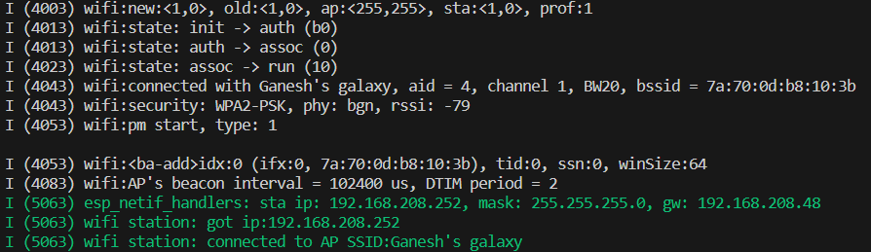

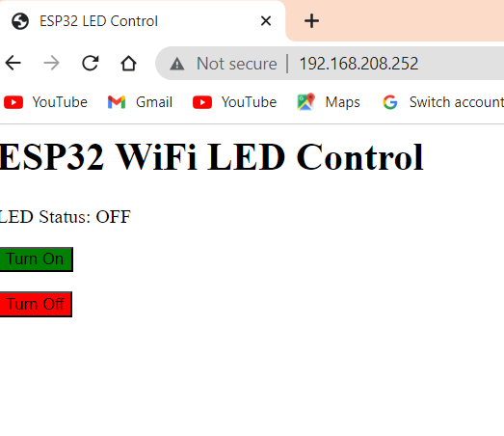 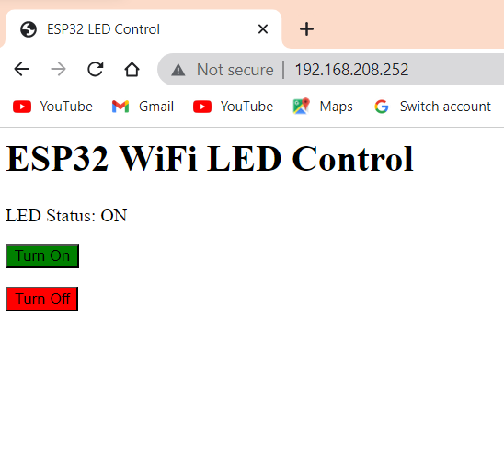

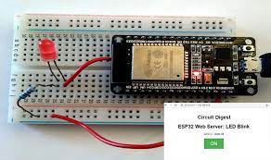 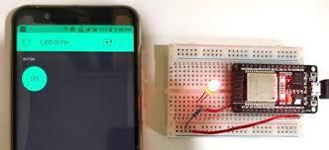

# **Control LED using ESP32 Wi-Fi AP Mode**

## **OBJECTIVE**:

## To Setup ESP32 in Access Point Mode (AP) and control the led

In this case, ESP32 acts as a router and creates a local wifi network with the desired name and password. Since there is a limited number of devices that can connect to this connection point, it is also referred to as the Soft Access Point.

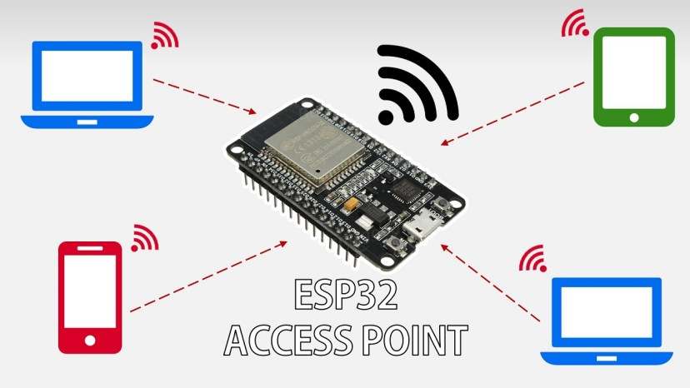

**CONNECTIONS:**

| **ESP32 GPIO Pin** | **LED Connection** |
| --- | --- |
| GPIO 25 | Anode (+) |
| GND | Cathode (-) |

**CIRCUIT DIAGRAM:**

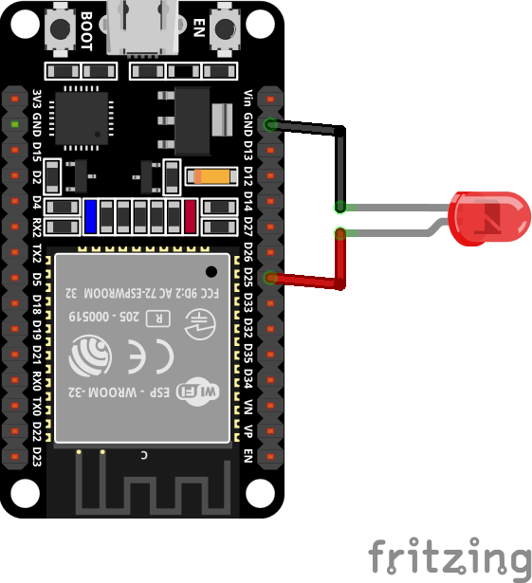

**CODE:**

#include <string.h>

#include <stdio.h>

#include <stdlib.h>

#include "freertos/FreeRTOS.h"

#include "freertos/task.h"

#include "esp_mac.h"

#include "esp_wifi.h"

#include "esp_event.h"

#include "esp_log.h"

#include "nvs_flash.h"

#include "driver/gpio.h"

#include "lwip/err.h"

#include "lwip/sys.h"

#include "esp_http_server.h"

#define EXAMPLE_ESP_WIFI_SSID      CONFIG_ESP_WIFI_SSID

#define EXAMPLE_ESP_WIFI_PASS      CONFIG_ESP_WIFI_PASSWORD

#define EXAMPLE_ESP_WIFI_CHANNEL   CONFIG_ESP_WIFI_CHANNEL

#define EXAMPLE_MAX_STA_CONN       CONFIG_ESP_MAX_STA_CONN

static const char *TAG = "wifi softAP";

static int ledPin = 25; // GPIO pin connected to the LED

static bool ledState = false; // Current state of the LED

static esp_err_t root_get_handler(httpd_req_t *req)

{

    char resp[50];

    sprintf(resp, "LED state: %s", (ledState) ? "ON" : "OFF");

    httpd_resp_send(req, resp, strlen(resp));

    return ESP_OK;

}

static esp_err_t toggle_led_get_handler(httpd_req_t *req)

{

    ledState = !ledState; // Toggle the LED state

    if (ledState) {

        gpio_set_level(ledPin, 1); // Turn on the LED

    } else {

        gpio_set_level(ledPin, 0); // Turn off the LED

    }

    httpd_resp_send(req, "LED state changed", strlen("LED state changed"));

    return ESP_OK;

}

httpd_handle_t start_webserver(void)

{

    httpd_handle_t server = NULL;

    httpd_config_t config = HTTPD_DEFAULT_CONFIG();

    // Create and start the HTTP server

    if (httpd_start(&server, &config) == ESP_OK) {

        // Set URI handlers

        httpd_uri_t root_uri = {

            .uri = "/",

            .method = HTTP_GET,

            .handler = root_get_handler,

            .user_ctx = NULL

        };

        httpd_register_uri_handler(server, &root_uri);

        httpd_uri_t toggle_led_uri = {

            .uri = "/toggle",

            .method = HTTP_GET,

            .handler = toggle_led_get_handler,

            .user_ctx = NULL

        };

        httpd_register_uri_handler(server, &toggle_led_uri);

        return server;

    }

    ESP_LOGI(TAG, "Error starting server!");

    return NULL;

}

void stop_webserver(httpd_handle_t server)

{

    // Stop the HTTP server

    httpd_stop(server);

}

static void wifi_event_handler(void* arg, esp_event_base_t event_base,

                                    int32_t event_id, void* event_data)

{

    if (event_id == WIFI_EVENT_AP_STACONNECTED) {

        wifi_event_ap_staconnected_t* event = (wifi_event_ap_staconnected_t*) event_data;

        ESP_LOGI(TAG, "station "MACSTR" join, AID=%d",

                 MAC2STR(event->mac), event->aid);

    } else if (event_id == WIFI_EVENT_AP_STADISCONNECTED) {

        wifi_event_ap_stadisconnected_t* event = (wifi_event_ap_stadisconnected_t*) event_data;

        ESP_LOGI(TAG, "station "MACSTR" leave, AID=%d",

                 MAC2STR(event->mac), event->aid);

    }

}

void wifi_init_softap(void)

{

    ESP_ERROR_CHECK(esp_netif_init());

    ESP_ERROR_CHECK(esp_event_loop_create_default());

    esp_netif_t *ap_netif =esp_netif_create_default_wifi_ap();

    wifi_init_config_t cfg = WIFI_INIT_CONFIG_DEFAULT();

    ESP_ERROR_CHECK(esp_wifi_init(&cfg));

    ESP_ERROR_CHECK(esp_event_handler_instance_register(WIFI_EVENT,

                                                        ESP_EVENT_ANY_ID,

                                                        &wifi_event_handler,

                                                        NULL,

                                                        NULL));

    wifi_config_t wifi_config = {

        .ap = {

            .ssid = EXAMPLE_ESP_WIFI_SSID,

            .ssid_len = strlen(EXAMPLE_ESP_WIFI_SSID),

            .channel = EXAMPLE_ESP_WIFI_CHANNEL,

            .password = EXAMPLE_ESP_WIFI_PASS,

            .max_connection = EXAMPLE_MAX_STA_CONN,

            .authmode = WIFI_AUTH_WPA_WPA2_PSK,

            .pmf_cfg = {

                    .required = false,

            },

        },

    };

    if (strlen(EXAMPLE_ESP_WIFI_PASS) == 0) {

        wifi_config.ap.authmode = WIFI_AUTH_OPEN;

    }

    ESP_ERROR_CHECK(esp_wifi_set_mode(WIFI_MODE_AP));

    ESP_ERROR_CHECK(esp_wifi_set_config(WIFI_IF_AP, &wifi_config));

    ESP_ERROR_CHECK(esp_wifi_start());

    ESP_LOGI(TAG, "wifi_init_softap finished. SSID:%s password:%s channel:%d",

             EXAMPLE_ESP_WIFI_SSID, EXAMPLE_ESP_WIFI_PASS, EXAMPLE_ESP_WIFI_CHANNEL);

}

void app_main(void)

{ // Initialize NVS

    esp_err_t ret = nvs_flash_init();

    if (ret == ESP_ERR_NVS_NO_FREE_PAGES || ret == ESP_ERR_NVS_NEW_VERSION_FOUND) {

        ESP_ERROR_CHECK(nvs_flash_erase());

        ret = nvs_flash_init();

    }

    ESP_ERROR_CHECK(ret);

ESP_LOGI(TAG, "ESP_WIFI_MODE_AP");

    wifi_init_softap();

    // Set up the LED pin as an output

    gpio_set_direction(ledPin, GPIO_MODE_OUTPUT);

    gpio_set_level(ledPin, 0);

    // Start the web server

    httpd_handle_t server = start_webserver();

     // Loop indefinitely

  while (1) {

        vTaskDelay(1000 / portTICK_PERIOD_MS);

    }

    // Clean up

    stop_webserver(server);

    esp_wifi_stop();

    esp_wifi_deinit();

}

->Build the code ,flash and monitor it after connecting the esp32 board through the USB

->After the code is successfully flashed , the code sets up an ESP32 device as a Wi-Fi Access point(Ap).

->Go to any web browser and type the IP address mentioned in the console. It starts an HTTP server to provide a web interface for controlling an LED.

->You can observe that webpage displays Led state off. Now go to search bar and type IP address/toggle. The state of led is changed and observed in the output.

**OUTPUT:**

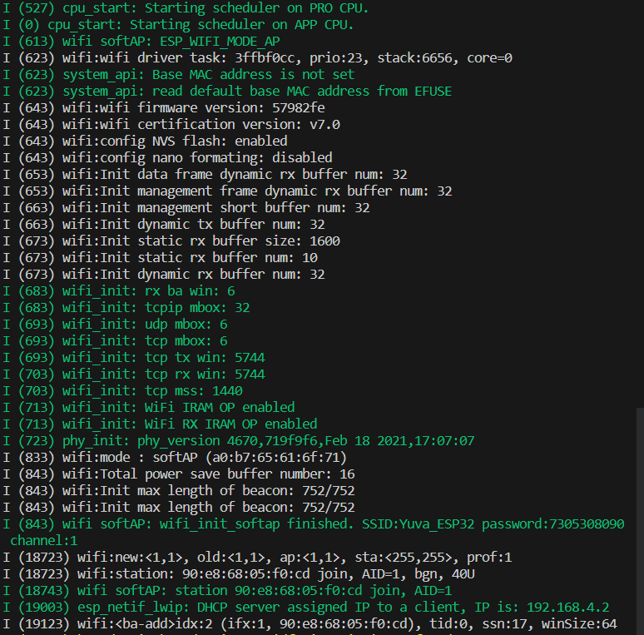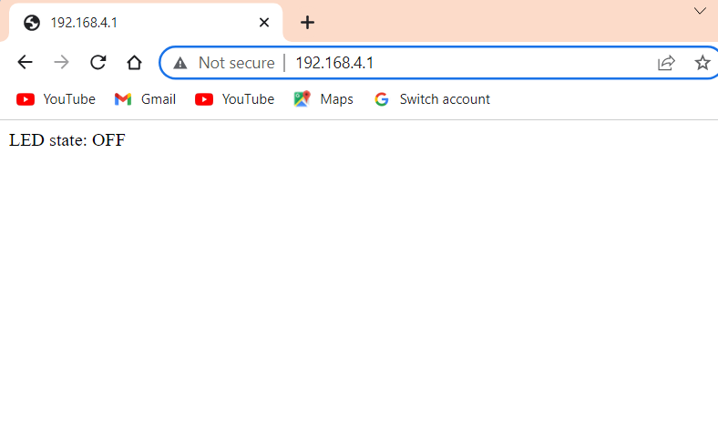 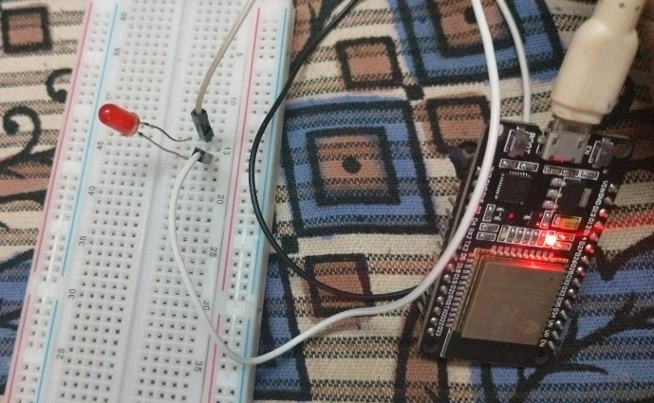

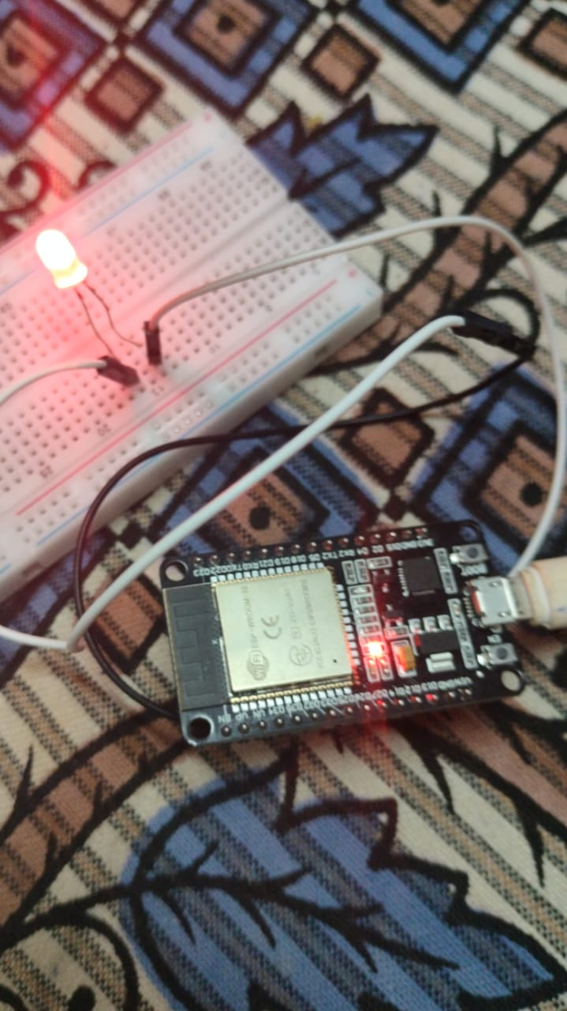

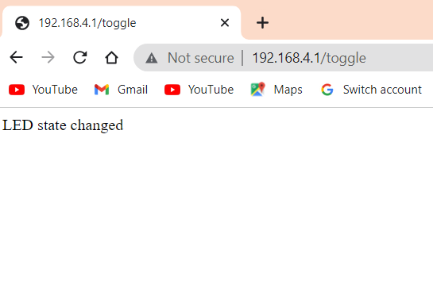

**Relay based AC fan on and off project**

**Aim:**

The aim of this project is to control an AC fan using a relay module. The relay will act as a switch to turn the fan on and off using a microcontroller or a digital signal.

**Components Required:**

1. AC Fan
2. Relay Module
3. Microcontroller or Arduino Board
4. Power Supply
5. Jumper Wires
6. Breadboard

**RELAY:**

* A relay is an electrically operated programmable switch that uses an electromagnet to mechanically control the switching of a circuit. It allows to control high-power devices (like the AC fan in this project) using a low-power signal (from a microcontroller).
* The relay can be programmatically controlled by ESP32 ⇒ ESP32 can control on/off the high voltage devices by using a relay.

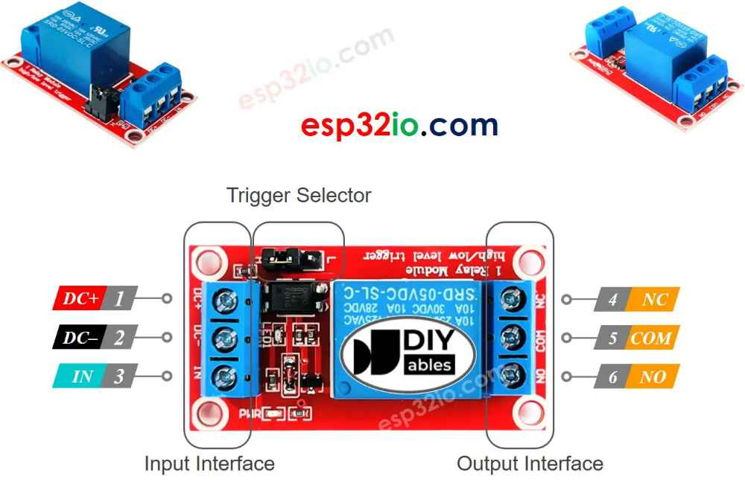

**The input pins**:

DC-pin: connect this pin to GND (OV)

DC+ pin: connect this pin to VCC (5V)

IN pin: receives the control signal from ESP32

**The output pins**:

NO pin: Normally Open pin

NC pin: Normally Closed pin

COM pin: the common pin

**Normally open mode:** Use only COM pin and NO pin

**Normally closed mode:** Use only COM pin and NC pin

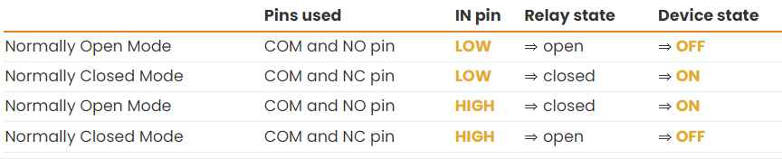

**CIRCUIT DIAGRAM:**

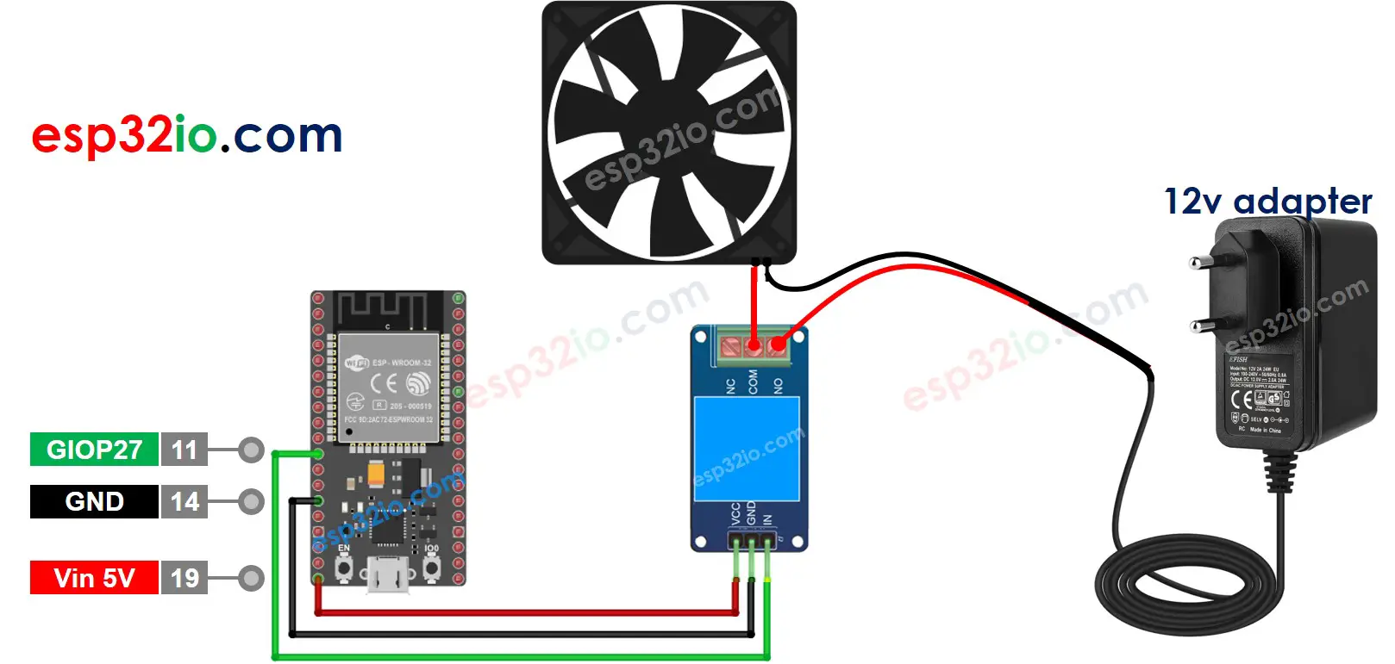



**CONNECTIONS:**

|  |  |
| --- | --- |
| **Relay Module** | **ESP32** |
| GND | GND |
| VCC | Vin(5V) |
| IN | GPIO27 |

**CODE:**

#include <stdio.h>

#include <freertos/FreeRTOS.h>

#include <freertos/task.h>

#include <driver/gpio.h>

#define RELAY_PIN GPIO_NUM_27

void app_main(void)

{

    // Configure the GPIO pin for the relay

    gpio_set_direction(RELAY_PIN, GPIO_MODE_OUTPUT);

    // Turn on the AC fan

    gpio_set_level(RELAY_PIN, 1);

    printf("AC fan turned on\n");

    vTaskDelay(5000 / portTICK_PERIOD_MS); // Wait for 5seconds

// Turn off the AC fan

    gpio_set_level(RELAY_PIN, 0);

    printf("AC fan turned off\n");

    vTaskDelay(1000 / portTICK_PERIOD_MS); // Wait for 1 second before restarting the task

    esp_restart(); // Restart the ESP32 to repeat the process

}

->Build the code ,flash and monitor it after connecting the esp32 board through the USB

->After the code is successfully flashed , the AC fan will turn on for 5 seconds and then turn off,again after 1 second it turns on and process continues .



**OUTPUT:**

I (0) cpu_start: App cpu up.

I (203) heap_init: Initializing. RAM available for dynamic allocation:

I (210) heap_init: At 3FFAE6E0 len 00001920 (6 KiB): DRAM

I (216) heap_init: At 3FFC7F20 len 000281E0 (160 KiB): DRAM

I (222) heap_init: At 3FFE0440 len 00003BC0 (14 KiB): D/IRAM

I (228) heap_init: At 3FFE4350 len 0001BCB0 (111 KiB): D/IRAM

I (235) heap_init: At 4009037C len 0000FC84 (62 KiB): IRAM

I (241) cpu_start: Pro cpu start user code

I (259) cpu_start: Starting scheduler on PRO CPU.

I (0) cpu_start: Starting scheduler on APP CPU.

AC fan turned on

AC fan turned off



**ESP32 Timer based led blink**

**2 led blink in 2 different timing**

**AIM:**

To create an ESP32-based timer-based LED blink project where two LEDs blink at different timings.

**COMPONENTS:**

1. ESP32 development board
2. Breadboard
3. Two LEDs (any color)
4. Two current-limiting resistors
5. Jumper wires

* ESP32 have two 64-bit general purpose timer groups and each have 16-bit pre-scalers and 64-bit up/down counters. We will trigger a specific ISR routine based on timer interrupt. The timer interrupts will be configured in ESP-IDF using esp_timer APIs.
* ESP-IDF provides a driver esp_timer High Resolution Timer that contains APIs to create both periodic and one-shot timers with a time resolution of microsecond and 64 bit range for the hardware timers.

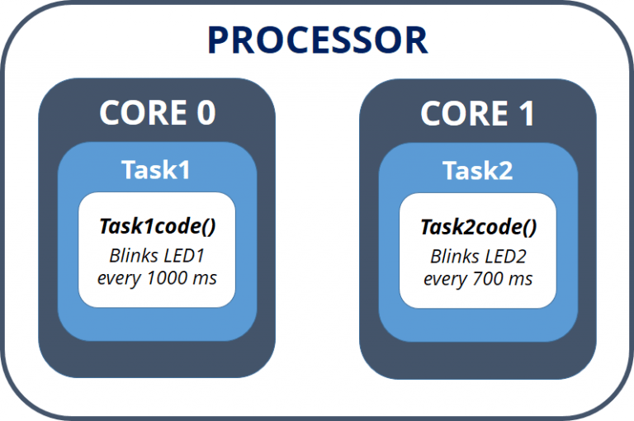

**CONNECTIONS:**

|  |  |
| --- | --- |
| **Component** | **GPIO Pin** |
| LED 1 (Positive leg) | GPIO 2 |
| LED 2 (Positive leg) | GPIO 4 |
| LED 1 (Negative leg) | Resistor |
| LED 2 (Negative leg) | Resistor |
| Resistor (Other end) | GND |

**CIRCUIT DIAGRAM:**

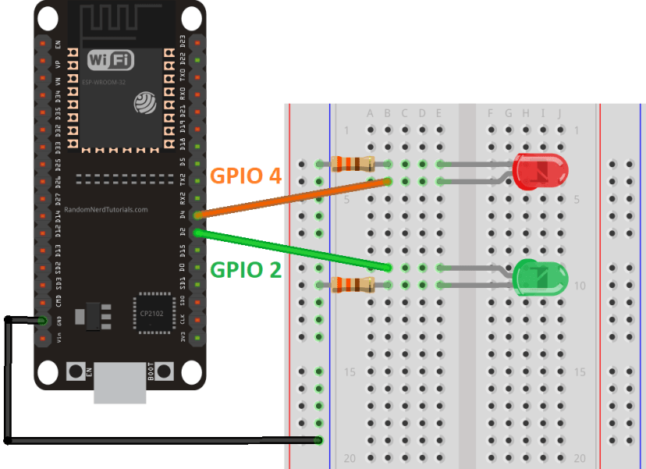

**PROCEDURE:**

1. Open your VS Code and head over to **View > Command Palette**. Type **ESP-IDF: New Project** in the search bar and press enter.
2. Create two tasks running on different cores:

* Task1 runs on core 0;
* Task2 runs on core 1;

**CODE:**

#include <stdio.h>

#include <freertos/FreeRTOS.h>

#include <freertos/task.h>

#include <driver/gpio.h>

#define LED_PIN_1 GPIO_NUM_2

#define LED_PIN_2 GPIO_NUM_4

void blink_task(void *pvParameters)

{

    gpio_set_direction(LED_PIN_1, GPIO_MODE_OUTPUT);

    gpio_set_direction(LED_PIN_2, GPIO_MODE_OUTPUT);

    while (1)

    { // Blink LED 1 every 1 second

        gpio_set_level(LED_PIN_1, 1);

        printf("LED 1 is ON\n");

        vTaskDelay(1000 / portTICK_PERIOD_MS);

        gpio_set_level(LED_PIN_1, 0);

        printf("LED 1 is OFF\n");

        vTaskDelay(1000 / portTICK_PERIOD_MS);

        // Blink LED 2 every 2 seconds

        gpio_set_level(LED_PIN_2, 1);

        printf("LED 2 is ON\n");

        vTaskDelay(2000 / portTICK_PERIOD_MS);

        gpio_set_level(LED_PIN_2, 0);

        printf("LED 2 is OFF\n");

        vTaskDelay(2000 / portTICK_PERIOD_MS);

    }

}

void app_main(void)

{

    gpio_set_direction(LED_PIN_1, GPIO_MODE_OUTPUT);

    gpio_set_direction(LED_PIN_2, GPIO_MODE_OUTPUT);

    xTaskCreate(&blink_task, "blink_task", 4096, NULL, 5, NULL);

}

->Build the code ,flash and monitor it after connecting the esp32 board through the USB

->After the code is successfully flashed , the state of the LEDs will be toggled by the blink_task function. The program will repeatedly turn on and off LED 1 every 1 second, and LED 2 every 2 seconds.

**OUTPUT:**



# **ESP32 with DC motor and L289N Motor driver using ESP-IDF**

**AIM:**

The aim of this project is to control a DC motor using an ESP32, L289N motor driver, and the ESP-IDF MCPWM motor driver library. The goal is to create an ESP-IDF project that allows us to control the speed and direction of the DC motor by utilizing the MCPWM module of the ESP32 and interfacing it with the L289N motor driver.

**COMPONENTS REQUIRED:**

1. ESP32 board
2. L289N Motor driver Module
3. External 3-12 V power supply
4. DC Motor
5. Push Button
6. 10k ohm pull up resistor
7. Connecting Wires
8. Breadboard

## **L298N Motor Driver Module:** The L298N motor driver module is a commonly used, affordable, and easy-to-use module for controlling DC or stepper motors. It is a dual-channel H-bridge motor driver that allows control over the speed and direction of two motors. The module includes components such as the L298N motor driver IC, voltage regulator, jumper enable, power LED, heat sink, resistors, and capacitors. The heat sink is used to dissipate heat generated by the motor driver IC. The module can be powered by either +12V or +5V terminals, with the option to use a voltage regulator for lower power supply voltages. The 5V pin can also serve as an output to power a microcontroller.

## L298N Motor Driver Module Pinout

**CONNECTIONS :**

|  |  |
| --- | --- |
| VCC | The VCC pin (+12V) is the power supply pin for the motor. Supply voltages between 6-12V. |
| GND | This is the pin that provides the common ground. |
| 5V | This is the +5V power supply pin for the L298N IC. It is used when the 5V enable jumper is not connected. When the jumper is connected, it acts as an output pin. |
| ENA | This pin controls the speed of the motor A through the PWM signal. |
| IN1 & IN2 | These are the input pins for motor A. They control the spinning direction for motor A. |
| IN3 & IN4 | These are the input pins for motor B. They control the spinning direction for motor B. |
| ENB | This pin controls the speed of the motor B through the PWM signal. |
| OUT1 & OUT2 | OUT1: Positive terminal for motor A. OUT2: Negative terminal for motor B.  These are the output pins for motor A. Motor A having voltage between 5-35V, will be connected through these two terminals. |
| OUT3 & OUT4 | OUT3: Positive terminal for motor A. OUT4: Negative terminal for motor B.  These are the output pins for motor B. |

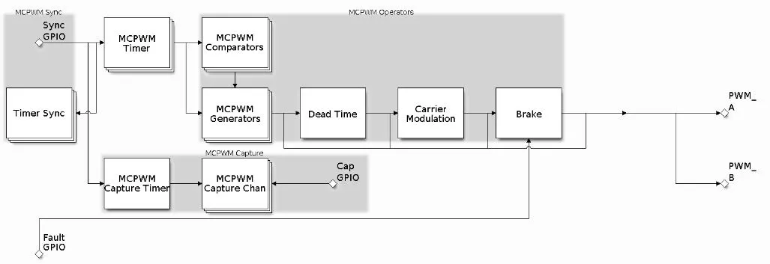

**CIRCUIT DIAGRAM:**

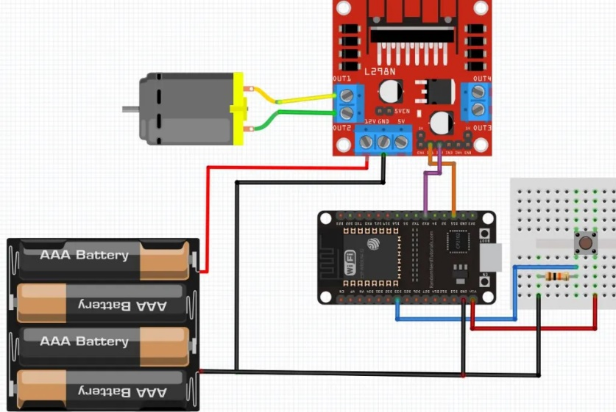

**PROCEDURE:**

Open your VS Code and head over to **View > Command Palette**.

Type **ESP-IDF : New Project** in the search bar and press enter.

Click ‘Choose Template’ button to proceed forward. In the Extension, select ESP-IDF option then go to Peripherals > mcpwm > mcpwm_brushed_dc_control. Now click ‘Create project using template mcpwm_brushed_dc_control.’  Go to **main > main.c**and paste the code given below

**CODE:**

#include <stdio.h>

#include "driver/mcpwm.h"

#include "soc/mcpwm_periph.h"

#include "freertos/FreeRTOS.h"

#include "freertos/task.h"

#include "driver/gpio.h"

#include "esp_attr.h"

#define GPIO_PWM0A_OUT 15   // Set GPIO 15 as PWM0A

#define GPIO_PWM0B_OUT 16   // Set GPIO 16 as PWM0B

#define PUSH_BUTTON_PIN_SPEED 33

int buttonState = 0;

int count_value = 0;

int prestate = 0;

static void mcpwm_example_gpio_initialize(void)

{

    printf("Initializing MCPWM GPIO...\n");

    mcpwm_gpio_init(MCPWM_UNIT_0, MCPWM0A, GPIO_PWM0A_OUT);

    mcpwm_gpio_init(MCPWM_UNIT_0, MCPWM0B, GPIO_PWM0B_OUT);

}

static void brushed_motor_forward(mcpwm_unit_t mcpwm_num, mcpwm_timer_t timer_num, float duty_cycle)

{

    mcpwm_set_signal_low(mcpwm_num, timer_num, MCPWM_OPR_B);

    mcpwm_set_duty(mcpwm_num, timer_num, MCPWM_OPR_A, duty_cycle);

    mcpwm_set_duty_type(mcpwm_num, timer_num, MCPWM_OPR_A, MCPWM_DUTY_MODE_0);

}

static void brushed_motor_backward(mcpwm_unit_t mcpwm_num, mcpwm_timer_t timer_num, float duty_cycle)

{

    mcpwm_set_signal_low(mcpwm_num, timer_num, MCPWM_OPR_A);

    mcpwm_set_duty(mcpwm_num, timer_num, MCPWM_OPR_B, duty_cycle);

    mcpwm_set_duty_type(mcpwm_num, timer_num, MCPWM_OPR_B, MCPWM_DUTY_MODE_0);

}

static void brushed_motor_stop(mcpwm_unit_t mcpwm_num, mcpwm_timer_t timer_num)

{

    mcpwm_set_signal_low(mcpwm_num, timer_num, MCPWM_OPR_A);

    mcpwm_set_signal_low(mcpwm_num, timer_num, MCPWM_OPR_B);

}

static void mcpwm_example_brushed_motor_control(void *arg)

{

    // 1. MCPWM GPIO initialization

    mcpwm_example_gpio_initialize();

    // 2. Initial MCPWM configuration

    printf("Configuring initial parameters of MCPWM...\n");

    mcpwm_config_t pwm_config;

    pwm_config.frequency = 1000;    // Frequency = 1000Hz

    pwm_config.cmpr_a = 0;    // Duty cycle of PWMxA = 0

    pwm_config.cmpr_b = 0;    // Duty cycle of PWMxb = 0

    pwm_config.counter_mode = MCPWM_UP_COUNTER;

    pwm_config.duty_mode = MCPWM_DUTY_MODE_0;

    mcpwm_init(MCPWM_UNIT_0, MCPWM_TIMER_0, &pwm_config);    // Configure PWM0A & PWM0B with above settings

    brushed_motor_forward(MCPWM_UNIT_0, MCPWM_TIMER_0, 20.0);

    vTaskDelay(5000 / portTICK_PERIOD_MS);

    brushed_motor_backward(MCPWM_UNIT_0, MCPWM_TIMER_0, 20.0);

    vTaskDelay(5000 / portTICK_PERIOD_MS);

    brushed_motor_stop(MCPWM_UNIT_0, MCPWM_TIMER_0);

    vTaskDelay(2000 / portTICK_PERIOD_MS);

    gpio_set_direction(PUSH_BUTTON_PIN_SPEED, GPIO_MODE_INPUT);

    while (1) {

        buttonState = gpio_get_level(PUSH_BUTTON_PIN_SPEED);

        if (buttonState == 1 && prestate == 0) {

            count_value += 10;

            float duty_cycle = count_value;

            brushed_motor_forward(MCPWM_UNIT_0, MCPWM_TIMER_0, duty_cycle);

            prestate = 1;

        } else if (buttonState == 0) {

            prestate = 0;

            brushed_motor_stop(MCPWM_UNIT_0, MCPWM_TIMER_0);

        }

        vTaskDelay(500 / portTICK_PERIOD_MS);

    }

}

void app_main(void)

{

    printf("Testing brushed motor...\n");

    xTaskCreate(mcpwm_example_brushed_motor_control, "mcpwm_example_brushed_motor_control", 4096, NULL, 5, NULL);

}

->Build the code ,flash and monitor it after connecting the esp32 board through the USB

->After the code is successfully flashed , the dc motor first moves forward for 5 seconds, then moves backward for 5 seconds, and then stops for 2 seconds until a push button is pressed. The push button count controls the speed of the motor, whereby each time the button is pressed, the duty cycle increases by 10. This causes a steady increase in the speed of the motor whenever the push button is pressed, otherwise, the motor stops. In the console you can view different messages on the ESP-IDF terminal indicating the initialization of the MCPWM GPIO and configuration of the initial parameters as well.

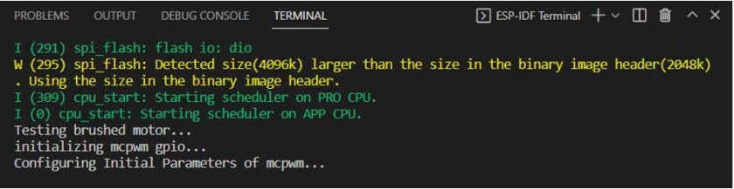



**ESP32 with SERVO MOTOR CONTROL**

**AIM:**

The aim of this project is to control a servo motor using an ESP32 microcontroller.

**COMPONENTS:**

1. Esp32
2. Servo Motor-SG90
3. Breadboard
4. Jumper wires for connections

**SERVO MOTOR:**

* A [**servo motor**](https://circuitdigest.com/article/servo-motor-working-and-basics) is a type of motor that is used to control the precise movement of a device. A servo motor is an electric device used for precise control of angular rotation.
* It typically consists of a **DC motor**, a **control circuit**, and a **feedback mechanism**. The feedback mechanism is used to provide information about the position of the motor shaft to the control circuit, which then adjusts the power to the motor accordingly.
* It is used in applications that demand precise control over motion, like in the case of control of a robotic arm
* The rotation angle of the servo motor is controlled by applying a PWM signal to it.By varying the width of the PWM signal, we can change the rotation angle and direction of the motor.

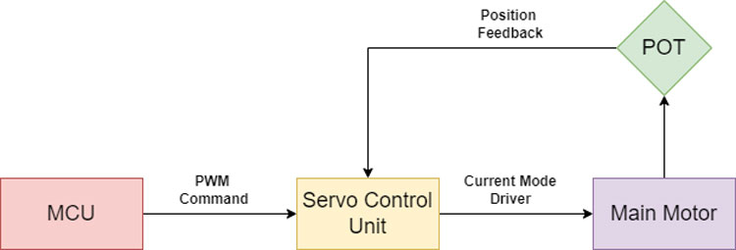 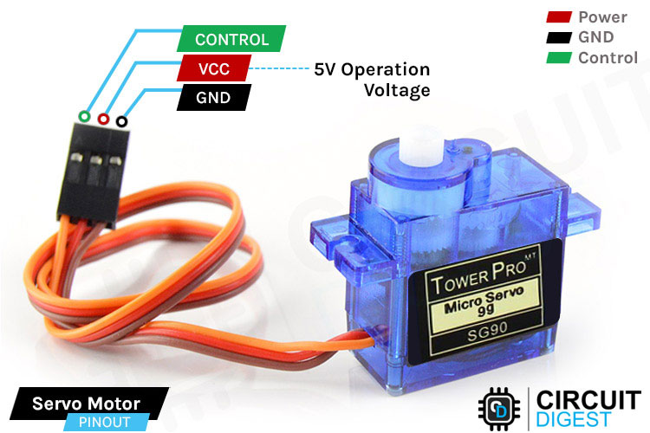

To control the angle of a servo motor, you need to provide a series of pulses with specific pulse lengths. A 1ms pulse corresponds to a 0-degree position, a 1.5ms pulse corresponds to a 90-degree position, and a 2ms pulse corresponds to a 180-degree position. Varying the pulse length between 1ms and 2ms allows you to control the angle of the servo motor.

| **Servo Motor** | **ESP32** |
| --- | --- |
| Power | 5V |
| Ground | Ground (GND) |
| Control | GPIO 26 |

**CONNECTIONS:**

**CIRCUIT DIAGRAM:**

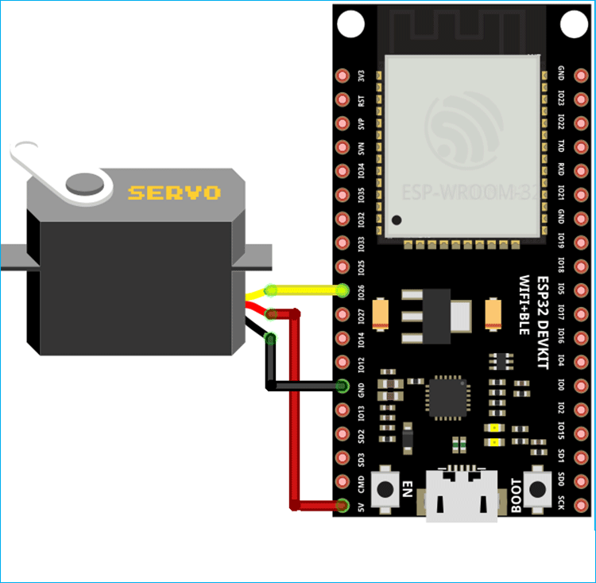

Open your VS Code and head over to **View > Command Palette**.

Type **ESP-IDF : New Project**

**CODE:**

#include "freertos/FreeRTOS.h"

#include "freertos/task.h"

#include "esp_log.h"

#include "driver/mcpwm_prelude.h"

static const char *TAG = "example";

#define SERVO_MIN_PULSEWIDTH_US 500  // Minimum pulse width in microsecond

#define SERVO_MAX_PULSEWIDTH_US 2500  // Maximum pulse width in microsecond

#define SERVO_MIN_DEGREE        -90   // Minimum angle

#define SERVO_MAX_DEGREE        90    // Maximum angle

#define SERVO_PULSE_GPIO        26     // GPIO connects to the PWM signal line

#define SERVO_TIMEBASE_RESOLUTION_HZ 1000000  // 1MHz, 1us per tick

#define SERVO_TIMEBASE_PERIOD        20000    // 20000 ticks, 20ms

static inline uint32_t example_angle_to_compare(int angle)

{

    return (angle - SERVO_MIN_DEGREE) * (SERVO_MAX_PULSEWIDTH_US - SERVO_MIN_PULSEWIDTH_US) / (SERVO_MAX_DEGREE - SERVO_MIN_DEGREE) + SERVO_MIN_PULSEWIDTH_US;

}

void app_main(void)

{

    ESP_LOGI(TAG, "Create timer and operator");

    mcpwm_timer_handle_t timer = NULL;

    mcpwm_timer_config_t timer_config = {

        .group_id = 0,

        .clk_src = MCPWM_TIMER_CLK_SRC_DEFAULT,

        .resolution_hz = SERVO_TIMEBASE_RESOLUTION_HZ,

        .period_ticks = SERVO_TIMEBASE_PERIOD,

        .count_mode = MCPWM_TIMER_COUNT_MODE_UP,

    };

    ESP_ERROR_CHECK(mcpwm_new_timer(&timer_config, &timer));

    mcpwm_oper_handle_t oper = NULL;

    mcpwm_operator_config_t operator_config = {

        .group_id = 0, // operator must be in the same group to the timer

    };

    ESP_ERROR_CHECK(mcpwm_new_operator(&operator_config, &oper));

    ESP_LOGI(TAG, "Connect timer and operator");

    ESP_ERROR_CHECK(mcpwm_operator_connect_timer(oper, timer));

    ESP_LOGI(TAG, "Create comparator and generator from the operator");

    mcpwm_cmpr_handle_t comparator = NULL;

    mcpwm_comparator_config_t comparator_config = {

        .flags.update_cmp_on_tez = true,

    };

    ESP_ERROR_CHECK(mcpwm_new_comparator(oper, &comparator_config, &comparator));

    mcpwm_gen_handle_t generator = NULL;

    mcpwm_generator_config_t generator_config = {

        .gen_gpio_num = SERVO_PULSE_GPIO,

    };

    ESP_ERROR_CHECK(mcpwm_new_generator(oper, &generator_config, &generator));

    // set the initial compare value, so that the servo will spin to the center position

    ESP_ERROR_CHECK(mcpwm_comparator_set_compare_value(comparator, example_angle_to_compare(0)));

    ESP_LOGI(TAG, "Set generator action on timer and compare event");

    // go high on counter empty

    ESP_ERROR_CHECK(mcpwm_generator_set_action_on_timer_event(generator,

                    MCPWM_GEN_TIMER_EVENT_ACTION(MCPWM_TIMER_DIRECTION_UP, MCPWM_TIMER_EVENT_EMPTY, MCPWM_GEN_ACTION_HIGH)));

    // go low on compare threshold

    ESP_ERROR_CHECK(mcpwm_generator_set_action_on_compare_event(generator,

                    MCPWM_GEN_COMPARE_EVENT_ACTION(MCPWM_TIMER_DIRECTION_UP, comparator, MCPWM_GEN_ACTION_LOW)));

    ESP_LOGI(TAG, "Enable and start timer");

    ESP_ERROR_CHECK(mcpwm_timer_enable(timer));

    ESP_ERROR_CHECK(mcpwm_timer_start_stop(timer, MCPWM_TIMER_START_NO_STOP));

    int angle = 0;

    int step = 2;

    while (1) {

        ESP_LOGI(TAG, "Angle of rotation: %d", angle);

    ESP_ERROR_CHECK(mcpwm_comparator_set_compare_value(comparator, example_angle_to_compare(angle)));

        //Add delay, since it takes time for servo to rotate, usually 200ms/60degree rotation under 5V power supply

        vTaskDelay(pdMS_TO_TICKS(500));

        if ((angle + step) > 60 || (angle + step) < -60) {

            step *= -1;

        }

        angle += step;

    }}

->Build the code ,flash and monitor it after connecting the esp32 board through the USB

->After the code is successfully flashed ,the servo motor will rotate from 0 to 180 degrees and then from 180 to 0 degrees in a continuous loop.

**OUTPUT:**

I (0) cpu_start: Starting scheduler on APP CPU.

I (305) example: Create timer and operator

I (305) example: Connect timer and operator

I (305) example: Create comparator and generator from the operator

I (315) gpio: GPIO[44]| InputEn: 0| OutputEn: 1| OpenDrain: 0| Pullup: 1| Pulldown: 0| Intr:0

I (325) example: Set generator action on timer and compare event

I (335) example: Enable and start timer

I (335) example: Angle of rotation: 0

I (1345) example: Angle of rotation: 2

I (2345) example: Angle of rotation: 4

I (3345) example: Angle of rotation: 6

I (4345) example: Angle of rotation: 8

I (5345) example: Angle of rotation: 10

I (6345) example: Angle of rotation: 12

I (7345) example: Angle of rotation: 14



# **Stepper Motor Control with L298N Motor Driver and ESP32**

**AIM:**

The aim of this project is to control a stepper motor using ESP32 microcontroller and an L298N motor driver**.**

**COMPONENT:**

1. ESP32 board
2. L289N Motor driver Module
3. NEMA 17 stepper motor
4. External 12 V power supply
5. Connecting Wire

## **Stepper Motor:**

* Stepper motors are DC brushless and synchronous motors that rotate in discrete steps of predefined values.
* They provide precise position control based on the number of steps per revolution.
* NEMA 17 stepper motors are bipolar, meaning they have two coils.
* The coils of the NEMA 17 motor are internally connected, with one pair of wires in green and black, and another pair in red and blue.
* To make the motor move, the coils need to be magnetized, and the rotation depends on the magnetic field.
* The induction of the coil determines the time required for a full magnetic state.
* The NEMA 17 motor operates at 12V, has 200 steps per revolution, and a speed of 60 rpm.
* Stepper motors, including NEMA 17, are commonly used in CNC machines, robotics, and 2D/3D printers.
* To control a bipolar stepper motor like NEMA 17, the L298N motor driver module is commonly used.

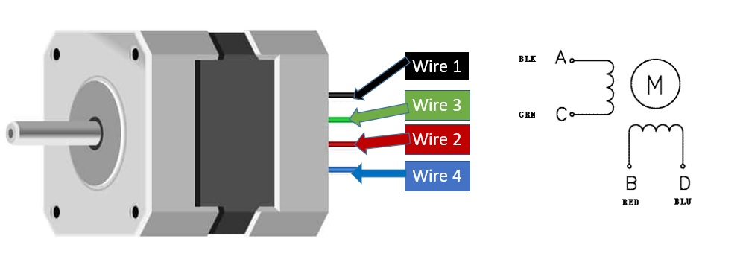

**CIRCUIT DIAGRAM:**

| **NEMA 17 Stepper Motor** | **L298N Motor Driver Module** |
| --- | --- |
| Black wire (A+) | OUT1 |
| Green wire (A-) | OUT2 |
| Red wire (B+) | OUT3 |
| Blue wire (B-) | OUT4 |
| Positive power supply | 12V terminal |
| Negative power supply | Common ground |
| GPIO14 | IN1 |
| GPIO27 | IN2 |
| GPIO26 | IN3 |
| GPIO25 | IN4 |

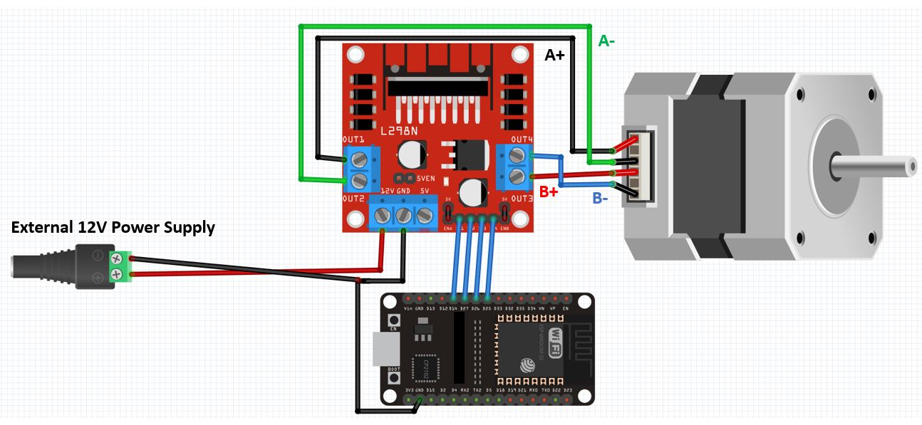**CONNECTIONS:**

Open your VS Code and head over to **View > Command Palette**.

Type **ESP-IDF : New Project**

**CODE:**

#include <stdio.h>

#include "freertos/FreeRTOS.h"

#include "freertos/task.h"

#include "driver/gpio.h"

#include "esp_system.h"

#include "esp_log.h"

#include "esp_vfs_dev.h"

#include "driver/gpio.h"

#define STEPS_PER_REV 200

#define IN1_GPIO 14

#define IN2_GPIO 27

#define IN3_GPIO 26

#define IN4_GPIO 25

void stepper_task(void *pvParameters)

{

    gpio_set_direction(IN1_GPIO, GPIO_MODE_OUTPUT);

    gpio_set_direction(IN2_GPIO, GPIO_MODE_OUTPUT);

    gpio_set_direction(IN3_GPIO, GPIO_MODE_OUTPUT);

    gpio_set_direction(IN4_GPIO, GPIO_MODE_OUTPUT);

    int step_delay = 500; // Delay between steps in milliseconds

    int steps = STEPS_PER_REV; // Number of steps for one revolution

    while (1)

    {

        printf("Rotating Clockwise...\n");

        for (int i = 0; i < steps; i++)

        {

            // Step sequence for clockwise rotation

            gpio_set_level(IN1_GPIO, 1);

            gpio_set_level(IN2_GPIO, 0);

            gpio_set_level(IN3_GPIO, 1);

            gpio_set_level(IN4_GPIO, 0);

            vTaskDelay(pdMS_TO_TICKS(step_delay));

            gpio_set_level(IN1_GPIO, 0);

            gpio_set_level(IN2_GPIO, 1);

            gpio_set_level(IN3_GPIO, 1);

            gpio_set_level(IN4_GPIO, 0);

            vTaskDelay(pdMS_TO_TICKS(step_delay));

            gpio_set_level(IN1_GPIO, 0);

            gpio_set_level(IN2_GPIO, 1);

            gpio_set_level(IN3_GPIO, 0);

            gpio_set_level(IN4_GPIO, 1);

            vTaskDelay(pdMS_TO_TICKS(step_delay));

            gpio_set_level(IN1_GPIO, 1);

            gpio_set_level(IN2_GPIO, 0);

            gpio_set_level(IN3_GPIO, 0);

            gpio_set_level(IN4_GPIO, 1);

            vTaskDelay(pdMS_TO_TICKS(step_delay));

        }

        vTaskDelay(pdMS_TO_TICKS(500));

        printf("Rotating Anti-clockwise...\n");

        for (int i = 0; i < steps; i++)

        {

            // Step sequence for anti-clockwise rotation

            gpio_set_level(IN1_GPIO, 1);

            gpio_set_level(IN2_GPIO, 0);

            gpio_set_level(IN3_GPIO, 0);

            gpio_set_level(IN4_GPIO, 1);

            vTaskDelay(pdMS_TO_TICKS(step_delay));

            gpio_set_level(IN1_GPIO, 0);

            gpio_set_level(IN2_GPIO, 1);

            gpio_set_level(IN3_GPIO, 0);

            gpio_set_level(IN4_GPIO, 1);

            vTaskDelay(pdMS_TO_TICKS(step_delay));

            gpio_set_level(IN1_GPIO, 0);

            gpio_set_level(IN2_GPIO, 1);

            gpio_set_level(IN3_GPIO, 1);

            gpio_set_level(IN4_GPIO, 0);

            vTaskDelay(pdMS_TO_TICKS(step_delay));

            gpio_set_level(IN1_GPIO, 1);

            gpio_set_level(IN2_GPIO, 0);

            gpio_set_level(IN3_GPIO, 1);

            gpio_set_level(IN4_GPIO, 0);

            vTaskDelay(pdMS_TO_TICKS(step_delay));

        }

        vTaskDelay(pdMS_TO_TICKS(500));

    }}

void app_main()

{

    xTaskCreate(stepper_task, "stepper_task", 2048, NULL, 5, NULL);

}

**OUTPUT:**

After building, flashing and monitoring the output is as follows:

Rotating Clockwise...

Rotating Anti-clockwise...

Rotating Clockwise...

Rotating Anti-clockwise...



**ADVANCED PROJECTS**

**1.ESP32 INTERFACE WITH GSM MODULE**

**AIM:**

The aim of the project is to interface an ESP32 microcontroller with a GSM module to enable communication via GSM network. This can be used for various applications such as sending SMS messages, making calls, and accessing internet services through the GSM network.

**COMPONENT:**

1. ESP32 Development Board
2. GSM Module (e.g., SIM800L or SIM900A)
3. SIM Card
4. 5V Power Supply (for the GSM module)
5. 3.3V Power Supply (for the ESP32 board)
6. Jumper Wires
7. Breadboard or PCB

### **SIM800L GSM** **Module:**

The SIM800L GSM/GPRS module has 12 pins which are NET, VCC, RST, RXD, TXD, GND, SPK-, SPK+, MIC-, MIC+, DTR, RING.

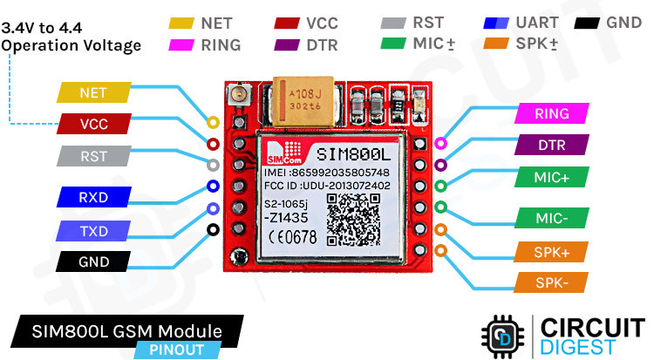

NET is a pin where you can solder the helical antenna that comes with the module.

VCC is the Power supply pin of the module and it needs to be powered anywhere from 3.4V to 4.4 volts. Connecting this module to a 5V supply will most likely destroy it and if you connect it to 3.3V it won't even run. A lithium battery or a buck converter with 2A current capacity is recommended for this module.

RST is the hard reset pin of the sim800L module. If you are having trouble communicating with this, pull the pin low for 100ms.

RXD is the RX pin for the module used in serial communication.

TXD is the TX pin for this module used in Serial communication.

GND is the Ground pin for this module; connect this pin to the Ground pin of the ESP32.

RING is the ring indicator pin of the module. This pin generally is active high. It will go low for 120ms to indicate incoming calls and can also be configured to pulse when an SMS is received.

DTR this pin can be used to put the module in sleep mode.Pulling the pin high puts the module in sleep mode and disables the serial***.*** Pulling it low will wake the module up.

MIC+- These two pins can be used to connect an external microphone to the module.

SPK+- these two pins can be used to connect an external speaker to the module.

### 

* The SIM800L module is a compact GSM/GPRS module.
* It has a minimalistic PCB design with a UFL connector, SIM800L module, capacitors, and a current limiting resistor for the LED.
* The backside of the board features a push-to-lock SIM card holder.
* The module operates at a voltage range of 3.4V to 4.4V, making it suitable for use with a lithium polymer battery.
* The breakout board has a breadboard-friendly 0.1" pin pitch, making it easy to use in prototyping.
* It has auto baud rate detection for simplified communication.
* An external antenna is required for network connectivity, with options for soldering a helical antenna or using the onboard UFL connector.
* The SIM800L module is compatible with 2G SIM cards.
* The LED on the module provides status indications:
* Blinking every one second: Module is running but unable to connect to the cellular network.
* Blinking every two seconds: GPRS data connection is active and ready to accept requests.
* Blinking every three seconds: Module is connected to the network and can send/receive voice and SMS.

 

**CIRCUIT DIAGRAM:**

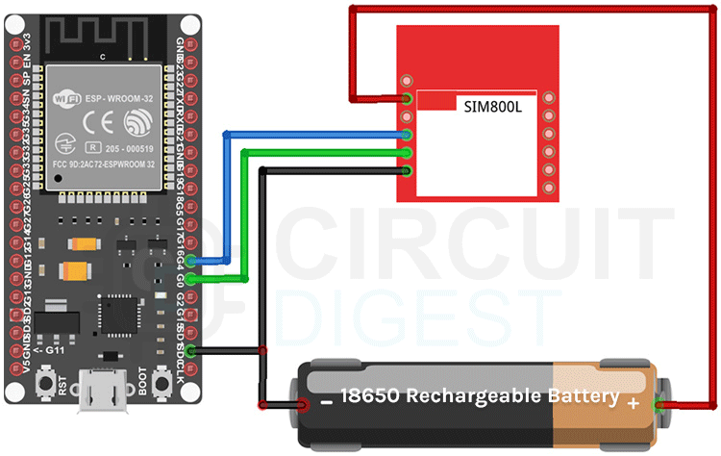

**CONNECTIONS:**

| **ESP32 Pin** | **SIM800L Pin** | **Function** |
| --- | --- | --- |
| 5V | VCC | Power Supply |
| GND | GND | Ground |
| GPIO Rx 2 | TX | Transmit (UART) |
| GPIO Tx 2 | RX | Receive (UART) |
| GPIO | RST | Reset |

Open your VS Code and head over to **View > Command Palette**.

Type **ESP-IDF : New Project** 

**CODE:**

#include <stdio.h>

#include "freertos/FreeRTOS.h"

#include "freertos/task.h"

#include "driver/uart.h"

#include "driver/gpio.h"

#define UART_NUM     UART_NUM_2

#define UART_TX_PIN  GPIO_NUM_17

#define UART_RX_PIN  GPIO_NUM_16

void setup();

void loop();

void test_sim800_module();

void updateSerial();

void send_SMS();

void configure_voice_call();

void make_call();

void setup() {

  uart_config_t uart_config = {

      .baud_rate = 9600,

      .data_bits = UART_DATA_8_BITS,

      .parity = UART_PARITY_DISABLE,

      .stop_bits = UART_STOP_BITS_1,

      .flow_ctrl = UART_HW_FLOWCTRL_DISABLE

  };

  uart_param_config(UART_NUM, &uart_config);

  uart_set_pin(UART_NUM, UART_TX_PIN, UART_RX_PIN, UART_PIN_NO_CHANGE, UART_PIN_NO_CHANGE);

  uart_driver_install(UART_NUM, 256, 0, 0, NULL, 0);

  vTaskDelay(3000 / portTICK_PERIOD_MS);

  test_sim800_module();

  send_SMS();

}

void loop() {

  updateSerial();

  vTaskDelay(500 / portTICK_PERIOD_MS);

}

void test_sim800_module() {

  uart_write_bytes(UART_NUM, "AT\r\n", 4);

  updateSerial();

  uart_write_bytes(UART_NUM, "AT+CSQ\r\n", 9);

  updateSerial();

  uart_write_bytes(UART_NUM, "AT+CCID\r\n", 10);

  updateSerial();

  uart_write_bytes(UART_NUM, "AT+CREG?\r\n", 11);

  updateSerial();

  uart_write_bytes(UART_NUM, "ATI\r\n", 6);

  updateSerial();

  uart_write_bytes(UART_NUM, "AT+CBC\r\n", 9);

  updateSerial();

}

void updateSerial() {

  uint8_t data;

  while (uart_read_bytes(UART_NUM, &data, 1, 0) == 1) {

    putchar(data);}

  fflush(stdout);}

void send_SMS() {

  uart_write_bytes(UART_NUM, "AT+CMGF=1\r\n", 12); // Configuring TEXT mode

  updateSerial();

  uart_write_bytes(UART_NUM, "AT+CMGS=\"+91123456789\"\r\n", 24); // Change ZZ with country code and xxxxxxxxxxx with phone number to send SMS

  updateSerial();

  uart_write_bytes(UART_NUM, "HELLO WORLD", 14); // Text content

  updateSerial();

  printf("\n");

  printf("Message Sent\n");

  uart_write_bytes(UART_NUM, "\x1A", 1);

}

void configure_voice_call() {

    uart_write_bytes(UART_NUM, "AT+CSVOICE=1\r\n", 13); // Configure voice call mode

    updateSerial();

}

void make_call() {

    uart_write_bytes(UART_NUM, "ATD+91123456789;\r\n", 18); // Replace "+91123456789" with the phone number to call

    updateSerial();

    printf("Making call...\n");

}

void app_main(void) {

    setup();

    while (1) {

        loop();   }

}

->Build the code ,flash and monitor it after connecting the esp32 board through the USB

->After the code is successfully flashed, Responses from the AT commands sent to the GSM module such as "OK", signal strength, SIM card information, registration status, module information, battery status,

->It sends the message "Message Sent" after attempting to send an SMS.

->Also for making call ,it says whether call is ongoing or ended.

**OUTPUT:**

**Sending message Making call**

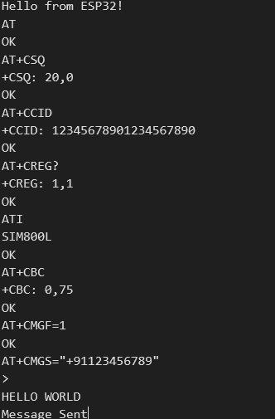 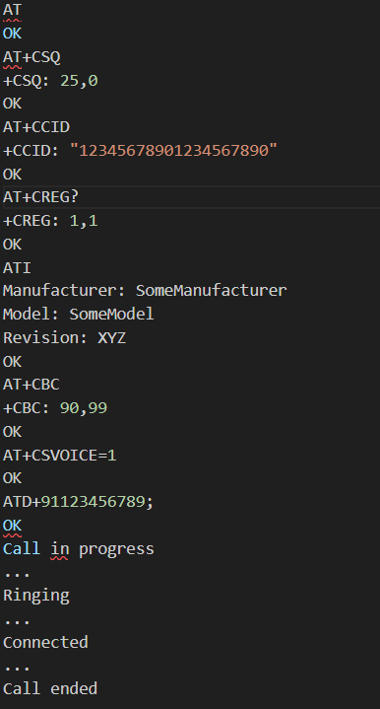



**2.ESP32 BLUETOOTH INTERFACE**

**AIM:**

The aim of this project is to create a Bluetooth SPP server using an ESP32 device, which can communicate with a mobile device over Bluetooth and exchange data via a virtual serial port.

**COMPONENTS:**

* ESP32 Development Board
* USB Cable
* Device with Bluetooth

**BLUETOOTH:**

* ESP32 supports both the Classic Bluetooth (Classic BT) and Bluetooth Low Energy (BLE) which can be configured with BLUEDROID Bluetooth Stack.
* ESP32 Bluetooth supports three types of Host Controller Interface (HCI): UART, SPI and VHCI (Virtual HCI) interfaces .
* ESP32 is a SoC (System on a Chip) that supports both Classic Bluetooth and Bluetooth Low Energy (BLE). It has a single pin for connecting to an antenna (LNA_IN). The ESP32 Bluetooth functionality can be configured with the BLUEDROID Bluetooth Stack, which supports UART, SPI, and VHCI (Virtual HCI) interfaces.
* The Classic Bluetooth is designed for one-to-one wireless communication between a master and a slave, commonly used in devices like keyboards, mice, and file transfer between devices. BLE, on the other hand, is designed for low power consumption and transferring small amounts of data
* The communication between the ESP32's processor and the Bluetooth controller is based on a serial interface. The BLUEDROID Bluetooth Stack provides support for various Classic Bluetooth profiles such as GAP, A2DP (SNK), and AVRCP (CT), as well as protocols like L2CAP, SDP, AVDTP, and AVCTP.

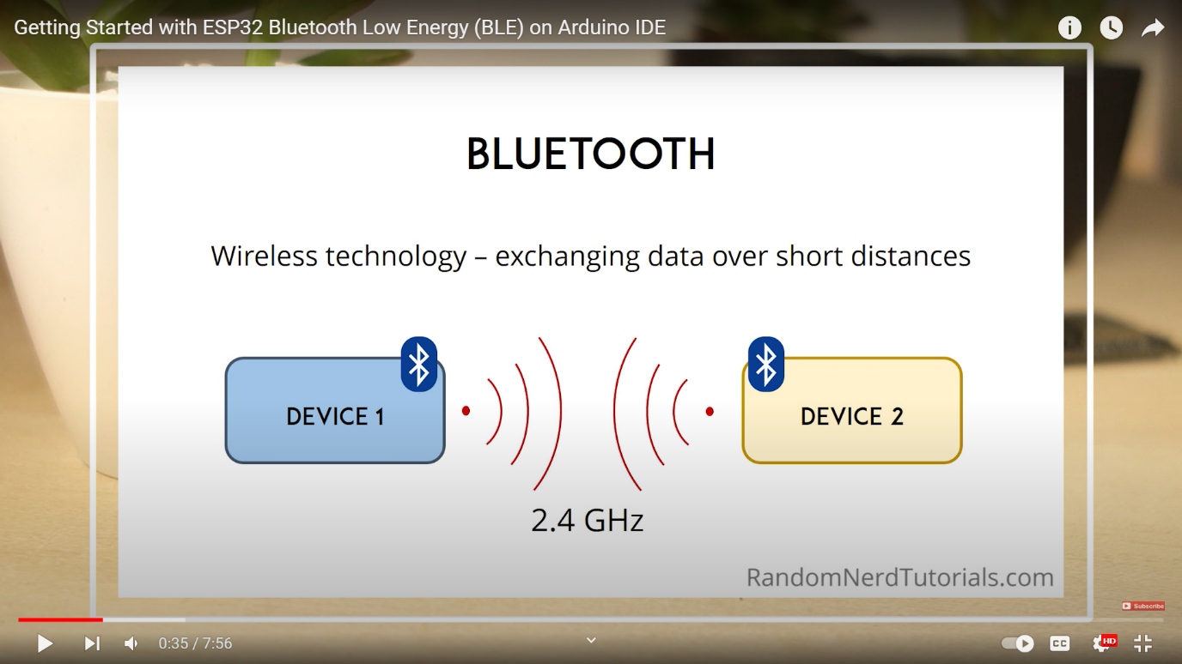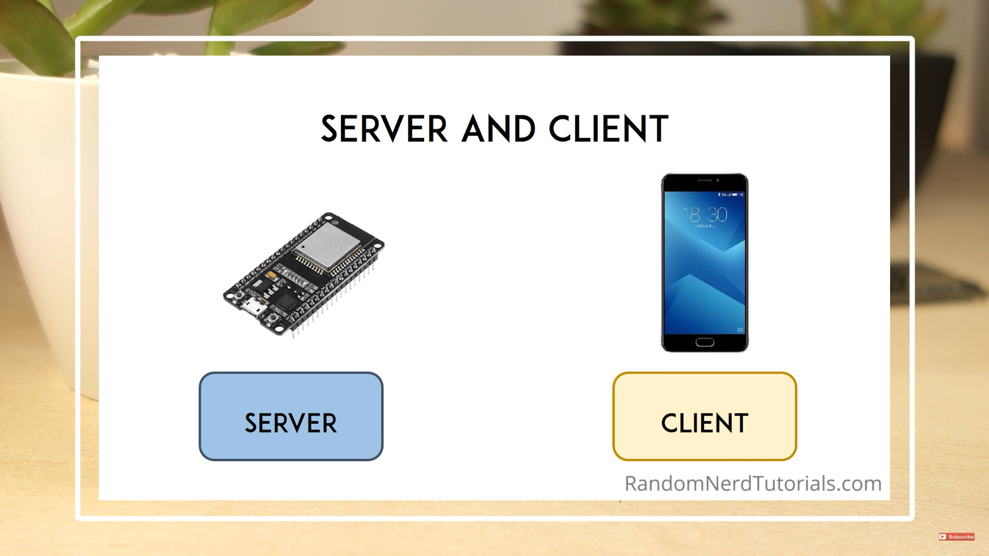

### Different Layers in BLE

A BLE device consists of three layers:

* Controller
* Host
* Application

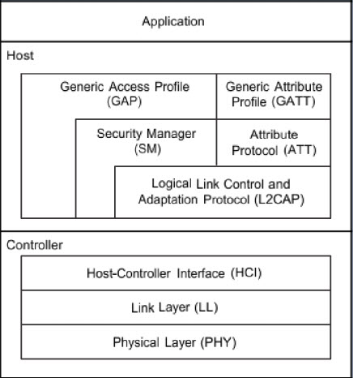

The controller contains the following:

* PHY – The Physical Layer
* LL – The Link Layer
* HCI – Controller side Host-Controller Interface

The host contains the following:

* HCI – Host side Host-Controller Interface
* L2CAP – Logical Link Control and Application Protocol
* SM – Security Manager
* ATT – Attribute Protocol
* GAP – Generic Access Profile
* GATT – Generic Attribute Profile

### **GATT:**

* GATT stands for Generic Attributes and it defines a hierarchical data structure that is exposed to connected BLE devices. This means that
* GATT defines the way that two BLE devices send and receive standard messages.
* GATT defines data transfer specifications between BLE devices using Services and Characteristics.
* Characteristic: A group of information transmitted between BLE devices, usually comprising a Value (data), Declaration (properties like read, write, notify), and Description (ASCII String).
* Service: A collection of Characteristics with a unique 16-bit or 128-bit UUID
* *UUID*: Universally Unique Identifier, a unique 16-bit or 128-bit ID given to each Service and Characteristic. 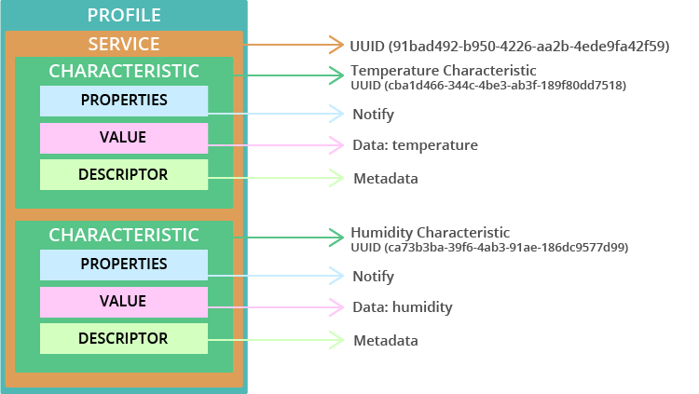
* BLE States: BLE devices can have 5 possible states –
* Standby
* Advertising
* Scanning
* Initiating
* Connected

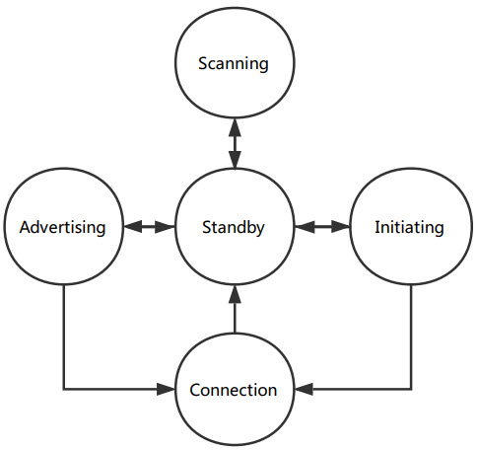

* BLE Network Topologies: BLE communication can be Broadcast Type (one-way data transfer) or Connection Type (two-way communication with Central and Peripheral devices).

**PROCEDURE:**

Open vs code->Create new project

**CODE:**

#include <stdio.h>

#include "freertos/FreeRTOS.h"

#include "freertos/task.h"

#include "freertos/event_groups.h"

#include "esp_event.h"

#include "nvs_flash.h"

#include "esp_log.h"

#include "esp_nimble_hci.h"

#include "nimble/nimble_port.h"

#include "nimble/nimble_port_freertos.h"

#include "host/ble_hs.h"

#include "services/gap/ble_svc_gap.h"

#include "services/gatt/ble_svc_gatt.h"

#include "sdkconfig.h"

char *TAG = "BLE-Server";

uint8_t ble_addr_type;

void ble_app_advertise(void);

// Write data to ESP32 defined as server

static int device_write(uint16_t conn_handle, uint16_t attr_handle, struct ble_gatt_access_ctxt *ctxt, void *arg)

{

    printf("Data from the client: %.*s\n", ctxt->om->om_len, ctxt->om->om_data);

    return 0;

}

// Read data from ESP32 defined as server

static int device_read(uint16_t con_handle, uint16_t attr_handle, struct ble_gatt_access_ctxt *ctxt, void *arg)

{

    os_mbuf_append(ctxt->om, "Data from the server", strlen("Data from the server"));

    return 0;

}

// Array of pointers to other service definitions

// UUID - Universal Unique Identifier

static const struct ble_gatt_svc_def gatt_svcs[] = {

    {.type = BLE_GATT_SVC_TYPE_PRIMARY,

     .uuid = BLE_UUID16_DECLARE(0x180),         // Define UUID for device type

     .characteristics = (struct ble_gatt_chr_def[]){

         {.uuid = BLE_UUID16_DECLARE(0xFEF4),     // Define UUID for reading

          .flags = BLE_GATT_CHR_F_READ,

          .access_cb = device_read},

         {.uuid = BLE_UUID16_DECLARE(0xDEAD),      // Define UUID for writing

          .flags = BLE_GATT_CHR_F_WRITE,

          .access_cb = device_write},

         {0}}},

    {0}};

// BLE event handling

static int ble_gap_event(struct ble_gap_event *event, void *arg)

{

    switch (event->type)

    {

    // Advertise if connected

    case BLE_GAP_EVENT_CONNECT:

        ESP_LOGI("GAP", "BLE GAP EVENT CONNECT %s", event->connect.status == 0 ? "OK!" : "FAILED!");

        if (event->connect.status != 0)

        {

            ble_app_advertise();

        }

        break;

    // Advertise again after completion of the event

    case BLE_GAP_EVENT_ADV_COMPLETE:

        ESP_LOGI("GAP", "BLE GAP EVENT");

        ble_app_advertise();

        break;

    // Handle client disconnection

    case BLE_GAP_EVENT_DISCONNECT:

        ESP_LOGI(TAG, "Client disconnected");

        ble_app_advertise(); // Restart advertising after disconnection

        break;

    default:

        break;

    }

    return 0;

}

// Define the BLE connection

void ble_app_advertise(void)

{

    // GAP - device name definition

    struct ble_hs_adv_fields fields;

    const char *device_name;

    memset(&fields, 0, sizeof(fields));

    device_name = ble_svc_gap_device_name(); // Read the BLE device name

    fields.name = (uint8_t *)device_name;

    fields.name_len = strlen(device_name);

    fields.name_is_complete = 1;

    ble_gap_adv_set_fields(&fields);

    // GAP - device connectivity definition

    struct ble_gap_adv_params adv_params;

    memset(&adv_params, 0, sizeof(adv_params));

    adv_params.conn_mode = BLE_GAP_CONN_MODE_UND; // connectable or non-connectable

    adv_params.disc_mode = BLE_GAP_DISC_MODE_GEN; // discoverable or non-discoverable

    ble_gap_adv_start(ble_addr_type, NULL, BLE_HS_FOREVER, &adv_params, ble_gap_event, NULL);

}

// The application

void ble_app_on_sync(void)

{

    ble_hs_id_infer_auto(0, &ble_addr_type); // Determines the best address type automatically

    ble_app_advertise();                     // Define the BLE connection

}

// The infinite task

void host_task(void *param)

{

    nimble_port_run(); // This function will return only when nimble_port_stop() is executed

}

void app_main()

{

    nvs_flash_init();                   // 1 - Initialize NVS flash

    esp_nimble_hci_init() // 2 - Initialize ESP controller

    nimble_port_init();                     // 3 - Initialize the host stack

    ble_svc_gap_device_name_set("BLE-Server"); // 4 - Initialize NimBLE configuration - server name

    ble_svc_gap_init();            // 4 - Initialize NimBLE configuration - gap service

    ble_svc_gatt_init()  // 4 - Initialize NimBLE configuration - gatt service

    ble_gatts_count_cfg(gatt_svcs);   // 4 - Initialize NimBLE configuration - config gatt services

    ble_gatts_add_svcs(gatt_svcs);             // 4 - Initialize NimBLE configuration - queues gatt services.

    ble_hs_cfg.sync_cb = ble_app_on_sync;      // 5 - Initialize application

    nimble_port_freertos_init(host_task);      // 6 - Run the thread

}

* Open menu configuration
* Go to Component config
* Enable Bluetooth and select Host as Nimble- BLE only and also enable controller
* Press Save

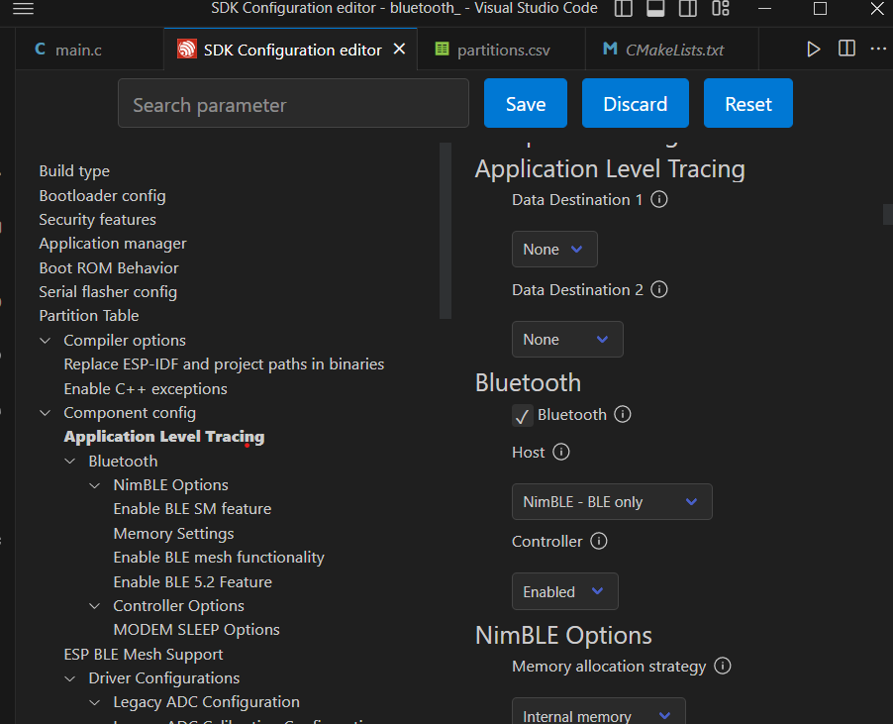

* Now go to main.c and build the project
* Connect the USB cable to esp32 and start Flashing and Monitoring the code.
* In your client device that is Mobile,go to playstore and install an app called **nRF Connect** which enables us to send data to server.

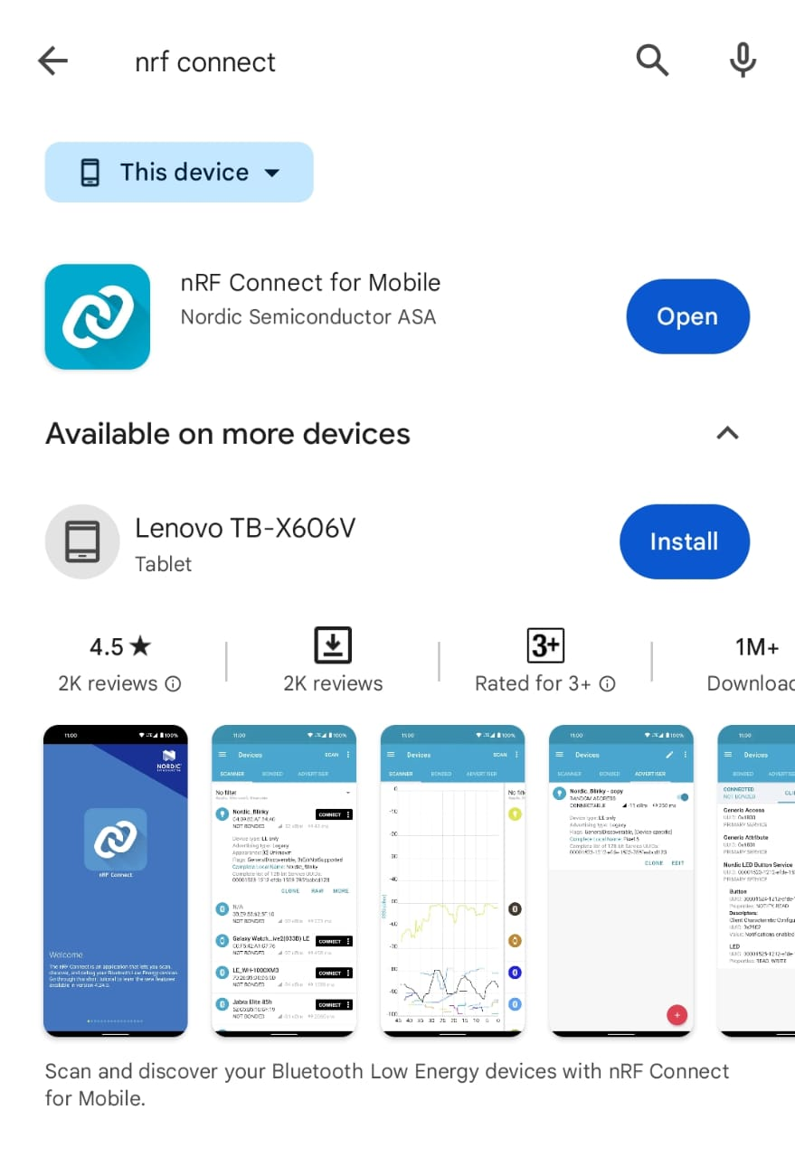

* Open the app->Devices->Check if u can find your esp device Ble_server->Connect

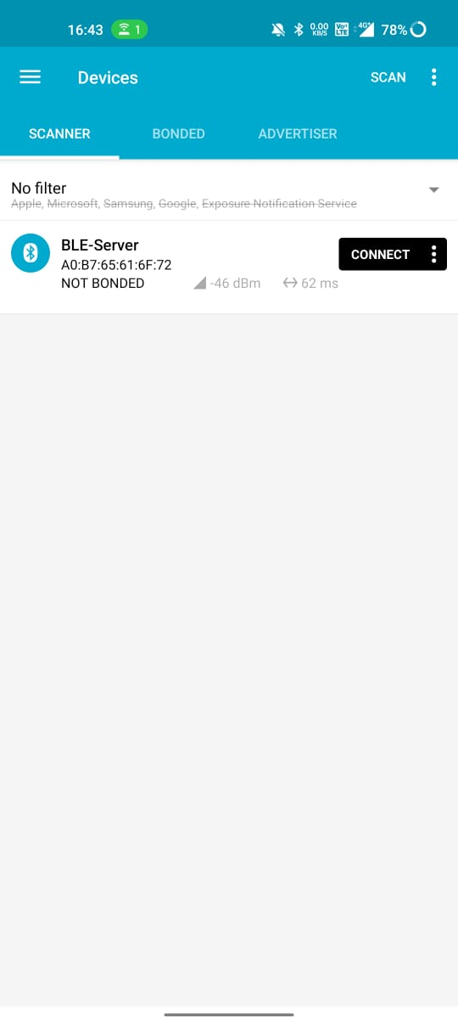

* Go to client->Unknown service->Unknown characteristic (Write)

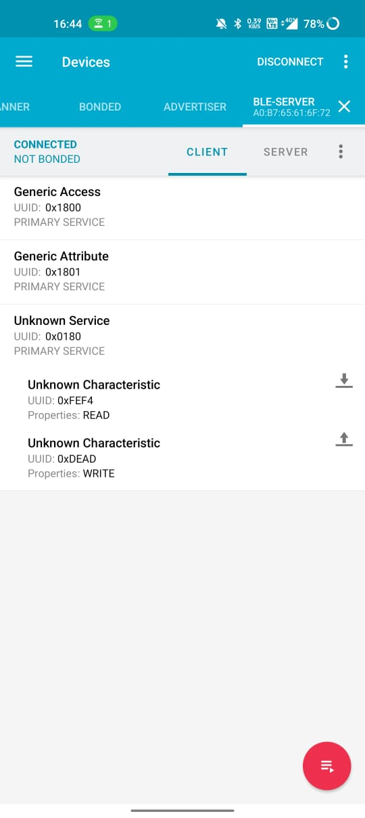

* Click new->select TEXT from the drop down menu

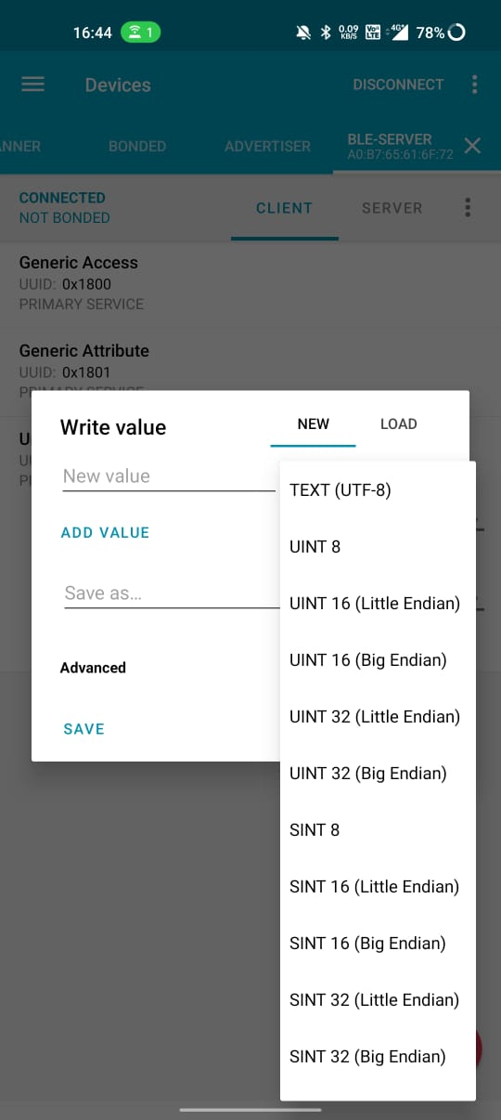

* Write the message you want to send
* Click send

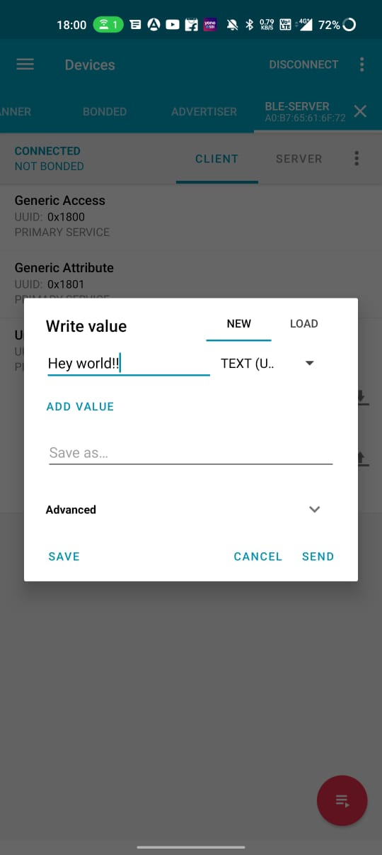 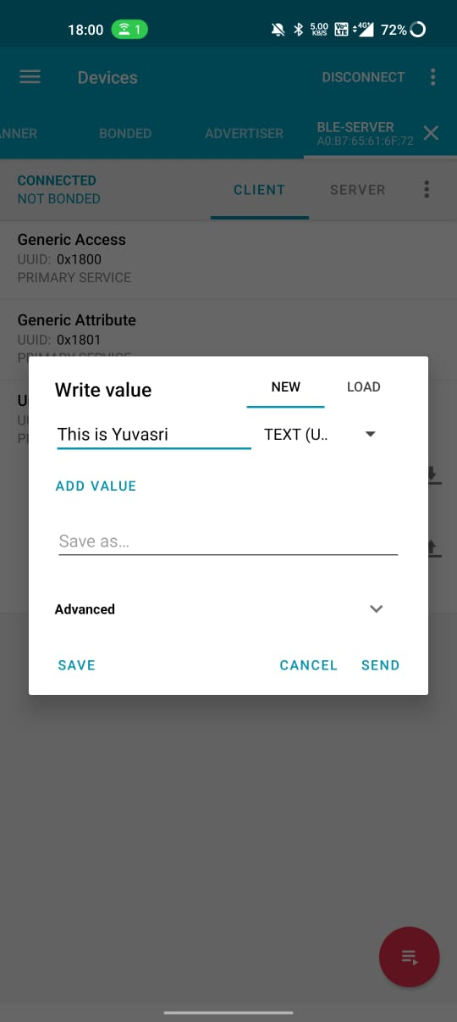

* You can see the messages you sent in the terminal monitor
* If you press disconnect the server will be disconnected and displayed in console

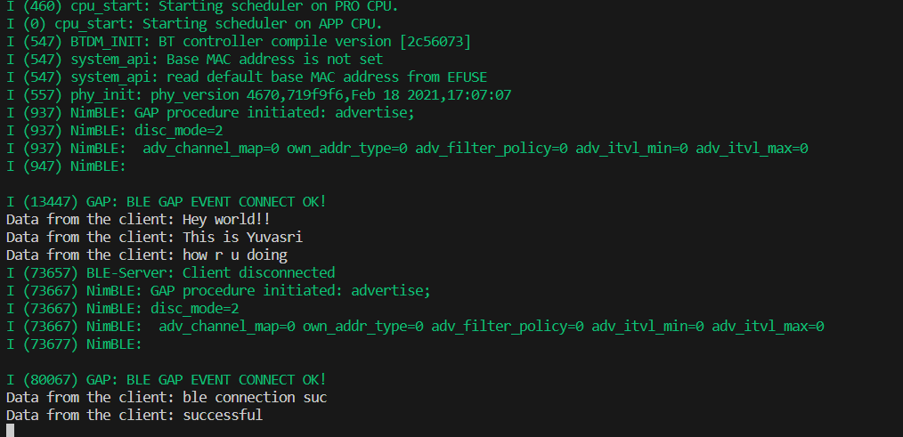

**3.ESP32 GPS INTERFACE**

**Aim:**

The aim of this project is to create an ESP32-based system that reads GPS data from a GPS module and displays the latitude, longitude, date, and time on a web page served by an HTTP server running on the ESP32.

**Components Needed:**

* ESP32 Development Board
* GPS Module Reciever (e.g., SIM28M)
* USB Cable (for programming and power supply)
* Wi-Fi Router (for connecting ESP32 to the network)
* Computer/Laptop for programming the ESP
* Breadboard
* Jumper wires

**SIM28M GPS RECIEVER:**

* SIM28M is a high-performance and reliable GPS module with MTK's high sensitivity navigation engine, providing industry-leading sensitivity, accuracy, and Time-to-First-Fix (TTFF) with low power consumption. It comes in a compact LCC type package.

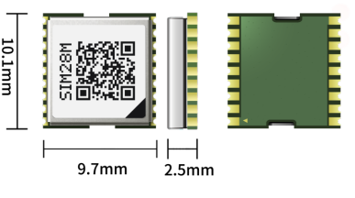

**Key Features and Benefits:**

* High Sensitivity: SIM28M offers high sensitivity navigation, allowing it to acquire and track signals from multiple satellite systems simultaneously.
* Tracking and Acquisition: The module supports 22 tracking channels and 66 acquisition channels, enabling it to efficiently acquire and maintain satellite signals.
* Advanced AGPS Technology: SIM28M combines MTK's EASY™ (Embedded Assist System) and AlwaysLocate™ technology, enabling rapid and accurate positioning by utilizing self-generated orbit prediction (EASY) and ephemeris prediction (EPO).
* SBAS Support: It supports SBAS ranging, including WAAS, EGNOS, GAGAN, and MSAS, further enhancing positioning accuracy.
* Jamming Removing: The module features jamming removal capabilities, improving performance in challenging environments.
* Low Noise Amplifier (LNA): An integrated low-noise amplifier enhances the module's sensitivity, ensuring reliable signal reception.
* Wide Power Supply Range: The module operates on a power supply range of 2.8V to 4.3V, with backup power support from 2.0V to 4.3V.
* Low Power Consumption: SIM28M is designed for power efficiency, with low power consumption during acquisition, tracking, and backup modes.
* Antenna Support: The module supports both active and passive antenna types with external antenna power options.
* Interface Support: It interfaces with external devices through UART, digital I/O, Pulse-per-second (PPS), and GPIO interfaces.
* Supported Protocols: SIM28M supports NEMA, PMTK, and PSIM protocols for communication with external devices.

Overall, SIM28M is an ideal GPS module for applications that require accurate and reliable positioning with low power consumption, making it suitable for a wide range of industrial and consumer applications.

**PROJECT SETUP:**

**Hardware Connection:**

* Connect the GPS module to the ESP32 using UART communication (TX and RX pins).
* Power the ESP32 using a USB cable connected to your computer or an external power supply.
* Make sure the ESP32 is connected to a Wi-Fi network to access the HTTP server.

|  |  |  |
| --- | --- | --- |
| **ESP32 Pin** | **GPS Module Pin** | **Purpose** |
| GPIO 16 | TX | UART TX (To GPS) |
| GPIO 17 | RX | UART RX (From GPS) |
| 3.3V | VCC | Connect to power supply (3.3V) |
| GND | GND | Connect to ground. |

**CIRCUIT DIAGRAM:**

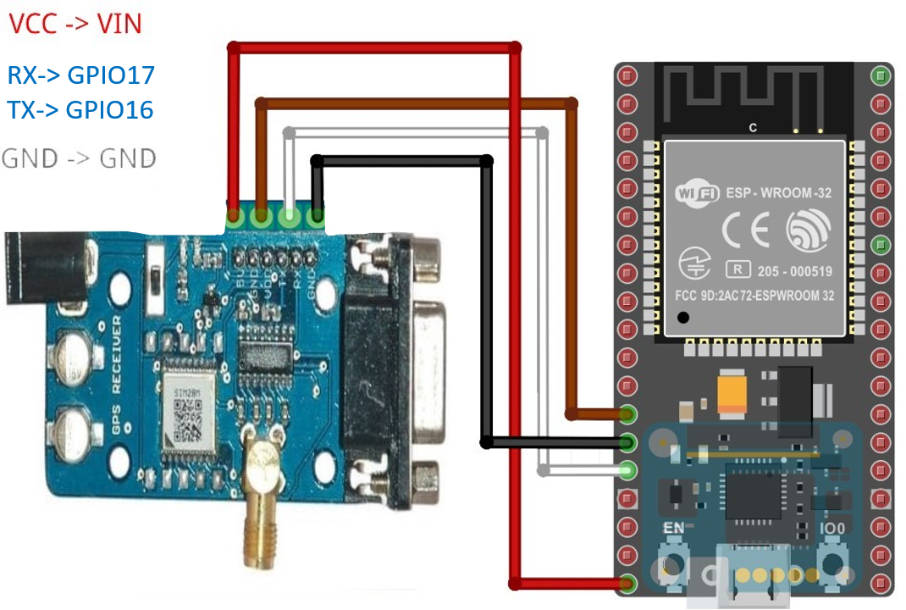

**Software Setup:**

* Install ESP-IDF and the required toolchain for ESP32 development.
* Set up the project using ESP-IDF's project setup tool (idf.py) and configure the project.

**GPS Data Parsing:**

Write a function to parse NMEA sentences received from the GPS module and extract latitude, longitude, date, and time information.

**HTTP Server Setup:**

* Implement an HTTP server using ESP-IDF's built-in HTTP server library.
* Create an HTTP server endpoint (e.g., "/gps") that will handle requests for GPS data.

**HTML Page Generation:**

* Design an HTML page template to display the GPS data received from the ESP32.
* Create a dynamic HTML page that updates the GPS data values using JavaScript or other appropriate methods.

**Web Server Handler Function:**

* Write a function to handle HTTP requests for GPS data.
* Combine the GPS data with the HTML template and send the response to the client.

**Main Application Logic:**

* Create tasks for reading GPS data and connecting to the Wi-Fi network.
* Start the HTTP server to handle client requests for GPS data.
* Implement a main loop to keep the application running.

**CODE:**

#include <stdio.h>

#include <string.h>

#include <stdlib.h>

#include "freertos/FreeRTOS.h"

#include "freertos/task.h"

#include "driver/uart.h"

#include "esp_log.h"

#include "esp_wifi.h"

#include "esp_event_loop.h"

#include "esp_http_server.h"

#include "esp_event.h"

#define GPS_UART_NUM UART_NUM_2

#define GPS_UART_TX_PIN 17

#define GPS_UART_RX_PIN 16

#define GPS_UART_BAUD_RATE 9600

#define HTTP_RESPONSE_MAX_SIZE 1500

#define WIFI_SSID "YOUR_WIFI_SSID"

#define WIFI_PASSWORD "YOUR_WIFI_PASSWORD"

float latitude, longitude;

char date_str[12] = "DD/MM/YY";

char time_str[12] = "HH:mm:ss";

/* HTTP server handler to send GPS data */

esp_err_t gps_data_handler(httpd_req_t *req) {

    char response[HTTP_RESPONSE_MAX_SIZE];

    snprintf(response, sizeof(response),

        "HTTP/1.1 200 OK\r\nContent-Type: text/html\r\n\r\n"

        "<!DOCTYPE html><html><head><title>GPS DATA</title>"

        "<style>a:link{background-color:RED;text-decoration:none;}"

        "table, th, td {border: 1px solid black; border-collapse: collapse;}"

        "</style></head><body style=\"background-color:YELLOW;\">"

        "<h1 style=\"color:RED;font-size:300%%;text-align:center;\">SIM28M (GPS RECEIVER) DATA</h1>"

        "<p style=\"color:BLUE;font-size:250%%;text-align:center;\"><b>Location Details</b></p>"

        "<table style=\"font-size:150%%;margin:auto;\">"

        "<tr><th>Latitude :-</th><td style=\"text-align:center;\">%.6f</td></tr>"

        "<tr><th>Longitude :-</th><td style=\"text-align:center;\">%.6f</td></tr>"

        "<tr><th>Date :-</th><td style=\"text-align:center;\">%s</td></tr>"

        "<tr><th>Time :-</th><td style=\"text-align:center;\">%s</td></tr>"

        "</table></body></html>",

        latitude, longitude, date_str, time_str

    );

    httpd_resp_send(req, response, strlen(response));

    return ESP_OK;

}

httpd_uri_t gps_data_uri = {

    .uri = "/gps",

    .method = HTTP_GET,

    .handler = gps_data_handler,

    .user_ctx = NULL

};

void parse_nmea(char *nmea_sentence, float *latitude, float *longitude) {

    char *token;

    char *rest = nmea_sentence;

    int count = 0;

    // Split the NMEA sentence using ',' as the delimiter

    while ((token = strtok_r(rest, ",", &rest)) != NULL) {

        count++;

        if (count == 3) {

            *latitude = atof(token); // Convert the latitude string to a float

        } else if (count == 5) {

            *longitude = atof(token); // Convert the longitude string to a float

            break;

        }

    }

}

void gps_task(void *pvParameters) {

    char nmea_sentence[128] = {0};

    uart_config_t uart_config = {

        .baud_rate = GPS_UART_BAUD_RATE,

        .data_bits = UART_DATA_8_BITS,

        .parity = UART_PARITY_DISABLE,

        .stop_bits = UART_STOP_BITS_1,

        .flow_ctrl = UART_HW_FLOWCTRL_DISABLE

    };

    uart_param_config(GPS_UART_NUM, &uart_config);

    uart_set_pin(GPS_UART_NUM, GPS_UART_TX_PIN, GPS_UART_RX_PIN, UART_PIN_NO_CHANGE, UART_PIN_NO_CHANGE);

    uart_driver_install(GPS_UART_NUM, 2048, 0, 0, NULL, 0);

    while(1) {

        // Read data from GPS module via UART

        int len = uart_read_bytes(GPS_UART_NUM, (uint8_t *)nmea_sentence, sizeof(nmea_sentence)-1, 100 / portTICK_PERIOD_MS);

        if (len > 0) {

            nmea_sentence[len] = '\0';

            // Check if the NMEA sentence starts with "$GPGGA"

            if (strncmp(nmea_sentence, "$GPGGA,", 7) == 0) {

                parse_nmea(nmea_sentence, &latitude, &longitude);

            }

        }

        vTaskDelay(100 / portTICK_PERIOD_MS);

    }

}

void wifi_task(void *pvParameters) {

    wifi_init_config_t cfg = WIFI_INIT_CONFIG_DEFAULT();

    esp_wifi_init(&cfg);

    esp_wifi_set_mode(WIFI_MODE_STA);

    wifi_config_t wifi_config = {

        .sta = {

            .ssid = WIFI_SSID,

            .password = WIFI_PASSWORD,

        },

    };

    esp_wifi_set_config(ESP_IF_WIFI_STA, &wifi_config);

    esp_wifi_start();

    esp_wifi_connect();

    while(1) {

        vTaskDelay(1000 / portTICK_PERIOD_MS);

    }

}

httpd_handle_t start_webserver(void) {

    httpd_config_t config = HTTPD_DEFAULT_CONFIG();

    httpd_handle_t server = NULL;

    if (httpd_start(&server, &config) == ESP_OK) {

        httpd_register_uri_handler(server, &gps_data_uri);

    }

    return server;

}

void stop_webserver(httpd_handle_t server) {

    httpd_stop(server);

}

void app_main() {

    httpd_handle_t server = NULL;

    xTaskCreate(gps_task, "gps_task", 4096, NULL, 5, NULL);

    xTaskCreate(wifi_task, "wifi_task", 4096, NULL, 4, NULL);

    server = start_webserver();

    while(1) {

        vTaskDelay(1000 / portTICK_PERIOD_MS);

    }

    if (server) {

        stop_webserver(server);

    }

}

->Build the code ,flash and monitor it after connecting the esp32 board through the USB

->After the code is successfully flashed, the ESP32 will act as a web server that serves a web page with real-time GPS data. The GPS data, including latitude, longitude, date, and time, will be read from the GPS module and updated dynamically on the web page .

**PROJECT FLOW:**

1. The ESP32 initializes and sets up the GPS module and Wi-Fi connection.
2. The ESP32 starts reading GPS data from the GPS module periodically.
3. When a client (web browser or HTTP client) accesses the ESP32's IP address with the "/gps" endpoint, the ESP32 responds with the GPS data.
4. The HTTP server generates a dynamic HTML page with the GPS data embedded.
5. The client receives the HTML page with the GPS data displayed.

**OUTPUT:**

SIM28M (GPS RECEIVER) DATA

Location Details

Latitude: XX.XXXXXX

Longitude: YY.YYYYYY

Date: YYYY-MM-DD

Time: HH:MM:SS

If the GPS module is not connected or if it fails to read GPS data, the displayed latitude and longitude values will remain unchanged. The date and time should still be provided by the ESP32 system clock.

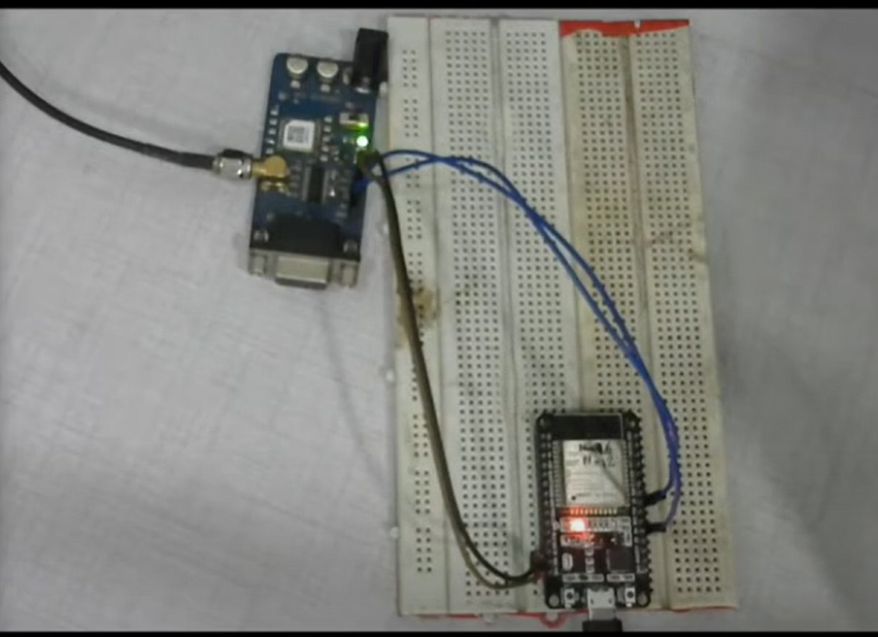

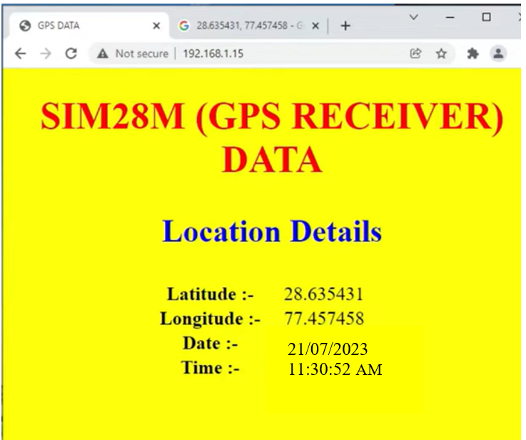

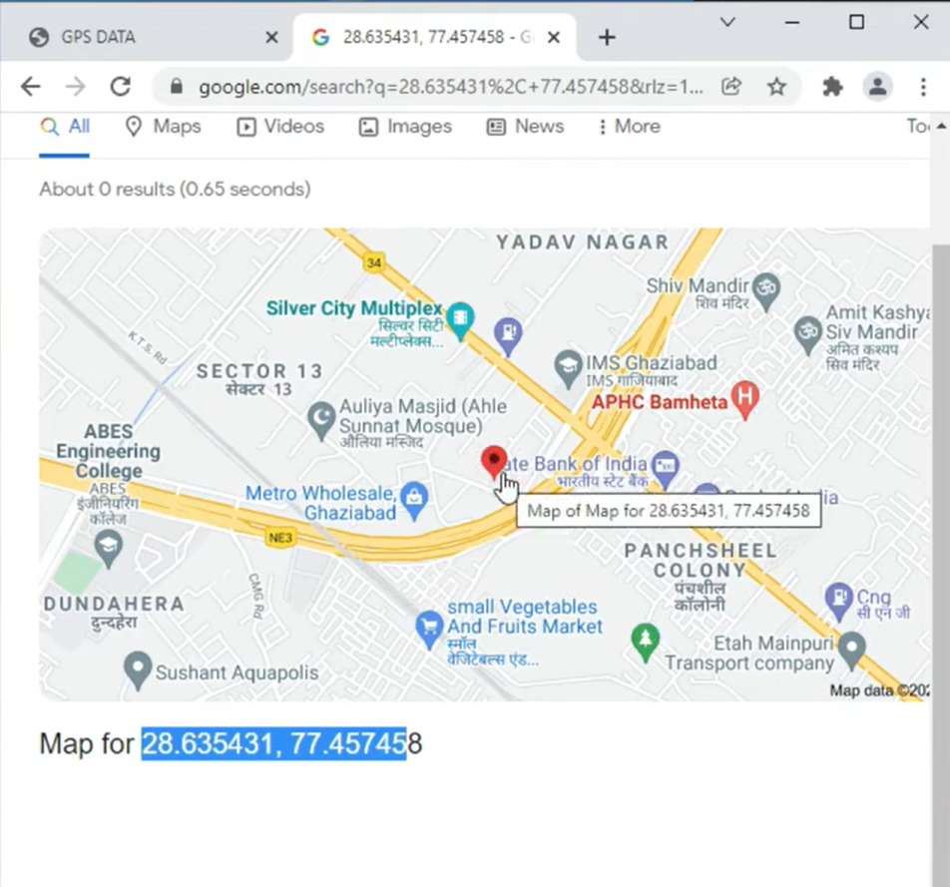

**4.RFID Attendance-Based System using ESP32**

**Aim:**

The aim of the project is to create a smart attendance system that utilizes RFID (Radio Frequency Identification) technology to automate attendance management.

**Components:**

* ESP32 Development Board
* RFID Reader
* RFID Tags/Cards
* LCD Display (optional)
* Power Supply
* LEDs/Buzzers (optional)

# **Overview of RFID:**

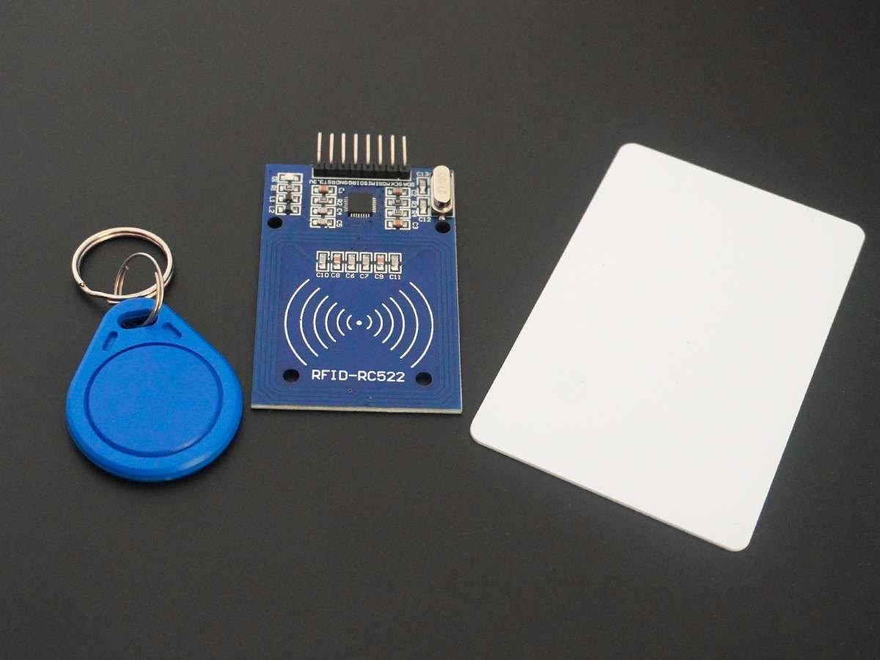

RC522 RFID Modules work on **13.56MHz** which is based on the MFRC522 controller which is designed by NXP Semi-conductor.The RC522 module supports SPI and I2C communication protocols. Here we are using the SPI communication Interface with the ESP32 board. This module operates on a **+3.3V/13-26mA** Power Supply

**RFID** (Radio Frequency Identification) works with the ESP32 by using electromagnetic fields to wirelessly identify and track tags or cards that contain unique identification information.

**RFID Tags/Cards**: RFID tags or cards are small devices that contain an integrated circuit and an antenna. These tags can be passive (no internal power source) or active (powered by a battery). Each tag has a unique identifier that can be read by an RFID reader**. RFID Reader Module**: The ESP32 is equipped with an RFID reader module that consists of a microcontroller (such as the RC522) and an antenna. The reader emits radio frequency signals through its antenna.

**Tag Identification:** When an RFID tag is brought close to the RFID reader's antenna, it receives the radio frequency signal emitted by the reader. In the case of passive tags, the tag draws power from the reader's signal and sends back its unique identifier.

**Data Processing:** The RFID reader's microcontroller processes the received data, including the unique identifier of the scanned tag.

**ESP32 Integration:** The ESP32 microcontroller (on the RFID reader module) communicates with the main ESP32 board, relaying the scanned tag's unique identifier to the ESP32.

**Data Handling**: The ESP32 processes the tag's unique identifier and performs actions based on the received data. For example, it can log the scanned tag's information, trigger specific events, or send the data to a remote server.

**Application Use:** The ESP32 can be integrated into various applications, such as access control systems, attendance tracking systems, inventory management, and more. It allows for easy and convenient identification and tracking of RFID-tagged items or individuals without the need for direct contact.

**Connections:**

|  |  |
| --- | --- |
| **RFID** | **ESP32 Pin** |
| SDA | D4 (GPIO4) |
| SCK | D5 (GPIO5) |
| MOSI | D7 (GPIO7) |
| MISO | D6 (GPIO6) |
| IRQ | - |
| RST | D3 (GPIO3) |
| GND | GND |
| 3.3V | 3.3V |

**Circuit diagram:**

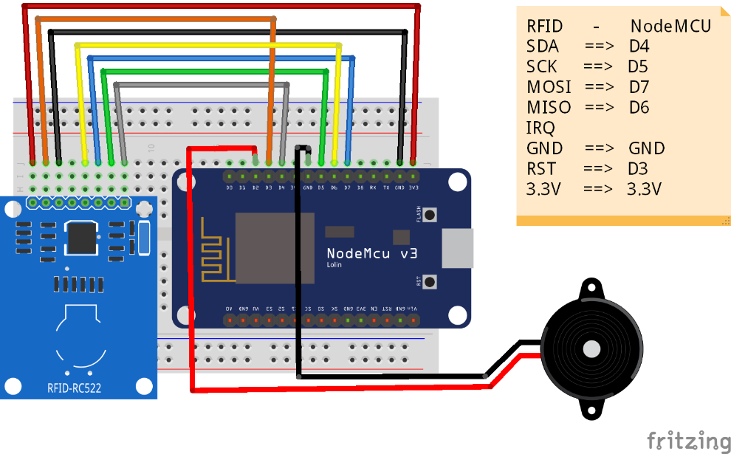

**PROCEDURE:**

**Creating Google Sheets:**

* Go to google sheets -> sign in with your account
* Open Extensions->Apps script ->in the new window paste the following code:

function doGet(e) {

Logger.log( JSON.stringify(e) );

var result = 'Ok';

if (e.parameter == 'undefined') {

result = 'No Parameters';

}

else {

var sheet_id = ' '; // Spreadsheet ID

var sheet = SpreadsheetApp.openById(sheet_id).getActiveSheet();

var newRow = sheet.getLastRow() + 1;

var rowData = [];

var Curr_Date = new Date();

rowData[0] = Curr_Date; // Date in column A

var Curr_Time = Utilities.formatDate(Curr_Date, "Asia/Kolkata", 'HH:mm:ss');

rowData[1] = Curr_Time; // Time in column B

for (var param in e.parameter) {

Logger.log('In for loop, param=' + param);

var value = stripQuotes(e.parameter[param]);

Logger.log(param + ':' + e.parameter[param]);

switch (param) {

case 'name':

rowData[2] = value; // Employee Name in column C

result = 'Employee Name Written on column C';

break;

default:

result = "unsupported parameter";

}

}

Logger.log(JSON.stringify(rowData));

var newRange = sheet.getRange(newRow, 1, 1, rowData.length);

newRange.setValues([rowData]);

}

return ContentService.createTextOutput(result);

}

function stripQuotes( value ) {

return value.replace(/^["']|['"]$/g, "");

}

-> Copy the spreadsheet id by going to the window spreadsheet is opened and paste in the code as shown below.

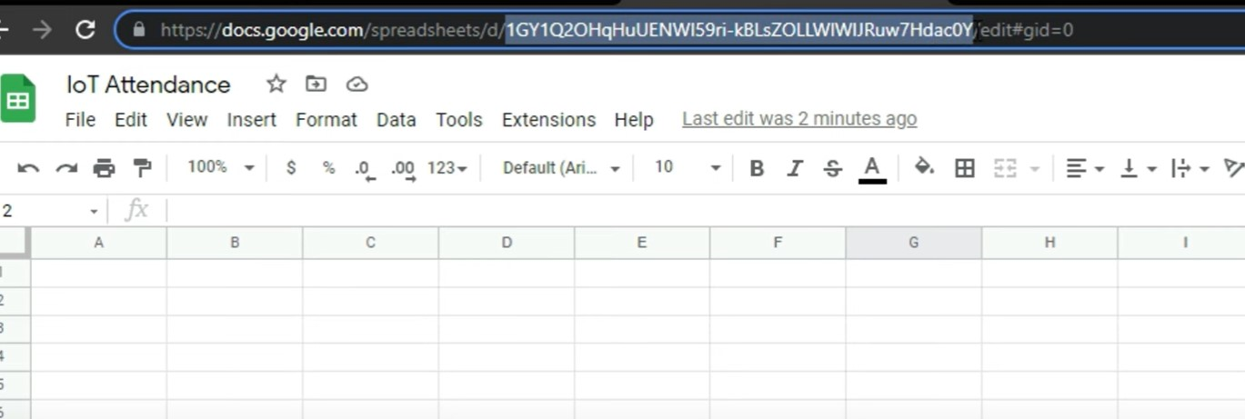

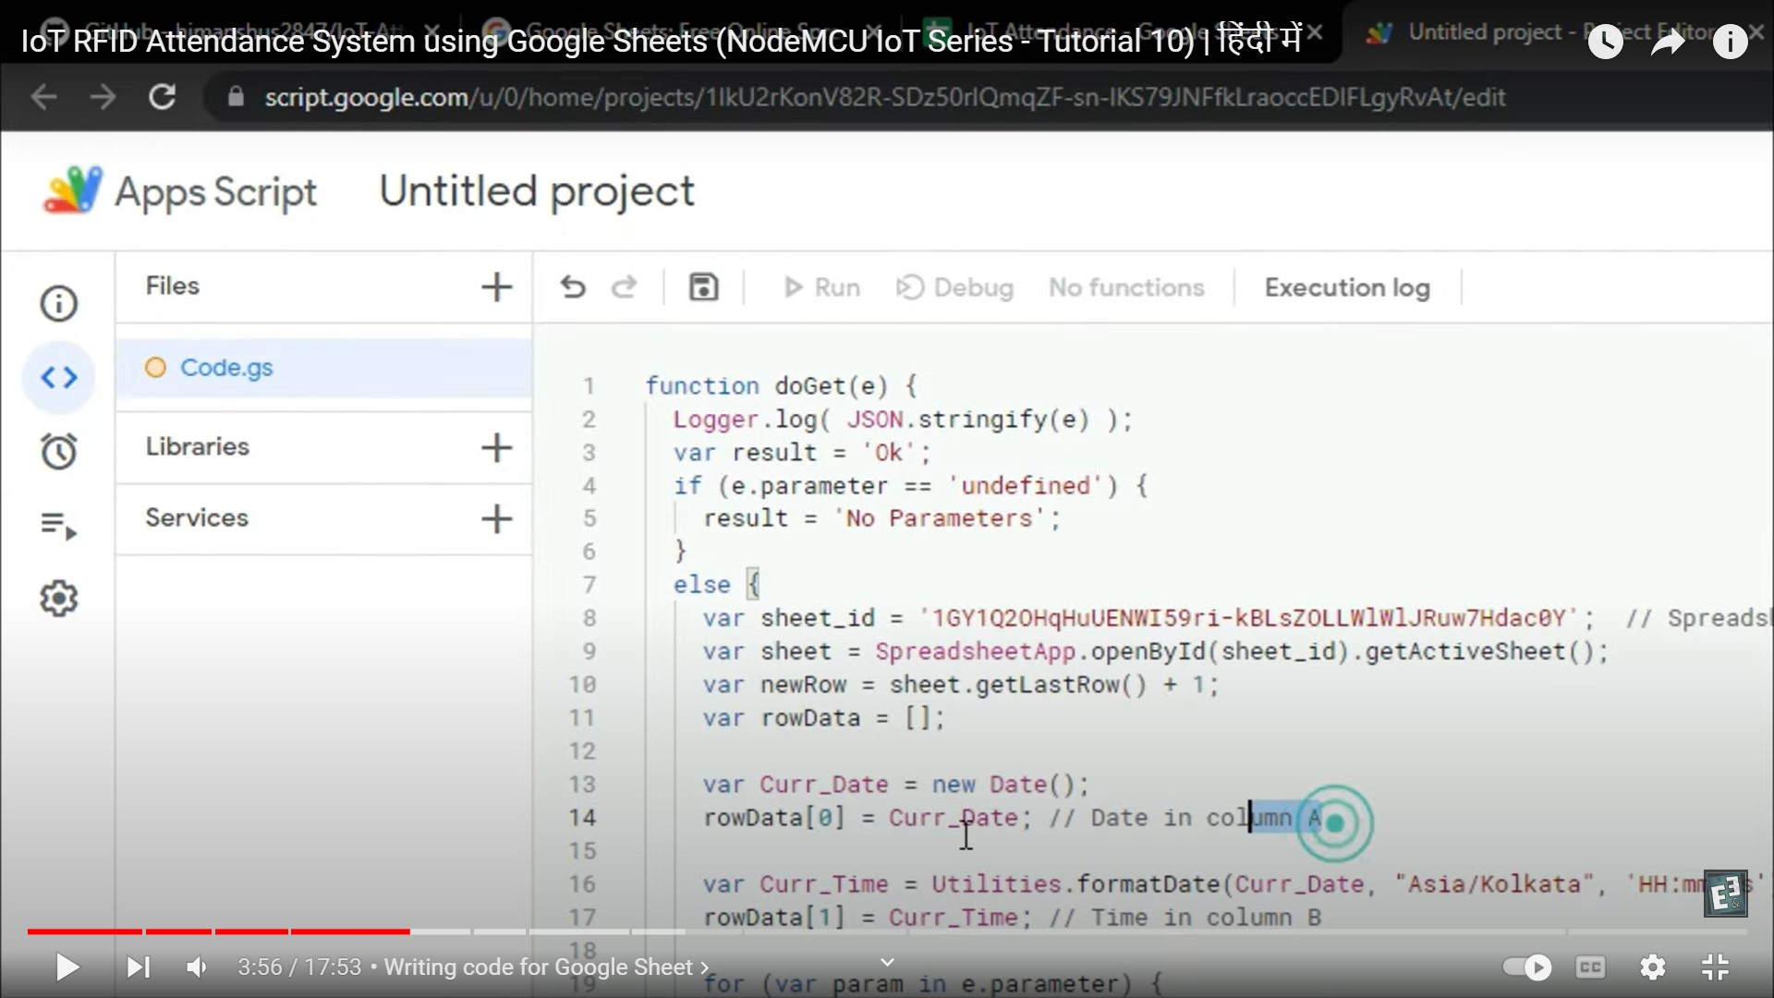

->Rename the untitled project to RFID and Save it.

->Go to Deploy->New deployment->select type->web app

->Select who can access->Anyone->Press Deploy->Authorise access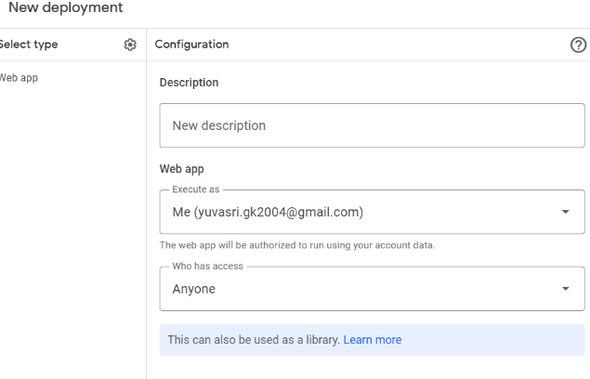

->Show advanced->Go to untitled project->Allow and copy the web app url->Done

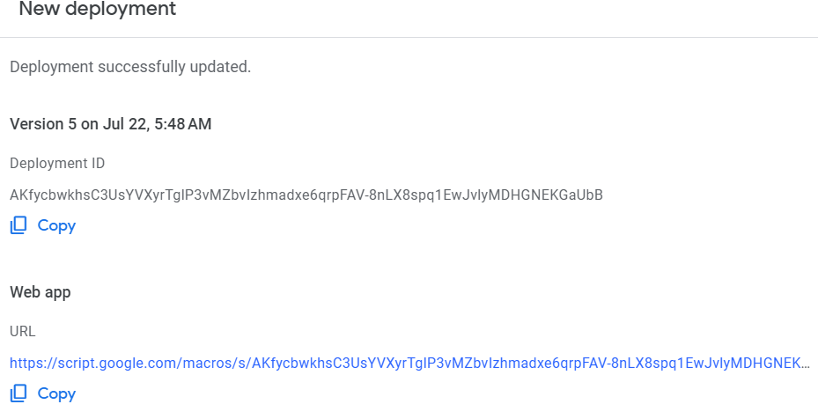

**CODE:**

Open Vscode

Create a new project in esp-idf

**Libraries:**

**rc522.c**

#include <freertos/FreeRTOS.h>

#include <freertos/task.h>

#include <esp_system.h>

#include <esp_log.h>

#include <string.h>

#include "rc522.h"

static const char* TAG = "rc522";

struct rc522 {

    bool running;                          /*<! Indicates whether rc522 task is running or not */

    rc522_config_t* config;                /*<! Configuration */

    TaskHandle_t task_handle;              /*<! Handle of task */

    esp_event_loop_handle_t event_handle;  /*<! Handle of event loop */

    spi_device_handle_t spi_handle;

    bool initialized;                      /*<! Set on the first start() when configuration is sent to rc522 */

    bool scanning;                         /*<! Whether the rc522 is in scanning or idle mode */

    bool tag_was_present_last_time;

    bool bus_initialized_by_user;          /*<! Whether the bus has been initialized manually by the user, before calling rc522_create function */

};

ESP_EVENT_DEFINE_BASE(RC522_EVENTS);

static esp_err_t rc522_spi_send(rc522_handle_t rc522, uint8_t* buffer, uint8_t length);

static esp_err_t rc522_spi_receive(rc522_handle_t rc522, uint8_t* buffer, uint8_t length, uint8_t addr);

static esp_err_t rc522_i2c_send(rc522_handle_t rc522, uint8_t* buffer, uint8_t length);

static esp_err_t rc522_i2c_receive(rc522_handle_t rc522, uint8_t* buffer, uint8_t length, uint8_t addr);

static void rc522_task(void* arg);

static esp_err_t rc522_write_n(rc522_handle_t rc522, uint8_t addr, uint8_t n, uint8_t *data)

{

    uint8_t* buffer = (uint8_t*) malloc(n + 1); // FIXME: memcheck

    buffer[0] = addr;

    memcpy(buffer + 1, data, n);

    esp_err_t ret;

    switch(rc522->config->transport) {

        case RC522_TRANSPORT_SPI:

            ret = rc522_spi_send(rc522, buffer, n + 1);

            break;

        case RC522_TRANSPORT_I2C:

            ret = rc522_i2c_send(rc522, buffer, n + 1);

            break;

        default:

            ESP_LOGE(TAG, "write: Unknown transport");

            ret = ESP_ERR_INVALID_STATE; // unknown transport

    }

    free(buffer);

    if(ESP_OK != ret) {

        ESP_LOGE(TAG, "Failed to write data (err: %s)", esp_err_to_name(ret));

    }

    return ret;

}

static inline esp_err_t rc522_write(rc522_handle_t rc522, uint8_t addr, uint8_t val)

{

    return rc522_write_n(rc522, addr, 1, &val);

}

static uint8_t* rc522_read_n(rc522_handle_t rc522, uint8_t addr, uint8_t n)

{

    uint8_t* buffer = (uint8_t*) malloc(n); // FIXME: memcheck

    esp_err_t ret;

    switch(rc522->config->transport) {

        case RC522_TRANSPORT_SPI:

            ret = rc522_spi_receive(rc522, buffer, n, addr);

            break;

        case RC522_TRANSPORT_I2C:

            ret = rc522_i2c_receive(rc522, buffer, n, addr);

            break;

        default:

            ESP_LOGE(TAG, "read: Unknown transport");

            ret = ESP_ERR_INVALID_STATE; // unknown transport

    }

    if(ESP_OK != ret) {

        free(buffer);

        buffer = NULL;

        ESP_LOGE(TAG, "Failed to read data (err: %s)", esp_err_to_name(ret));

    }

    return buffer;

}

static inline uint8_t rc522_read(rc522_handle_t rc522, uint8_t addr)

{

    uint8_t* buffer = rc522_read_n(rc522, addr, 1);

    uint8_t res = buffer[0];

    free(buffer);

    return res;

}

static inline esp_err_t rc522_set_bitmask(rc522_handle_t rc522, uint8_t addr, uint8_t mask)

{

    return rc522_write(rc522, addr, rc522_read(rc522, addr) | mask);

}

static inline esp_err_t rc522_clear_bitmask(rc522_handle_t rc522, uint8_t addr, uint8_t mask)

{

    return rc522_write(rc522, addr, rc522_read(rc522, addr) & ~mask);

}

static inline uint8_t rc522_firmware(rc522_handle_t rc522)

{

    return rc522_read(rc522, 0x37);

}

static esp_err_t rc522_antenna_on(rc522_handle_t rc522)

{

    esp_err_t err;

    if(~ (rc522_read(rc522, 0x14) & 0x03)) {

        err = rc522_set_bitmask(rc522, 0x14, 0x03);

        if(err != ESP_OK) {

            return err;

        }

    }

    return rc522_write(rc522, 0x26, 0x60); // 43dB gain

}

rc522_config_t* rc522_clone_config(rc522_config_t* config)

{

    rc522_config_t* new_config = calloc(1, sizeof(rc522_config_t)); // FIXME: memcheck

    memcpy(new_config, config, sizeof(rc522_config_t));

    // defaults

    new_config->scan_interval_ms = config->scan_interval_ms < 50 ? RC522_DEFAULT_SCAN_INTERVAL_MS : config->scan_interval_ms;

    new_config->task_stack_size = config->task_stack_size == 0 ? RC522_DEFAULT_TASK_STACK_SIZE : config->task_stack_size;

    new_config->task_priority = config->task_priority == 0 ? RC522_DEFAULT_TASK_STACK_PRIORITY : config->task_priority;

    new_config->spi.clock_speed_hz = config->spi.clock_speed_hz == 0 ? RC522_DEFAULT_SPI_CLOCK_SPEED_HZ : config->spi.clock_speed_hz;

    new_config->i2c.rw_timeout_ms = config->i2c.rw_timeout_ms == 0 ? RC522_DEFAULT_I2C_RW_TIMEOUT_MS : config->i2c.rw_timeout_ms;

    new_config->i2c.clock_speed_hz = config->i2c.clock_speed_hz == 0 ? RC522_DEFAULT_I2C_CLOCK_SPEED_HZ : config->i2c.clock_speed_hz;

    return new_config;

}

static esp_err_t rc522_create_transport(rc522_handle_t rc522)

{

    esp_err_t ret;

    switch(rc522->config->transport) {

        case RC522_TRANSPORT_SPI: {

                spi_device_interface_config_t devcfg = {

                    .clock_speed_hz = rc522->config->spi.clock_speed_hz,

                    .mode = 0,

                    .spics_io_num = rc522->config->spi.sda_gpio,

                    .queue_size = 7,

                    .flags = rc522->config->spi.device_flags,

                };

                rc522->bus_initialized_by_user = rc522->config->spi.bus_is_initialized;

                if(! rc522->bus_initialized_by_user) {

                    spi_bus_config_t buscfg = {

                        .miso_io_num = rc522->config->spi.miso_gpio,

                        .mosi_io_num = rc522->config->spi.mosi_gpio,

                        .sclk_io_num = rc522->config->spi.sck_gpio,

                        .quadwp_io_num = -1,

                        .quadhd_io_num = -1,

                    };

                    if(ESP_OK != (ret = spi_bus_initialize(rc522->config->spi.host, &buscfg, 0))) {

                        break;

                    }

                }

                ret = spi_bus_add_device(rc522->config->spi.host, &devcfg, &rc522->spi_handle);

            }

            break;

        case RC522_TRANSPORT_I2C: {

                i2c_config_t conf = {

                    .mode = I2C_MODE_MASTER,

                    .sda_io_num = rc522->config->i2c.sda_gpio,

                    .scl_io_num = rc522->config->i2c.scl_gpio,

                    .sda_pullup_en = GPIO_PULLUP_ENABLE,

                    .scl_pullup_en = GPIO_PULLUP_ENABLE,

                    .master.clk_speed = rc522->config->i2c.clock_speed_hz,

                };

                if(ESP_OK != (ret = i2c_param_config(rc522->config->i2c.port, &conf))) {

                    break;

                }

                ret = i2c_driver_install(rc522->config->i2c.port, conf.mode, false, false, 0x00);

            }

            break;

        default:

            ESP_LOGE(TAG, "create_transport: Unknown transport");

            ret = ESP_ERR_INVALID_STATE; // unknown transport

            break;

    }

    return ret;

}

esp_err_t rc522_create(rc522_config_t* config, rc522_handle_t* out_rc522)

{

    if(! config || ! out_rc522) {

        return ESP_ERR_INVALID_ARG;

    }

    esp_err_t ret;

    rc522_handle_t rc522 = calloc(1, sizeof(struct rc522)); // FIXME: memcheck

    rc522->config = rc522_clone_config(config);

    if(ESP_OK != (ret = rc522_create_transport(rc522))) {

        ESP_LOGE(TAG, "Cannot create transport");

        rc522_destroy(rc522);

        return ret;

    }

    esp_event_loop_args_t event_args = {

        .queue_size = 1,

        .task_name = NULL, // no task will be created

    };

    if(ESP_OK != (ret = esp_event_loop_create(&event_args, &rc522->event_handle))) {

        ESP_LOGE(TAG, "Cannot create event loop");

        rc522_destroy(rc522);

        return ret;

    }

    rc522->running = true;

    if (xTaskCreate(rc522_task, "rc522_task", rc522->config->task_stack_size, rc522, rc522->config->task_priority, &rc522->task_handle) != pdTRUE) {

        ESP_LOGE(TAG, "Cannot create task");

        rc522_destroy(rc522);

        return ret;

    }

    *out_rc522 = rc522;

    return ESP_OK;

}

esp_err_t rc522_register_events(rc522_handle_t rc522, rc522_event_t event, esp_event_handler_t event_handler, void* event_handler_arg)

{

    if(! rc522) {

        return ESP_ERR_INVALID_ARG;

    }

    return esp_event_handler_register_with(rc522->event_handle, RC522_EVENTS, event, event_handler, event_handler_arg);

}

esp_err_t rc522_unregister_events(rc522_handle_t rc522, rc522_event_t event, esp_event_handler_t event_handler)

{

    if(! rc522) {

        return ESP_ERR_INVALID_ARG;

    }

    return esp_event_handler_unregister_with(rc522->event_handle, RC522_EVENTS, event, event_handler);

}

static uint64_t rc522_sn_to_u64(uint8_t* sn)

{

    if(! sn) {

        return 0;

    }

    uint64_t result = 0;

    for(int i = 4; i >= 0; i--) {

        result |= ((uint64_t) sn[i] << (i * 8));

    }

    return result;

}

/* Returns pointer to dynamically allocated array of two element */

static uint8_t* rc522_calculate_crc(rc522_handle_t rc522, uint8_t *data, uint8_t n)

{

    rc522_clear_bitmask(rc522, 0x05, 0x04);

    rc522_set_bitmask(rc522, 0x0A, 0x80);

    rc522_write_n(rc522, 0x09, n, data);

    rc522_write(rc522, 0x01, 0x03);

    uint8_t i = 255;

    uint8_t nn = 0;

    for(;;) {

        nn = rc522_read(rc522, 0x05);

        i--;

        if(! (i != 0 && ! (nn & 0x04))) {

            break;

        }

    }

    uint8_t* res = (uint8_t*) malloc(2); // FIXME: memcheck

    res[0] = rc522_read(rc522, 0x22);

    res[1] = rc522_read(rc522, 0x21);

    return res;

}

static uint8_t* rc522_card_write(rc522_handle_t rc522, uint8_t cmd, uint8_t *data, uint8_t n, uint8_t* res_n)

{

    uint8_t *result = NULL;

    uint8_t irq = 0x00;

    uint8_t irq_wait = 0x00;

    uint8_t last_bits = 0;

    uint8_t nn = 0;

    if(cmd == 0x0E) {

        irq = 0x12;

        irq_wait = 0x10;

    }

    else if(cmd == 0x0C) {

        irq = 0x77;

        irq_wait = 0x30;

    }

    rc522_write(rc522, 0x02, irq | 0x80);

    rc522_clear_bitmask(rc522, 0x04, 0x80);

    rc522_set_bitmask(rc522, 0x0A, 0x80);

    rc522_write(rc522, 0x01, 0x00);

    rc522_write_n(rc522, 0x09, n, data);

    rc522_write(rc522, 0x01, cmd);

    if(cmd == 0x0C) {

        rc522_set_bitmask(rc522, 0x0D, 0x80);

    }

    uint16_t i = 1000;

    for(;;) {

        nn = rc522_read(rc522, 0x04);

        i--;

        if(! (i != 0 && (((nn & 0x01) == 0) && ((nn & irq_wait) == 0)))) {

            break;

        }

    }

    rc522_clear_bitmask(rc522, 0x0D, 0x80);

    if(i != 0) {

        if((rc522_read(rc522, 0x06) & 0x1B) == 0x00) {

            if(cmd == 0x0C) {

                nn = rc522_read(rc522, 0x0A);

                last_bits = rc522_read(rc522, 0x0C) & 0x07;

                if (last_bits != 0) {

                    *res_n = (nn - 1) + last_bits;

                } else {

                    *res_n = nn;

                }

                result = (uint8_t*) malloc(*res_n); // FIXME: memcheck

                for(i = 0; i < *res_n; i++) {

                    result[i] = rc522_read(rc522, 0x09);

                }

            }

        }

    }

    return result;

}

static uint8_t* rc522_request(rc522_handle_t rc522, uint8_t* res_n)

{

    uint8_t* result = NULL;

    rc522_write(rc522, 0x0D, 0x07);

    uint8_t req_mode = 0x26;

    result = rc522_card_write(rc522, 0x0C, &req_mode, 1, res_n);

    if(*res_n * 8 != 0x10) {

        free(result);

        return NULL;

    }

    return result;

}

static uint8_t* rc522_anticoll(rc522_handle_t rc522)

{

    uint8_t res_n;

    rc522_write(rc522, 0x0D, 0x00);

    uint8_t* result = rc522_card_write(rc522, 0x0C, (uint8_t[]) { 0x93, 0x20 }, 2, &res_n);

    if(result && res_n != 5) { // all cards/tags serial numbers is 5 bytes long (?)

        free(result);

        return NULL;

    }

    return result;

}

static uint8_t* rc522_get_tag(rc522_handle_t rc522)

{

    uint8_t* result = NULL;

    uint8_t* res_data = NULL;

    uint8_t res_data_n;

    res_data = rc522_request(rc522, &res_data_n);

    if(res_data != NULL) {

        free(res_data);

        result = rc522_anticoll(rc522);

        if(result != NULL) {

            uint8_t buf[] = { 0x50, 0x00, 0x00, 0x00 };

            uint8_t* crc = rc522_calculate_crc(rc522, buf, 2);

            buf[2] = crc[0];

            buf[3] = crc[1];

            free(crc);

            res_data = rc522_card_write(rc522, 0x0C, buf, 4, &res_data_n);

            free(res_data);

            rc522_clear_bitmask(rc522, 0x08, 0x08);

            return result;

        }

    }

    return NULL;

}

esp_err_t rc522_start(rc522_handle_t rc522)

{

    if(! rc522) {

        return ESP_ERR_INVALID_ARG;

    }

    if(rc522->scanning) { // Already in scan mode

        return ESP_OK;

    }

    if(! rc522->initialized) {

        // Initialization will be done only once, on the first call of start function

        esp_err_t err;

        // ---------- RW test ------------

        const uint8_t test_addr = 0x24, test_val = 0x25;

        for(uint8_t i = test_val; i < test_val + 2; i++) {

            if((err = rc522_write(rc522, test_addr, i)) != ESP_OK || rc522_read(rc522, test_addr) != i) {

                ESP_LOGE(TAG, "Read/write test failed");

                rc522_destroy(rc522);

                return err;

            }

        }

        // ------- End of RW test --------

        rc522_write(rc522, 0x01, 0x0F);

        rc522_write(rc522, 0x2A, 0x8D);

        rc522_write(rc522, 0x2B, 0x3E);

        rc522_write(rc522, 0x2D, 0x1E);

        rc522_write(rc522, 0x2C, 0x00);

        rc522_write(rc522, 0x15, 0x40);

        rc522_write(rc522, 0x11, 0x3D);

        rc522_antenna_on(rc522);

        rc522->initialized = true;

        ESP_LOGI(TAG, "Initialized (firmware v%d.0)", (rc522_firmware(rc522) & 0x03));

    }

    rc522->scanning = true;

    return ESP_OK;

}

esp_err_t rc522_pause(rc522_handle_t rc522)

{

    if(! rc522) {

        return ESP_ERR_INVALID_ARG;

    }

    if(! rc522->scanning) {

        return ESP_OK;

    }

    rc522->scanning = false;

    return ESP_OK;

}

static void rc522_destroy_transport(rc522_handle_t rc522)

{

    switch(rc522->config->transport) {

        case RC522_TRANSPORT_SPI:

            spi_bus_remove_device(rc522->spi_handle);

            if(rc522->bus_initialized_by_user) {

                spi_bus_free(rc522->config->spi.host);

            }

            break;

        case RC522_TRANSPORT_I2C:

            i2c_driver_delete(rc522->config->i2c.port);

            break;

        default:

            ESP_LOGW(TAG, "destroy_transport: Unknown transport");

    }

}

void rc522_destroy(rc522_handle_t rc522)

{

    if(! rc522) {

        return;

    }

    if(xTaskGetCurrentTaskHandle() == rc522->task_handle) {

        ESP_LOGE(TAG, "Cannot destroy rc522 from event handler");

        return;

    }

    rc522_pause(rc522); // stop task

    rc522->running = false; // task will delete himself

    // FIXME: Wait for task to exit

    rc522_destroy_transport(rc522);

    if(rc522->event_handle) {

        esp_event_loop_delete(rc522->event_handle);

        rc522->event_handle = NULL;

    }

    free(rc522->config);

    rc522->config = NULL;

    free(rc522);

    rc522 = NULL;

}

static esp_err_t rc522_dispatch_event(rc522_handle_t rc522, rc522_event_t event, void* data)

{

    if(! rc522) {

        return ESP_ERR_INVALID_ARG;

    }

    rc522_event_data_t e_data = {

        .rc522 = rc522,

        .ptr = data,

    };

    esp_err_t err;

    if(ESP_OK != (err = esp_event_post_to(rc522->event_handle, RC522_EVENTS, event, &e_data, sizeof(rc522_event_data_t), portMAX_DELAY))) {

        return err;

    }

    return esp_event_loop_run(rc522->event_handle, 0);

}

static esp_err_t rc522_spi_send(rc522_handle_t rc522, uint8_t* buffer, uint8_t length)

{

    buffer[0] = (buffer[0] << 1) & 0x7E;

    return spi_device_transmit(rc522->spi_handle, &(spi_transaction_t){

        .length = 8 * length,

        .tx_buffer = buffer,

    });

}

static esp_err_t rc522_spi_receive(rc522_handle_t rc522, uint8_t* buffer, uint8_t length, uint8_t addr)

{

    addr = ((addr << 1) & 0x7E) | 0x80;

    esp_err_t ret;

    if(SPI_DEVICE_HALFDUPLEX & rc522->config->spi.device_flags) {

        ret = spi_device_transmit(rc522->spi_handle, &(spi_transaction_t){

            .flags = SPI_TRANS_USE_TXDATA,

            .length = 8,

            .tx_data[0] = addr,

            .rxlength = 8 * length,

            .rx_buffer = buffer,

        });

    } else { // Fullduplex

        if(ESP_OK != (ret = spi_device_transmit(rc522->spi_handle, &(spi_transaction_t){

            .flags = SPI_TRANS_USE_TXDATA,

            .length = 8,

            .tx_data[0] = addr,

        }))) {

            return ret;

        };

        ret = spi_device_transmit(rc522->spi_handle, &(spi_transaction_t){

            .flags = 0x00,

            .length = 8,

            .rxlength = 8 * length,

            .rx_buffer = buffer,

        });

    }

    return ret;

}

static esp_err_t rc522_i2c_send(rc522_handle_t rc522, uint8_t* buffer, uint8_t length)

{

    return i2c_master_write_to_device(rc522->config->i2c.port, RC522_I2C_ADDRESS, buffer, length, rc522->config->i2c.rw_timeout_ms / portTICK_PERIOD_MS);

}

static esp_err_t rc522_i2c_receive(rc522_handle_t rc522, uint8_t* buffer, uint8_t length, uint8_t addr)

{

    return i2c_master_write_read_device(rc522->config->i2c.port, RC522_I2C_ADDRESS, &addr, 1, buffer, length, rc522->config->i2c.rw_timeout_ms / portTICK_PERIOD_MS);

}

static void rc522_task(void* arg)

{

    rc522_handle_t rc522 = (rc522_handle_t) arg;

    while(rc522->running) {

        if(! rc522->scanning) {

            // Idling...

            vTaskDelay(100 / portTICK_PERIOD_MS);

            continue;

        }

        uint8_t* serial_no_array = rc522_get_tag(rc522);

        if(! serial_no_array) {

            rc522->tag_was_present_last_time = false;

        } else if(! rc522->tag_was_present_last_time) {

            rc522_tag_t tag = {

                .serial_number = rc522_sn_to_u64(serial_no_array),

            };

            free(serial_no_array);

            rc522_dispatch_event(rc522, RC522_EVENT_TAG_SCANNED, &tag);

            rc522->tag_was_present_last_time = true;

        } else {

            free(serial_no_array);

        }

        int delay_interval_ms = rc522->config->scan_interval_ms;

        if(rc522->tag_was_present_last_time) {

            delay_interval_ms *= 2; // extra scan-bursting prevention

        }

        vTaskDelay(delay_interval_ms / portTICK_PERIOD_MS);

    }

    vTaskDelete(NULL);

}

**Header files :**

#pragma once

#ifdef __cplusplus

extern "C" {

#endif

#include <esp_event.h>

#include <driver/spi_master.h>

#include <driver/i2c.h>

#define RC522_I2C_ADDRESS (0x28)

#define RC522_DEFAULT_SCAN_INTERVAL_MS (125)

#define RC522_DEFAULT_TASK_STACK_SIZE (4 * 1024)

#define RC522_DEFAULT_TASK_STACK_PRIORITY (4)

#define RC522_DEFAULT_SPI_CLOCK_SPEED_HZ (5000000)

#define RC522_DEFAULT_I2C_RW_TIMEOUT_MS (1000)

#define RC522_DEFAULT_I2C_CLOCK_SPEED_HZ (100000)

ESP_EVENT_DECLARE_BASE(RC522_EVENTS);

typedef struct rc522* rc522_handle_t;

typedef enum {

    RC522_TRANSPORT_SPI,

    RC522_TRANSPORT_I2C,

} rc522_transport_t;

typedef struct {

    uint16_t scan_interval_ms;         /*<! How fast will ESP32 scan for nearby tags, in miliseconds */

    size_t task_stack_size;            /*<! Stack size of rc522 task */

    uint8_t task_priority;             /*<! Priority of rc522 task */

    rc522_transport_t transport;       /*<! Transport that will be used. Defaults to SPI */

    union {

        struct {

            spi_host_device_t host;

            int miso_gpio;

            int mosi_gpio;

            int sck_gpio;

            int sda_gpio;

            int clock_speed_hz;

            uint32_t device_flags;     /*<! Bitwise OR of SPI_DEVICE_* flags */

            /**

             * @brief Set to true if the bus is already initialized.

             *        NOTE: This property will be removed in future,

             *        once when https://github.com/espressif/esp-idf/issues/8745 is resolved

             *

             */

            bool bus_is_initialized;

        } spi;

        struct {

            i2c_port_t port;

            int sda_gpio;

            int scl_gpio;

            int rw_timeout_ms;

            uint32_t clock_speed_hz;

        } i2c;

    };

} rc522_config_t;

typedef enum {

    RC522_EVENT_ANY = ESP_EVENT_ANY_ID,

    RC522_EVENT_NONE,

    RC522_EVENT_TAG_SCANNED,             /*<! Tag scanned */

} rc522_event_t;

typedef struct {

    rc522_handle_t rc522;

    void* ptr;

    spi_device_handle_t spi;

    uint8_t sda_pin;

} rc522_event_data_t;

typedef struct {

    uint64_t serial_number;

} rc522_tag_t;

/**

 * @brief Create RC522 scanner handle.

 *        To start scanning tags call the rc522_start function.

 * @param config Configuration

 * @param out_rc522 Pointer to resulting new handle

 * @return ESP_OK on success

 */

esp_err_t rc522_create(rc522_config_t* config, rc522_handle_t* out_rc522);

esp_err_t rc522_register_events(rc522_handle_t rc522, rc522_event_t event, esp_event_handler_t event_handler, void* event_handler_arg);

esp_err_t rc522_unregister_events(rc522_handle_t rc522, rc522_event_t event, esp_event_handler_t event_handler);

/**

 * @brief Start to scan tags. If already started, ESP_OK will just be returned. Initialization function had to be

 *        called before this one.

 * @param rc522 Handle

 * @return ESP_OK on success

 */

esp_err_t rc522_start(rc522_handle_t rc522);

/**

 * @brief Start to scan tags. If already started, ESP_OK will just be returned.

 * @param rc522 Handle

 * @return ESP_OK on success

 */

#define rc522_resume(rc522) rc522_start(rc522)

/**

 * @brief Pause scan tags. If already paused, ESP_OK will just be returned.

 * @param rc522 Handle

 * @return ESP_OK on success

 */

esp_err_t rc522_pause(rc522_handle_t rc522);

/**

 * @brief Destroy RC522 and free all resources. Cannot be called from event handler.

 * @param rc522 Handle

 */

void rc522_destroy(rc522_handle_t rc522);

#ifdef __cplusplus

}

#endif

**Component.mk file**

# Name of the component

COMPONENT_NAME := rc522

# Source files for the component

COMPONENT_SRCS := rc522.c

# Include directories for the component

COMPONENT_ADD_INCLUDEDIRS := .

# Component requires other components (if any)

COMPONENT_REQUIRES :=

include $(IDF_PATH)/make/component.mk

**Cmakelists.txt:**

idf_component_register(

    INCLUDE_DIRS .

    SRCS rc522.c

    REQUIRES esp_event driver

)

Create a folder named components and create files named rf522.h and rf522.c ,Cmakelists.txt and component.mk paste the above codes.

The project directory is supposed to look as shown below

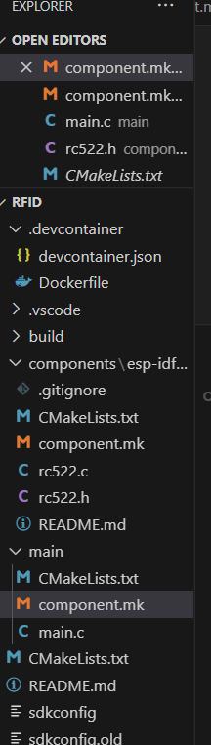

**CODE for main.c:**

#include <stdio.h>

#include <string.h>

#include <freertos/FreeRTOS.h>

#include <freertos/task.h>

#include <esp_system.h>

#include <esp_log.h>

#include <rc522.h>

#include <esp_http_client.h>

#include <cJSON.h>

// Define the TAG for logging

static const char* TAG = "main";

// RFID handle

rc522_handle_t rc522;

// RFID event handler

static void rfid_event_handler(void* handler_args, esp_event_base_t base, int32_t id, void* event_data)

{

    rc522_event_data_t* data = (rc522_event_data_t*)event_data;

    // Get the serial number of the scanned RFID tag

    uint64_t serial_number = data->ptr ? ((rc522_tag_t*)data->ptr)->serial_number : 0;

    // Convert the serial number to a string

    char serial_number_str[17]; // Assuming 64-bit serial number

    sprintf(serial_number_str, "%016llx", serial_number);

    // Log the scanned RFID tag

    ESP_LOGI(TAG, "Scanned RFID tag: %s", serial_number_str);

    // Create JSON object to hold the data

    cJSON* root = cJSON_CreateObject();

    cJSON_AddStringToObject(root, "serial_number", serial_number_str);

    // Add additional data fields to the JSON object

    cJSON_AddStringToObject(root, "name", "Yuvasri"); // Replace "Yuvasri" with the actual scanned name

    cJSON_AddStringToObject(root, "entry_time", "09:00 AM"); // Replace with actual entry time

    cJSON_AddStringToObject(root, "entry_date", "2023-07-21"); // Replace with actual entry date

    cJSON_AddNumberToObject(root, "visitor_count", 1); // Replace with actual visitor count

    // Convert the JSON object to a string

    char* payload = cJSON_Print(root);

    // Send the data to the Google Sheets script using HTTP POST

    esp_http_client_config_t config = {

        .url = "https://script.google.com/macros/s/AKfycbzfUu1XzCKO4Fnmhunwv5uvRHKrxnONhoprBOrfX04pl92eOYQaensSq9Iqebbr4rbK/exec", **//paste the copied url from google sheets here**

        .method = HTTP_METHOD_POST,

        .timeout_ms = 5000, // Set a suitable timeout value

    };

    esp_http_client_handle_t client = esp_http_client_init(&config);

     esp_http_client_set_post_field(client, payload, strlen(payload));

    // Perform the HTTP request

    esp_err_t err = esp_http_client_perform(client);

    if (err == ESP_OK) {

        ESP_LOGI(TAG, "Data sent to Google Sheets successfully");

    } else {

        ESP_LOGE(TAG, "Failed to send data to Google Sheets: %s", esp_err_to_name(err));

    }

    esp_http_client_cleanup(client);

    cJSON_Delete(root);

    free(payload);

    // No need to return a value in a void function

}

void app_main()

{

    // Initialize the RFID configuration

    rc522_config_t config;

    config.scan_interval_ms = 2000; // Adjust the scan interval as needed

    config.transport = RC522_TRANSPORT_SPI; // Change to RC522_TRANSPORT_I2C if using I2C interface

    // Configure the SPI settings

    config.spi.miso_gpio = 19;

    config.spi.mosi_gpio = 23;

    config.spi.sck_gpio = 18;

    config.spi.sda_gpio = 22;

    config.spi.clock_speed_hz = RC522_DEFAULT_SPI_CLOCK_SPEED_HZ;

    // Create the RFID handle

    rc522_handle_t rc522;

    esp_err_t err = rc522_create(&config, &rc522);

    if (err != ESP_OK) {

        ESP_LOGE(TAG, "Failed to create RC522 handle: %s", esp_err_to_name(err));

        return;

    }

    // Register RFID event handler

    err = rc522_register_events(rc522, RC522_EVENT_TAG_SCANNED, rfid_event_handler, NULL);

    if (err != ESP_OK) {

        ESP_LOGE(TAG, "Failed to register RFID event handler: %s", esp_err_to_name(err));

        rc522_destroy(rc522);

        return;

    }

    // Start RFID scanning

    rc522_start(rc522);

}

->Build the code ,flash and monitor it after connecting the esp32 board through the USB,select the port

->After the code is successfully flashed, the ESP32 with the RC522 RFID module is now set up to read RFID tags, extract their unique identifiers, and send the data to a Google Sheets script for further processing or storage. The script hosted on Google Sheets can be configured to handle the received data, such as logging attendance, tracking visitor counts.

**OUTPUT:**

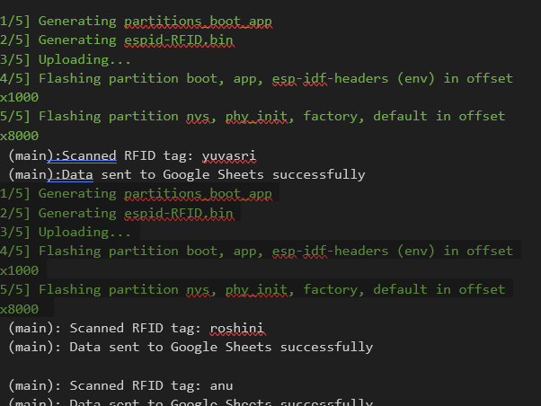

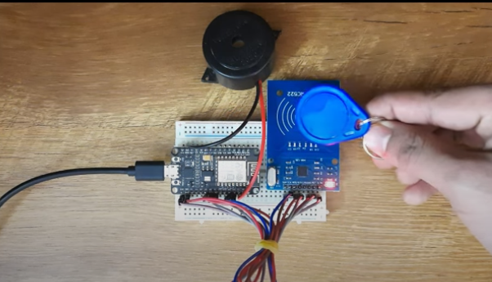

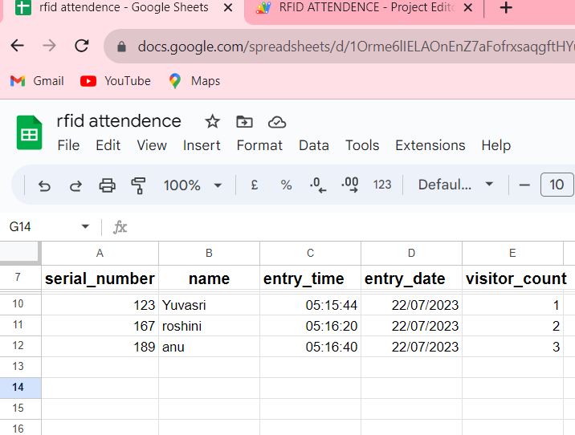

**5.TFT** **DISPLAY INTERFACE WITH ESP32**

**AIM:**

The aim of this project is to interface a TFT (Thin-Film Transistor) display with an ESP32 microcontroller and develop a system that can display graphics, text, and other visual elements on the screen.

**COMPONENTS:**

* ESP32 Development Board
* TFT Display Module
* Breadboard
* Jumper Wires
* Level Shifter (if required, depending on the logic voltage levels of the TFT display)
* Power Supply
* Resistors and Capacitors
* USB Cable

**TFT OVERVIEW:**

TFT LCD (Thin-Film-Transistor Liquid Crystal Display) is a popular display technology widely used in embedded systems, particularly in devices like mobile phones, tablets, handheld devices, industrial HMI (Human-Machine Interface) panels, and more. It offers several advantages that make it suitable for these applications:

**Structure and Working Principle:**

* TFT displays have a sandwich-like structure with liquid crystal material filled between two glass plates.
* The liquid crystal molecules change their orientation based on the electric charge applied to them, controlling the passage of light through the display.
* Each pixel in a TFT display is paired with a thin-film transistor (TFT), which acts as a switch and capacitor. This allows individual pixels to retain their charge and state, providing better image quality and faster refresh rates.

**Active Matrix Technology:**

* TFT displays utilize an active matrix design, where each pixel has its transistor that can be independently controlled.
* This active matrix allows for quicker and more precise control of each pixel, resulting in better image quality and responsiveness compared to passive matrix displays.

**Color Display and Resolution:**

* TFT displays support color output using RGB (red, green, blue) color filters for each pixel.
* The resolution of the display is determined by the underlying density of the color matrix and TFT layout. Higher resolution provides better image detail.

**Backlighting:**

* TFT displays require a backlight to illuminate the screen since the TFT screen itself does not emit light.
* LED backlights are commonly used in modern TFT displays as they are energy-efficient and allow for slimmer designs.

**Benefits:**

* TFT LCDs are lightweight, thin, and energy-efficient, making them suitable for portable and battery-powered devices.
* They offer better image quality, color reproduction, and viewing angles compared to older display technologies like CRT and monochrome passive LCDs.
* TFT displays are relatively affordable, making them a cost-effective choice for various applications.

**Uses in Embedded Systems:**

* TFT displays find extensive use in embedded systems due to their versatility and performance.
* They are used in smartphones, tablets, MP3 players, digital cameras, and other portable consumer electronics.
* In industrial embedded systems, TFT displays serve as intuitive and interactive HMI panels for control and monitoring.
* TFT displays are also utilized in automotive infotainment systems, medical devices, home automation interfaces.
* Overall, TFT displays have revolutionized the way information is presented in embedded systems, offering visually appealing and interactive user interfaces in a wide range of applications. Their widespread adoption is driven by their efficiency, color capabilities, and overall cost-effectiveness in the market.

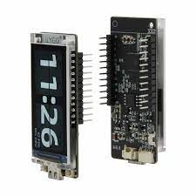 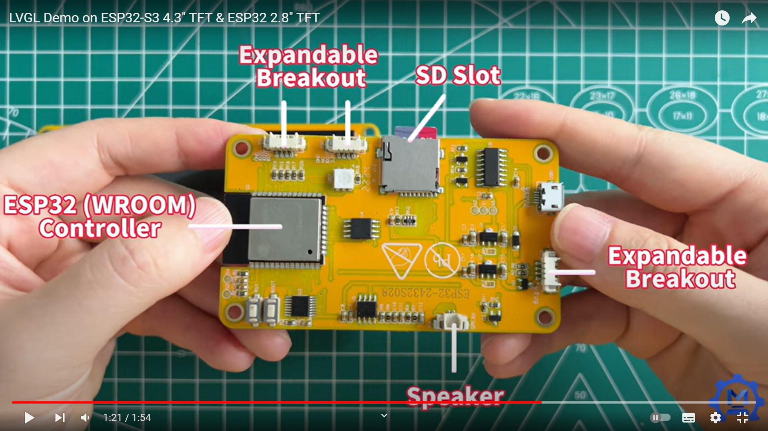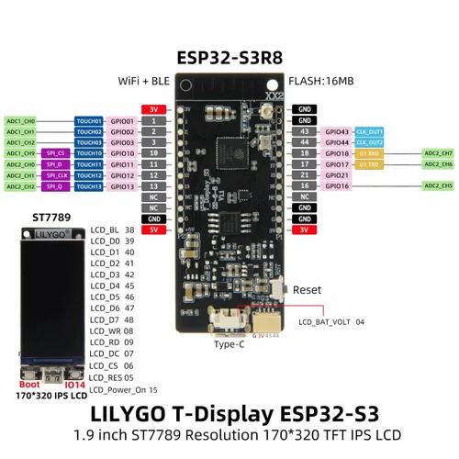

* Download EspTouch from playstore.
* Log in with password.

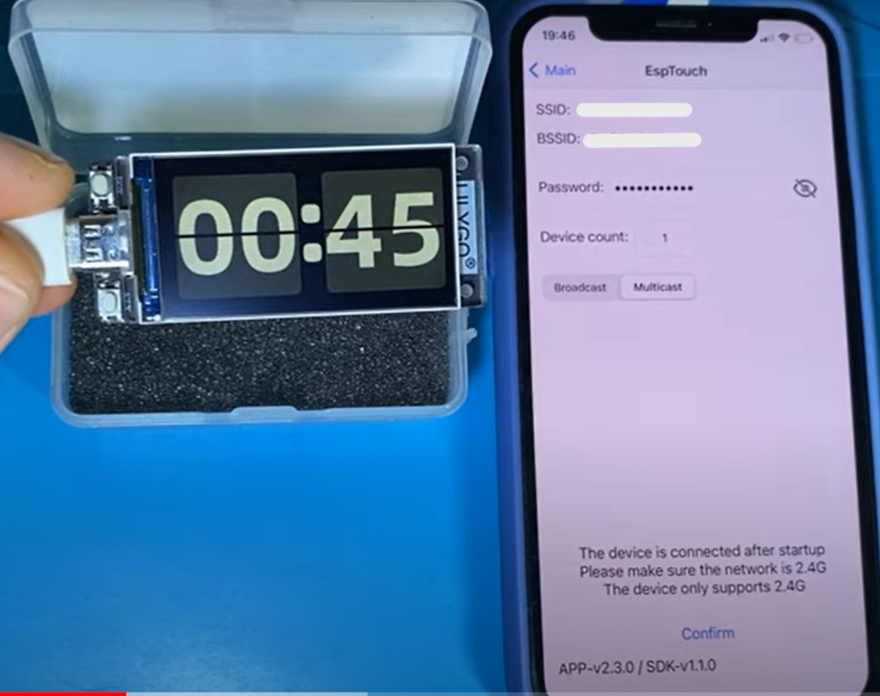

**Connections:**

ESP Board LCD Screen

┌─────────────┐ ┌────────────────┐

│ │ │ │

│ 3V3 ├─────────────►│ VCC │

│ │ │ │

│ GND ├──────────────┤ GND │

│ │ │ │

│ DATA[0..7] │◄────────────►│ DATA[0..7] │

│ │ │ │

│ PCLK ├─────────────►│ PCLK │

│ │ │ │

│ CS ├─────────────►│ CS │

│ │ │ │

│ D/C ├─────────────►│ D/C │

│ │ │ │

│ RST ├─────────────►│ RST │

│ │ │ │

│ BK_LIGHT ├─────────────►│ BCKL │

│ │ │ │

└─────────────┘ └────────────────┘

**LVGL LIBRARY:**

LVGL (Light and Versatile Graphics Library) is an open-source graphics library specifically designed for embedded systems. It provides a rich set of graphical elements and features, allowing developers to create visually appealing and interactive user interfaces on various display technologies, including TFT displays. Integrating LVGL into an ESP-IDF project in Visual Studio Code involves several steps, as below:

Step 1: Set Up ESP-IDF Environment:

Install ESP-IDF on your system. You can follow the official guide for installation: https://docs.espressif.com/projects/esp-idf/en/latest/esp32/get-started/

Step 2: Create an ESP-IDF Project:

Create a new ESP-IDF project using the esp-idf.py command-line tool or use an existing one.

Step 3: Set Up LVGL Library:

* Download the LVGL library from the official GitHub repository: <https://github.com/lvgl/lvgl>
* Extract the LVGL library to a location of your choice.

Step 4: Configure LVGL for ESP-IDF:

* Inside the LVGL library folder, navigate to the lv_conf_template.h file and rename it to lv_conf.h.
* Open the lv_conf.h file and configure it according to your requirements. This file allows you to customize various aspects of LVGL, such as display resolution, color depth, font settings, etc.

Step 5: Include LVGL in ESP-IDF Project:

* Copy the entire LVGL library folder into your ESP-IDF project's components directory. If the components folder doesn't exist, create it in the project directory .
* In your ESP-IDF project, navigate to the CMakeLists.txt file, and add the LVGL component to your project's components list. For example:
* Copy code: set(EXTRA_COMPONENT_DIRS "components/lvgl")

Step 6: Configure Display Driver (TFT): LVGL requires a display driver to interface with the TFT display. You'll need to choose or create a display driver that is compatible with your TFT display and ESP32.

* Depending on the specific driver, you may need to add it as a separate component or integrate it directly into your project.

Step 7: Initialize LVGL in Your Application:

* In your ESP-IDF project, create a new source file (e.g., main.c or any other relevant name).
* In this source file, include the necessary LVGL headers, such as lvgl.h, and initialize LVGL using appropriate functions. For example:
* Copy code

#include "lvgl/lvgl.h"

void app_main(void) {

// Initialize LVGL

lv_init();

// Your LVGL code and application logic goes here

}

Step 8: Build and Flash the Project:

* Use the ESP-IDF build system (idf.py build) to build your project and ensure there are no compilation errors.
* Connect your ESP32 development board to your computer and use the ESP-IDF build system (idf.py flash) to flash the firmware onto the board.

Step 9: Interact with LVGL:

* Now that LVGL is integrated into your ESP-IDF project and running on your ESP32, you can start creating your user interface using LVGL's API.
* Remember to refer to the LVGL documentation at <https://docs.lvgl.io/8.3/index.html> and examples to understand the library's capabilities and how to use its various features effectively.
* Additionally, adjust the LVGL configuration and display driver according to your specific TFT display's requirements.
* Download or clone the library from GitHub with git clone <https://github.com/lvgl/lvgl.git>
* Copy the lvgl folder into your project.
* Copy lvgl/lv_conf_template.h as lv_conf.h next to the lvgl folder, change the first #if 0 to 1 to enable the file's content and set the LV_COLOR_DEPTH defines.
* Include lvgl/lvgl.h in files where you need to use LVGL related functions.
* Call lv_tick_inc(x) every x milliseconds in a Timer or Task (x should be between 1 and 10). It is required for the internal timing, of LVGL. Alternatively, configure LV_TICK_CUSTOM (see lv_conf.h) so that LVGL can retrieve the current time directly.

**CODE:**

**lvgl_demo_ui.c**

#include "lvgl_demo_ui.h"

static lv_style_t style;

static lv_style_t bgStyle;

static lv_obj_t *arc[3];

static lv_obj_t *meter;

static lv_color_t arc_color[] =

{

    LV_COLOR_MAKE(0xFF, 0x00, 0x28),

    LV_COLOR_MAKE(0x14, 0xFF, 0x00),

    LV_COLOR_MAKE(0xFF, 0xFF, 0xFF),

};

void lvgl_demo_ui(lv_obj_t *scr);

static void anim_timer_cb(lv_timer_t *timer);

void set_value(void *indic, int32_t v)

{

    lv_meter_set_indicator_end_value(meter, indic, v);

}

static void anim_timer_cb(lv_timer_t *timer)

{

    my_timer_context_t *timer_ctx = (my_timer_context_t *) timer->user_data;

    int count = timer_ctx->count_val;

    lv_obj_t *scr = timer_ctx->scr;

    // Play arc animation

    if (count < 90)

    {

        lv_coord_t arc_start = count > 0 ? (1 - cosf(count / 180.0f * PI)) * 270 : 0;

        lv_coord_t arc_len = (sinf(count / 180.0f * PI) + 1) * 135;

        for (size_t i = 0; i < sizeof(arc) / sizeof(arc[0]); i++)

        {

            lv_arc_set_bg_angles(arc[i], arc_start, arc_len);

            lv_arc_set_rotation(arc[i], (count + 120 * (i + 1)) % 360);

        }

    }

    // Delete arcs when animation finished

    if (count == 90)

    {

        for (size_t i = 0; i < sizeof(arc) / sizeof(arc[0]); i++)

        {

            lv_obj_del(arc[i]);

        }

    }

    // Delete timer when all animation finished

    if ((count += 5) == 220)

    {

        lv_timer_del(timer);

    }

    else

    {

        timer_ctx->count_val = count;

    }

}

void lvgl_demo_ui(lv_obj_t *scr)

{

    // Create arcs

    for (size_t i = 0; i < sizeof(arc) / sizeof(arc[0]); i++)

    {

        arc[i] = lv_arc_create(scr);

        // Set arc caption

        lv_obj_set_size(arc[i], 220 - 30 * i, 220 - 30 * i);

        lv_arc_set_bg_angles(arc[i], 120 * i, 10 + 120 * i);

        lv_arc_set_value(arc[i], 0);

        // Set arc style

        lv_obj_remove_style(arc[i], NULL, LV_PART_KNOB);

        lv_obj_set_style_arc_width(arc[i], 10, 0);

        lv_obj_set_style_arc_color(arc[i], arc_color[i], 0);

        // Make arc center

        lv_obj_center(arc[i]);

    }

    // Create timer for animation

    static my_timer_context_t my_tim_ctx =

    {

        .count_val = -90,

    };

    my_tim_ctx.scr = scr;

    // page 1 - arc animation

    meter = lv_meter_create(scr);

    lv_obj_center(meter);

    lv_obj_set_size(meter, 170, 170);

    // Remove the circle from the middle

    lv_obj_remove_style(meter, NULL, LV_PART_INDICATOR);

    // Add a scale first

    lv_meter_t *scale = lv_meter_add_arc(meter);

    lv_meter_set_scale_ticks(meter, scale, 11, 2, 10, lv_palette_main(LV_PALETTE_GREY));

    lv_meter_set_scale_major_ticks(meter, scale, 1, 2, 15, lv_color_hex3(0xeee), 10);

    lv_meter_set_scale_range(meter, scale, 0, 100, 270, 90);

    // Add a three arc indicator

lv_meter_indicator_t *indic1 = lv_meter_add_arc(meter, scale, 10, lv_color_hex3(0x00F), 0);

    lv_meter_indicator_t *indic2 = lv_meter_add_arc(meter, scale, 10, lv_color_hex3(0x0F0), -10);

    lv_meter_indicator_t *indic3 = lv_meter_add_arc(meter, scale, 10, lv_color_hex3(0xF00), -20);

    // Create an animation to set the value

    lv_anim_t a;

    lv_anim_init(&a);

    lv_anim_set_exec_cb(&a, set_value);

    lv_anim_set_values(&a, 0, 100);

    lv_anim_set_repeat_delay(&a, 100);

    lv_anim_set_playback_delay(&a, 100);

    lv_anim_set_repeat_count(&a, LV_ANIM_REPEAT_INFINITE);

    lv_anim_set_time(&a, 2000);

    lv_anim_set_playback_time(&a, 500);

    lv_anim_set_var(&a, indic1);

    lv_anim_start(&a);

    lv_anim_set_time(&a, 1000);

    lv_anim_set_playback_time(&a, 1000);

    lv_anim_set_var(&a, indic2);

    lv_anim_start(&a);

    lv_anim_set_time(&a, 1000);

    lv_anim_set_playback_time(&a, 2000);

    lv_anim_set_var(&a, indic3);

    lv_anim_start(&a);}

**lvgl_demo_ui.h:**

#ifndef MAIN_LVGL_DEMO_UI_H_

#define MAIN_LVGL_DEMO_UI_H_

/* INCLUDES -------------------------------------------------*/

#include <math.h>

#include "esp_log.h"

#include <lvgl.h>

/* MACROS ------------------------------------------------------*/

#ifndef PI

#define PI  (3.14159f)

#endif

typedef struct

{

    lv_obj_t *scr;

    int count_val;

} my_timer_context_t;

/* VARIABLES ------------------------------------------------------*/

/* FUNCTIONS DECLARATION -----------------------------------------*/

void lvgl_demo_ui(lv_obj_t *scr);

#endif /* MAIN_LVGL_DEMO_UI_H_ */

**main.c:**

#include <stdio.h>

#include "freertos/FreeRTOS.h"

#include "freertos/task.h"

#include "esp_timer.h"

#include "esp_lcd_panel_io.h"

#include "esp_lcd_panel_vendor.h"

#include "esp_lcd_panel_ops.h"

#include "driver/gpio.h"

#include "esp_err.h"

#include "esp_log.h"

/* include lvgl.h path according to your folder name*/

#include "C:\Users\YUVA\Desktop\espid\TFTDISPLAY\components\lvgl\lvgl\lvgl.h"

#include "main.h"

#include "lvgl_demo_ui.h"

/* PRIVATE FUNCTIONS DECLARATION ---------------------------------------------*/

static void example_increase_lvgl_tick(void *arg);

static bool example_notify_lvgl_flush_ready(esp_lcd_panel_io_handle_t panel_io, esp_lcd_panel_io_event_data_t *edata, void *user_ctx);

static void example_lvgl_flush_cb(lv_fs_drv_t *drv, const lv_area_t *area, lv_color_t *color_map);

static void main_creatSysteTasks(void);

static void lvglTimerTask(void* param);

/* FUNCTION PROTOTYPES ------------------------------*/

static bool example_notify_lvgl_flush_ready(esp_lcd_panel_io_handle_t panel_io, esp_lcd_panel_io_event_data_t *edata, void *user_ctx)

{

    lv_fs_drv_t *disp_driver = (lv_fs_drv_t *)user_ctx;

    lv_disp_flush_ready(disp_driver);

    return false;

}

static void example_lvgl_flush_cb(lv_fs_drv_t *drv, const lv_area_t *area, lv_color_t *color_map)

{

    esp_lcd_panel_handle_t panel_handle = (esp_lcd_panel_handle_t)drv->user_data;

    int offsetx1 = area->x1;

    int offsetx2 = area->x2;

    int offsety1 = area->y1;

    int offsety2 = area->y2;

    // copy a buffer's content to a specific area of the display

    esp_lcd_panel_draw_bitmap(panel_handle, offsetx1, offsety1, offsetx2 + 1, offsety2 + 1, color_map);

}

static void example_increase_lvgl_tick(void *arg)

{

    /* Tell LVGL how many milliseconds has elapsed */

    lv_tick_inc(EXAMPLE_LVGL_TICK_PERIOD_MS);

}

static void lvglTimerTask(void* param)

{

    while(1)

    {

        // The task running lv_timer_handler should have lower priority than that running `lv_tick_inc`

        lv_timer_handler();

        vTaskDelay(10 / portTICK_PERIOD_MS);

    }

}

static void main_creatSysteTasks(void)

{

    xTaskCreatePinnedToCore(lvglTimerTask, "lvgl Timer", 10000, NULL, 4, NULL, 1);

}

void app_main(void)

{  static lv_disp_draw_buf_t disp_buf; // contains internal graphic buffer(s) called draw buffer(s)

    static lv_disp_drv_t disp_drv;      // contains callback functions

    // GPIO configuration

        ESP_LOGI(TAG, "Turn off LCD backlight");

    gpio_config_t bk_gpio_config = {

        .mode = GPIO_MODE_OUTPUT,

        .pin_bit_mask = 1ULL << EXAMPLE_PIN_NUM_BK_LIGHT

    };

    ESP_ERROR_CHECK(gpio_config(&bk_gpio_config));

    esp_rom_gpio_pad_select_gpio(EXAMPLE_PIN_NUM_BK_LIGHT);

    esp_rom_gpio_pad_select_gpio(EXAMPLE_PIN_RD);

    esp_rom_gpio_pad_select_gpio(EXAMPLE_PIN_PWR);

    gpio_set_direction(EXAMPLE_PIN_RD, EXAMPLE_PIN_NUM_BK_LIGHT);

    gpio_set_direction(EXAMPLE_PIN_RD, GPIO_MODE_OUTPUT);

    gpio_set_direction(EXAMPLE_PIN_PWR, GPIO_MODE_OUTPUT);

    gpio_set_level(EXAMPLE_PIN_RD, true);

    gpio_set_level(EXAMPLE_PIN_NUM_BK_LIGHT, EXAMPLE_LCD_BK_LIGHT_OFF_LEVEL);

    ESP_LOGI(TAG, "Initialize Intel 8080 bus");

    esp_lcd_i80_bus_handle_t i80_bus = NULL;

    esp_lcd_i80_bus_config_t bus_config = {

        .dc_gpio_num = EXAMPLE_PIN_NUM_DC,

        .wr_gpio_num = EXAMPLE_PIN_NUM_PCLK,

        .clk_src    = LCD_CLK_SRC_PLL160M,

        .data_gpio_nums =

        {

            EXAMPLE_PIN_NUM_DATA0,

            EXAMPLE_PIN_NUM_DATA1,

            EXAMPLE_PIN_NUM_DATA2,

            EXAMPLE_PIN_NUM_DATA3,

            EXAMPLE_PIN_NUM_DATA4,

            EXAMPLE_PIN_NUM_DATA5,

            EXAMPLE_PIN_NUM_DATA6,

            EXAMPLE_PIN_NUM_DATA7, },

        .bus_width = 8,

        .max_transfer_bytes = LVGL_LCD_BUF_SIZE * sizeof(uint16_t)

    };

    ESP_ERROR_CHECK(esp_lcd_new_i80_bus(&bus_config, &i80_bus));

    esp_lcd_panel_io_handle_t io_handle = NULL;

    esp_lcd_panel_io_i80_config_t io_config = {

        .cs_gpio_num = EXAMPLE_PIN_NUM_CS,

        .pclk_hz = EXAMPLE_LCD_PIXEL_CLOCK_HZ,

        .trans_queue_depth = 20,

        .dc_levels = {

            .dc_idle_level = 0,

            .dc_cmd_level = 0,

            .dc_dummy_level = 0,

            .dc_data_level = 1,

        },

        .on_color_trans_done = example_notify_lvgl_flush_ready,

        .user_ctx = &disp_drv,

        .lcd_cmd_bits = EXAMPLE_LCD_CMD_BITS,

        .lcd_param_bits = EXAMPLE_LCD_PARAM_BITS,

    };

    ESP_ERROR_CHECK(esp_lcd_new_panel_io_i80(i80_bus, &io_config, &io_handle));

ESP_LOGI(TAG, "Install LCD driver of st7789");

    esp_lcd_panel_handle_t panel_handle = NULL;

esp_lcd_panel_dev_config_t panel_config =

    {

        .reset_gpio_num = EXAMPLE_PIN_NUM_RST,

        .color_space = ESP_LCD_COLOR_SPACE_RGB,

        .bits_per_pixel = 16,

    };

ESP_ERROR_CHECK(esp_lcd_new_panel_st7789(io_handle, &panel_config, &panel_handle));

    esp_lcd_panel_reset(panel_handle);

    esp_lcd_panel_init(panel_handle);

    esp_lcd_panel_invert_color(panel_handle, true);

    esp_lcd_panel_swap_xy(panel_handle, true);

    esp_lcd_panel_mirror(panel_handle, false, true);

    // the gap is LCD panel specific, even panels with the same driver IC, can have different gap value

    esp_lcd_panel_set_gap(panel_handle, 0, 35);

    ESP_LOGI(TAG, "Turn on LCD backlight");

    gpio_set_level(EXAMPLE_PIN_PWR, true);

    gpio_set_level(EXAMPLE_PIN_NUM_BK_LIGHT, EXAMPLE_LCD_BK_LIGHT_ON_LEVEL);

    ESP_LOGI(TAG, "Initialize LVGL library");

    lv_init();

    lv_color_t *buf1 = heap_caps_malloc(LVGL_LCD_BUF_SIZE * sizeof(lv_color_t), MALLOC_CAP_DMA );

    assert(buf1);

    lv_disp_draw_buf_init(&disp_buf, buf1, NULL, LVGL_LCD_BUF_SIZE);

ESP_LOGI(TAG, "Register display driver to LVGL");

    lv_fs_drv_init(&disp_drv);

    disp_drv.hor_res = EXAMPLE_LCD_H_RES;

    disp_drv.ver_res = EXAMPLE_LCD_V_RES;

    disp_drv.flush_cb = example_lvgl_flush_cb;

    disp_drv.draw_buf = &disp_buf;

    disp_drv.user_data = panel_handle; // Add your panel_handle obtained from the display initialization

    lv_disp_t *disp = lv_fs_drv_register(&disp_drv);

    // Configuration is completed.

    ESP_LOGI(TAG, "Install LVGL tick timer");

    // Tick interface for LVGL using esp_timer to generate 2ms periodic event

    const esp_timer_create_args_t lvgl_tick_timer_args = {

        .callback = &example_increase_lvgl_tick,

        .name = "lvgl_tick"

    };

    esp_timer_handle_t lvgl_tick_timer = NULL;

    ESP_ERROR_CHECK(esp_timer_create(&lvgl_tick_timer_args, &lvgl_tick_timer));

    ESP_ERROR_CHECK(esp_timer_start_periodic(lvgl_tick_timer, EXAMPLE_LVGL_TICK_PERIOD_MS * 1000));

    ESP_LOGI(TAG, "Display LVGL animation");

    lv_obj_t *scr = lv_disp_get_scr_act(disp);

    lvgl_demo_ui(scr);

    main_creatSysteTasks();

}

**main.h**

#ifndef MAIN_H_

#define MAIN_H_

#define EXAMPLE_LCD_PIXEL_CLOCK_HZ     (6528000) // 170 (h) * 320 (w) * 2 (sizeof(lv_color_t)) * 60 (max fps)

#define EXAMPLE_LCD_BK_LIGHT_ON_LEVEL  1

#define EXAMPLE_LCD_BK_LIGHT_OFF_LEVEL !EXAMPLE_LCD_BK_LIGHT_ON_LEVEL

#define EXAMPLE_PIN_NUM_DATA0          39

#define EXAMPLE_PIN_NUM_DATA1          40

#define EXAMPLE_PIN_NUM_DATA2          41

#define EXAMPLE_PIN_NUM_DATA3          42

#define EXAMPLE_PIN_NUM_DATA4          45

#define EXAMPLE_PIN_NUM_DATA5          46

#define EXAMPLE_PIN_NUM_DATA6          47

#define EXAMPLE_PIN_NUM_DATA7          48

#define EXAMPLE_PIN_RD                 GPIO_NUM_9

#define EXAMPLE_PIN_PWR                15

#define EXAMPLE_PIN_NUM_PCLK           GPIO_NUM_8       //LCD_WR

#define EXAMPLE_PIN_NUM_CS             6

#define EXAMPLE_PIN_NUM_DC             7

#define EXAMPLE_PIN_NUM_RST            5

#define EXAMPLE_PIN_NUM_BK_LIGHT       38

// The pixel number in horizontal and vertical

#define EXAMPLE_LCD_H_RES              320

#define EXAMPLE_LCD_V_RES              170

#define LVGL_LCD_BUF_SIZE            (EXAMPLE_LCD_H_RES * EXAMPLE_LCD_V_RES)

// Bit number used to represent command and parameter

#define EXAMPLE_LCD_CMD_BITS           8

#define EXAMPLE_LCD_PARAM_BITS         8

#define EXAMPLE_LVGL_TICK_PERIOD_MS    2

/* ENUMORATIONS ---------------------------------------------*/

/* STRUCTURES & TYPEDEFS ------------------------------------------*/

/* VARIABLES ----------------------------------------------------*/

/* FUNCTIONS DECLARATION ---------------------------------------*/

#endif /* MAIN_MAIN_H_ */

* This code is just a sample demonstration of integrating the LVGL library alter it according to the requirements .
* Build, flash and monitor the project.
* After flashing the code to the ESP32 board, the system initializes the TFT display, LVGL library, and necessary peripherals. The TFT display is set up using the ESP-IDF's LCD panel interface, and the LVGL library is initialized to create graphical user interfaces (GUIs). The TFT display is driven by LVGL, which handles the rendering of graphics and user interactions.
* Upon successful initialization, LVGL starts displaying the graphical animation on the TFT screen. The LVGL tick timer is also activated to keep track of time for LVGL's internal timing

**OUTPUT:**

I (0) cpu_start: Starting scheduler on APP CPU.

I (418) example: Turn off LCD backlight

I (418) gpio: GPIO[2]| InputEn: 0| OutputEn: 1| OpenDrain: 0| Pullup: 0| Pulldown: 0| Intr:0

I (428) example: Initialize Intel 8080 bus

I (438) example: Install LCD driver of st7789

I (558) example: Turn on LCD backlight

I (558) example: Initialize LVGL library

I (558) example: Register display driver to LVGL

I (558) example: Install LVGL tick timer

I (558) example: Display LVGL animation

